LESSON 9 – PROMISE ROAD GOES THROUGH EGYPT
第 9 课 – 承诺之路穿过埃及
Genesis 37 - 50
创世纪37-50
THEME: To give a preview of Israel’s history in relation to Jesus Christ.
主题： 揭示以色列与耶稣基督有关的历史
Have you ever looked through a telescope? If you did, you saw far off in the distance. Now we are going to meet a man on PROMISE ROAD whose life is like looking through a telescope. Through his experiences, we can see far off in the distance on THE HIGHWAY OF LIFE to the time of Jesus Christ. We can call such a man a type because he is a picture of events to come. Joseph is a picture of the Lord Jesus Christ. Like Joseph, Jesus was treated harshly by the Jews when He lived on this earth.
你曾经用望远镜观察过吗？ 如果你这样做过，你就知道如何看到远处。 现在，我们将在承诺之路上遇到一个人，他的人生就像通过望远镜去观察。 通过他的经历，我们可以生命大道上遥望耶稣基督的时代。我们可以称这样的人为典型，因为他是未来事件的写照。 约瑟夫是主耶稣基督的映射，像约瑟夫一样，耶稣在世上受到犹太人的严厉对待。
Israel’s favorite son was Joseph because Joseph was the son of his old age (Genesis 37:3). He treated Joseph better than the others, and he made him a robe of many colors. His brothers saw that their father loved Joseph more than them. They hated him and they could not speak kindly to him. Then Joseph had an unusual dream, and he shared it with his brothers. They hated him even more (Genesis 37:3-5).
以色列最喜欢的儿子是约瑟夫，因为约瑟夫是他年老时生的儿子（创世记37:3）。 他对约瑟夫比其他人都好，他给他做了一件五彩长袍。 他的兄弟们看到他们的父亲爱约瑟夫胜过爱他们就憎恨他，甚至不能和善的对他说话。 然后约瑟夫做了一个不寻常的梦，并把这个梦告诉了他的兄弟们，因此他们更恨他了（创世记 37:3-5）。
One day his brothers went to feed their father’s flock in *Shechem. Israel sent Joseph there to check everything out. When Joseph found his brothers in *Dothan, they plotted to kill him. They said, “Look, this dreamer is coming…” (Genesis 37:19). However, Reuben, the oldest brother, told them that they were not going to hurt him, but that they could throw him into an empty pit. Once Joseph arrived, they stripped him of his colorful robe and then they threw him into the empty pit (Genesis 37:24).
有一天，他的兄弟们去舍根喂养他们父亲的羊群。 以色列派约瑟夫去那里看看一切是否安好。 当约瑟夫在 多森 找到他的兄弟时，他们密谋要杀了他。 他们说：“看哪，这做梦就要实现了……”（创世记 37:19）。 然而，大哥鲁本告诉他们，他们不该伤害他，但他们可以把他扔进一个空坑里。 约瑟夫一到，他们就剥去他五彩长袍，把他扔到了空坑里（创世记 37:24）。
While they were eating, they saw a caravan of Ishmaelite traders heading to Egypt. One of the brothers named Judah suggested that they sell Joseph for twenty pieces of silver to the traders. Reuben was not there when this happened. When he arrived, he said, “The lad is no more; and I, where shall I go?” So they dipped Joseph’s colorful robe into some goat’s blood. Then they brought it to their father, and they asked him if he thought it belonged to Joseph. Israel recognized it, and he concluded that Joseph had been killed by a wild beast. He refused to be comforted, and he wept for him (Genesis 37:12-35).
他们吃饭的时候，看见一队以实玛利人商队前往埃及。一个名叫犹大的兄弟建议他们以二十块钱的价格将约瑟夫卖给商人。这些事情发生时，鲁本不在。 当他到达时，他说：“小伙子已经不在了； 而我，我该去哪里？” 于是他们将约瑟夫的彩色长袍浸入山羊的血中，然后把它带到他们的父亲面前，问他是否认为它是属于约瑟夫的。 以色列认出了这长袍，他断定约瑟夫是被野兽杀死的。 他拒绝安慰，并为他哭泣（创世记 37:12-35）
Once the traders arrived in Egypt, they sold Joseph to Potiphar, Pharaoh’s officer, the captain of the bodyguard. The Lord was with Joseph, so he became the overseer of Potiphar’s house. While he was there, Potiphar’s wife tried to seduce him. When he avoided her, she falsely accused him of sexual misconduct (Genesis 39:11-15).
商人到达埃及后，就把约瑟夫卖给了法老的臣仆，保镖队长波提乏。主与约瑟夫同在，所以他成为波提乏家的监工。当他在那里时，波提乏的妻子试图引诱他。 当他躲避她时，她诬告他玷污了她（创世记 39:11-15）。
Although Joseph was sent to prison, the Lord was with him. He gave him favour in the sight of the chief jailer. The chief jailer delegated the job of overseer for all the prisoners to Joseph. The chief cupbearer and the chief baker were also in prison. They both had different dreams, and Joseph was able to interpret them. Joseph told them that within three days the chief cupbearer would be restored to his position, but the chief baker would die. Although the dreams came true, the chief cupbearer did not remember Joseph (Genesis 40:20-23).
虽然约瑟夫被送进监狱，但主与他同在。 他在狱卒面前给了他恩惠。 狱卒将所有囚犯的监督工作委托给约瑟夫。 酒政总长和厨师长也在监狱里。 他们做了不同的梦，约瑟夫能帮他们解梦。约瑟告诉他们，酒政三日内会恢复他的职位，但厨师长会死。 虽然这两个梦最后都成真，但酒政却将约瑟夫忘记了（创世记 40:20-23）。
One day Pharaoh had two dreams. Not any of the magicians of Egypt nor any wise men could interpret the dreams. Then the chief cupbearer remembered Joseph, and he told Pharaoh about Joseph’s ability to interpret dreams. Joseph was able to interpret them because God helped him. Joseph learned from the dreams that there would be seven years of abundance and seven years of severe famine. When Joseph suggested that they store food to prepare for the seven years of famine, Pharaoh was very pleased (Genesis 41:33-38).
有一天，法老做了两个梦。 埃及的术士和智者都不能解梦。 这时，酒政想起了约瑟夫，他告诉法老约瑟夫有解梦的能力。约瑟夫能够解释它们是因为上帝帮助了他。 约瑟夫从梦中得知将会有七年的丰裕和七年的大饥荒。 当约瑟夫建议他们储存食物来为七年的饥荒做准备时，法老非常高兴（创世记 41:33-38）。
So Pharaoh said to Joseph, “...God has shown you of all this, there is no one as discerning and wise as you. You shall be over my house, and all my people shall be ruled according to your word; only in regard to the throne will I be greater than you” (Genesis 41:39-40). Pharaoh set Joseph, who was thirty years old when he stood before him, over all the land of Egypt. He named him Zaphnath-Paaneah.
于是法老对约瑟夫说：“……这一切都是神向你显明的，没有人像你一样有洞察力和智慧。 你将管理我的家，我的所有人民都将遵从你的话语； 惟独在宝座上的我比你大”（创世记 41：39-40）。 法老派约瑟夫（约瑟夫这时已是三十岁）管理埃及全地。 他给他起名叫 Zaphnath-Paaneah。
When the seven years of plenty in Egypt came to an end, there was famine in all the lands. However, Egypt had stored enough food. Joseph’s ten brothers went to Egypt to buy food. Since Joseph was the ruler over all the land, he was the one who sold food to all the people. When Joseph’s brothers came, they bowed down to him. They did not recognize him, but Joseph recognized them. He tested them to see if their hearts had changed since the day that they had sold him.
当埃及七年的丰年结束时，全地都发生饥荒。 然而，埃及已经储存了足够的食物。 约瑟夫的十个兄弟去埃及买食物。 因为约瑟夫是全地的统治者，所以他就是卖粮食给万民的。 约瑟夫的哥哥们来了，都向他下拜。 他们没有认出他，但约瑟夫认出了他们。 他试探他们，看看从卖他那天后，他们的心是否发生了变化。
Chapters 42-44 of Genesis describe the tests which Joseph used on his brothers. Once they proved to be sincerely repentant, Joseph then revealed himself to them. We can imagine their weeping and their rejoicing when they learned that he was their brother! Joseph did not see his brothers as enemies because of his perspective. Joseph said, “it was not you who sent me here, but God; and He has made me a father to Pharaoh and lord of all his house, and ruler throughout all the land of Egypt” (Genesis 45:8). Joseph was a man who understood his life with a divine perspective.
创世记第 42-44 章描述了约瑟夫对他的兄弟们进行的测试。 一旦证明他们真诚地悔改，约瑟夫就向他们表明了自己的身份。 当他们得知他是他们的兄弟时，我们可以想象他们的哭泣和喜悦！ 根据约瑟夫的认知，他没有将他的兄弟视为敌人。 约瑟夫说：“派我到这里来的不是你，而是上帝；他又立我为法老的父亲，作他全家的主，作埃及全地的统治者”（创世记 45:8）。约瑟夫是一个从神圣的视角理解自己生命的人。

. 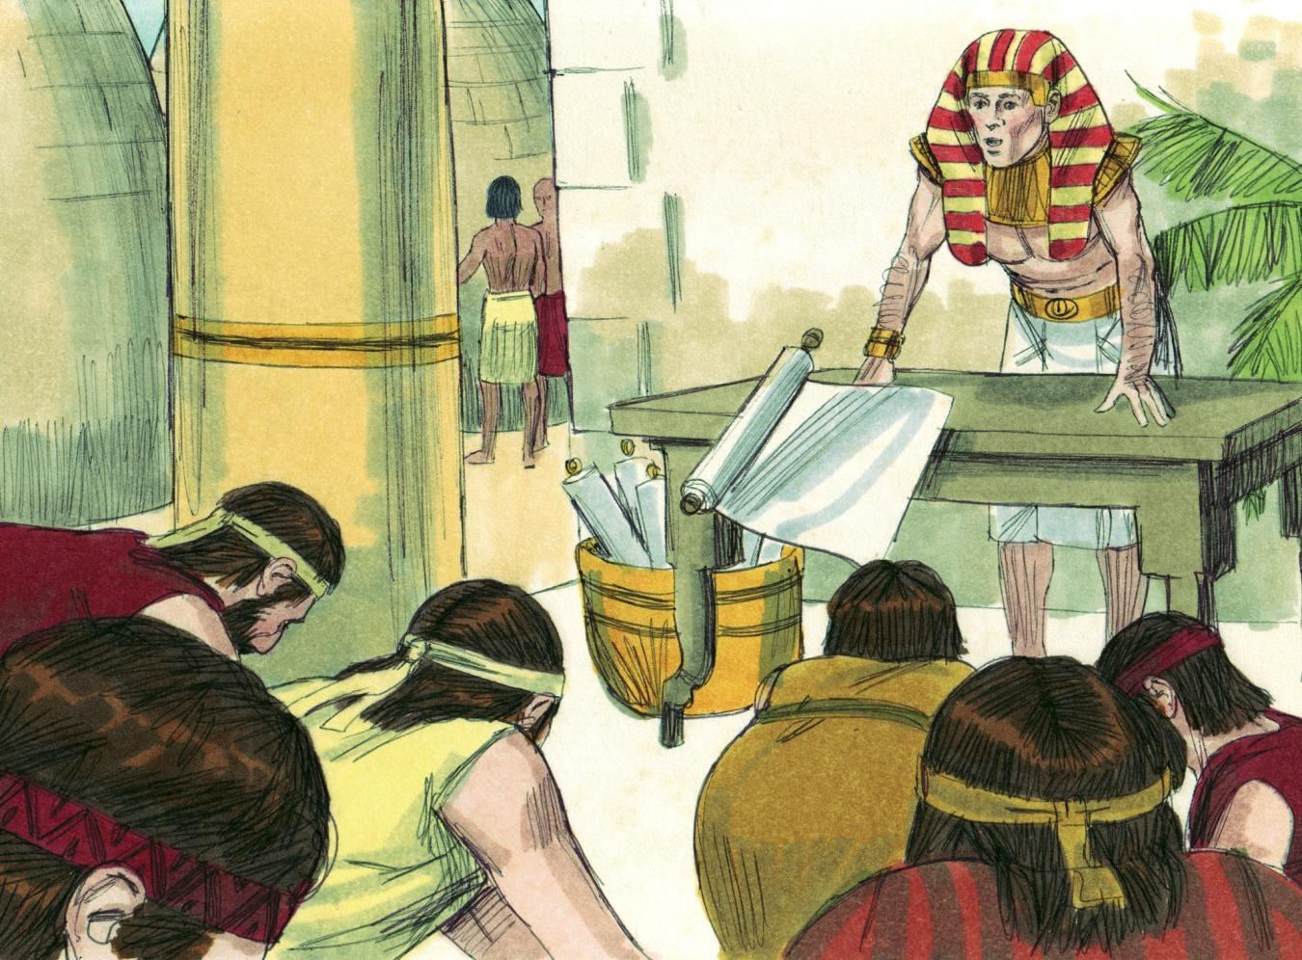
Source: Sweet Publishing - for illustration purposes of Genesis 42:6 only

Joseph then requested that his father come to Egypt and for the whole family to live in Egypt. God promised to bless Israel in Egypt, and He would bring Israel’s descendants out again (Genesis 46:3-4).
约瑟夫然后请求让他的父亲来埃及，并让全家住在埃及。神应许要在埃及祝福以色列，他会带领以色列的后裔再次出来（创世记 46:3-4）。
Now we will look through the telescope, far ahead. In how many ways are Joseph’s life experiences like the experiences of Jesus?
现在我们将通过望远镜去观察更远的未来。 约瑟夫的人生经历在多少方面与耶稣的经历相似？
- Both were beloved sons. Matthew 3:17.
两人都是心爱的儿子。 马太福音 3:17
- Both were faithful to the will of the father. John 8:29.
两人都忠于父亲的旨意。 约翰福音 8:29。
- Both wore a robe. John 19:23.
两人都穿着长袍。 约翰福音 19:23。
- Both were hated without a cause. John 15:25.
两人都被无缘无故地被憎恨。 约翰福音 15:25
- Both were not received by their own family. John 1:11.
两人都没有被自己的家人接纳。 约翰福音 1:11。
- Both were delivered for pieces of silver. Matthew 26:15.
两者都是以白银的形式被出卖。 马太福音 26:15。
- Both were tempted to sin. Matthew 4:3.
两人都受到了犯罪的诱惑。 马太福音 4:3。
- Both were falsely accused. Matthew 26:60.
两人都被诬告。 马太福音 26:60。
- Both had companions in humiliation: one lost, one saved. Luke 23:32.
两人都有一同受辱的同伴：一个死去了，一个得救了。 路加福音 23:32。
- Both were obedient and exalted. Philippians 2:8-11.
两人都很顺从，也很崇高。 腓立比书 2:8-11
- Both were 30 years old when they received power. Luke 3:23.
得权力时，他们都是30岁。 路加福音 3:23。
- Both were (Joseph) and will be (Jesus) honoured by their brethren. Zechariah 12:10.
两人都曾经（约瑟）并将（耶稣）受到他们弟兄的尊敬。撒迦利亚书 12:10。
Israel and Joseph both died in Egypt, but they died in hope. Joseph said to his brothers, “I am dying; but God will surely visit you, and bring you out of this land to the land of which He swore to Abraham, to Isaac and to Jacob” (Genesis 50:24). PROMISE ROAD reminds us that God cannot lie and that we should never forget His promises.
以色列和约瑟夫都死在埃及，但他们是在希望中死去的。约瑟夫对他的兄弟们说：“我快死了； 但神必眷顾你，领你出这地，到他向亚伯拉罕、以撒、雅各起誓应许之地”（创世记 50:24）。 应许之路提醒我们，上帝不会说谎，我们永远不应该忘记他的应许。

Is this wonderful God your Father? He can be your Father if you trust His Son, the Lord Jesus Christ, as your personal Saviour from going to hell. With Him He will give you His justification and His glorification (Romans 8:28-32).
这位奇妙的神是你的父吗？ 如果你相信他的儿子主耶稣基督是你免于下地狱的个人救主，他就可以成为你的父亲。 与他一起，他会给你他的称义和他的荣耀（罗马书 8:28-32）。
MEMORY VERSE: “He who did not spare His own Son, but delivered Him up for us all, how shall He not with Him also freely give us all things?” Romans 8:32.
背诵经文：“既不爱惜自己的儿子，为我们众人舍了他，岂不与他一同白白地赐给我们一切吗？” 罗马书 8:32。
*Shechem was a city in Canaan. 示剑是迦南的一座城。
*Dothan was a place north of Shechem. 多坍是示剑以北的一个地方。

LESSON 9 – WORKSHEET
You will find listed below 9 statements about our Lord Jesus Christ. Under each statement fill in the fact which concerned Joseph in a similar way.
你会发现下面列出了关于我们的主耶稣基督的 9 个陈述。 在每个陈述下，以类似的方式填写与约瑟夫有关的事实。
- The Lord Jesus Christ was the beloved Son of God, the Father.
Matthew 3:17.主耶稣基督是天父的爱子。马太福音 3:17。
Joseph was the beloved son of ___________________. Genesis 37:3.
约瑟夫是 ___________________ 的挚爱儿子。 创世记 37:3。
- Jesus was hated without a cause. John 15:25.
耶稣被无缘无故地憎恨。 约翰福音 15:25。
Joseph was ___________________________________. Genesis 37:5, 11.
约瑟夫被__________________________________。 创世记 37:5, 11。
- Jesus was not received by His own, the Jews. John 1:11.
耶稣没有被他自己的犹太人接纳。 约翰福音 1:11。
Joseph was not received by _________________________. Genesis 37:18.
_______________ 没有接待约瑟夫。 创世记 37:18。
- Jesus was delivered for 30 pieces of silver. Matthew 26:15.
耶稣被卖了 30 块银子。 马太福音 26:15。
Joseph was delivered for __________________________ . Genesis 37:28.
约瑟夫被卖了 __________________________ 。创世纪37：28
- Jesus was tempted to sin by the devil. Matthew 4:3.
耶稣被魔鬼引诱犯罪。 马太福音 4:3。
Joseph was tempted to sin by ________________________ . Genesis 39:7.
约瑟被______________引诱犯罪。 创世记 39:7
- Jesus was falsely accused by false witnesses. Matthew 26:60.
耶稣被假见证人诬告。 马太福音 26:60
Joseph was falsely accused by ___________________ . Genesis 39:17,18.
约瑟被 ___________________ 诬告。 创世记 39:17,18。
- Jesus had two companions in humiliation, one thief was lost, one was saved. Luke 23:32
耶稣有两个受辱的同伴，一个小偷迷失了，一个得救了。 路加福音 23:32
Joseph had two companions in _______________________ . Genesis 40:1-3.
约瑟夫在 _____________ 有两个同伴。 创世记 40:1-3。
- Jesus saves people from eternal death to eternal life. John 3:16.
耶稣将人从永死中拯救到永生。 约翰福音 3:16。
Joseph saved people from _______________________ . Genesis 41:56,57.
约瑟夫从 _______________________ 拯救了人们。 创世记 41:56,57。
- Jesus will one day be honoured by His brethren, the Jews, and will reign over them. Zechariah 12:10.
有一天，耶稣会受到他的弟兄犹太人的尊崇，并将统治他们。撒迦利亚书 12:10。
Joseph was honoured by __________________________ . Genesis 45:26.
约瑟夫受到 __________________________ 的表彰。 创世记 45:26。
- Write Romans 8:32: ____________________________________________
________________________________________________________________________________________________________________________
写下罗马书 8:32

