LESSON 8 – A WRESTLING MATCH ON PROMISE ROAD
第 8 课 – 承诺路上的摔跤比赛
Genesis 25 - 35
创世纪25-35
THEME: To show that obeying the Holy Spirit can bring us victory.
主题： 表明顺服圣灵能给我们带来胜利。
Do you understand the word “wrestling?” To wrestle means to use force in pinning down an opponent for a certain amount of time. There are two kinds of wrestling matches in this world: the physical match between people we can see, and the spiritual match which we cannot see. Today as we travel, we shall hear of a very unusual wrestling match between a man and God.
你理解“摔跤”这个词吗？ 摔跤是指使用武力将对手压制一段时间。 这个世界上的摔跤比赛有两种，一种是我们能看到的人和人之间肉体的比赛，另一种是我们看不见的精神比赛。今天我们旅行的时候，我们会听到一场非常不寻常的人与神之间的摔跤比赛。
After the death of Abraham, God appeared to Isaac and confirmed to him all the great promises which He had made to his father Abraham (Genesis 26:2-5). God had promised that He would multiply the descendants of Abraham as the stars of heaven. Isaac believed God.
亚伯拉罕死后，神向以撒显现，并对他确定了对他父亲亚伯拉罕的所有伟大应许（创世记 26:2-5）。 神应许祂要使亚伯拉罕的后裔繁衍为天上的星辰。 以撒相信上帝
Twins were born to Isaac and Rebekah. Although they were brothers, Esau and Jacob always struggled with each other, even in the womb (Genesis 25:22,23). Esau “was a skillful hunter, a man of the field; but Jacob was a mild man, dwelling in tents” (Genesis 25:27). God had told Rebekah that the older son Esau would someday serve the younger son Jacob. The family knew that God kept His promises, but they did not know how it would happen.
以撒和丽贝卡生了一对双胞胎。 虽然他们是兄弟，但以扫和雅各总是互相争斗，即使在母腹中也是如此（创世记 25:22,23）。 以扫“是个精明的猎人，是田野的人； 但雅各是个温和的人，住在帐棚里”（创世记 25:27）。 上帝告诉利百加，大儿子以扫有一天会服侍小儿子雅各。 这家人知道上帝信守了他的应许，但他们不知道这会如何发生。
First, Esau sold his birthright to Jacob for some stew because he was hungry (Genesis 25:29-34). Second, Rebekah helped Jacob to obtain Isaac’s blessing by taking advantage of his blindness. Since Esau despised his birthright, he also lost his opportunity to receive Isaac’s blessing (Genesis 27:1-33). As a result, Jacob fled from home so that Esau would not kill him after Isaac’s death (Genesis 27:41).
首先，以扫因为饿了，为了吃炖菜，就把长子的名分卖给了雅各（创世记 25:29-34）。 其次，利贝卡用以撒的失明帮助雅各得到了以撒的祝福。 由于以扫轻视他长子的名分，他也失去了接受以撒祝福的机会（创世记 27:1-33）。 结果，雅各离家出走，以免以扫在以撒死后杀死他（创世记 27:41）。
Isaac and Rebekah wanted Jacob to go to Haran to live with Rebekah’s brother Laban. They wanted Jacob to choose a wife from the daughters of Laban (Genesis 28:1-2). It was during this trip that God appeared to Jacob in a dream (Genesis 28:12-15). God promised to go with him, and that He would bring him back to the land of Isaac (Canaan). God wanted Jacob to trust Him to work out His plans, and He wanted Jacob to obey Him (Genesis 28:20-22).
以撒和利百加希望雅各去哈兰与利百加的兄弟拉班同住。他们希望雅各从拉班的女儿中选择一个做妻子（创世记28:1-2）。正是在这次旅行中，上帝在梦中向雅各显现（创世记 28:12-15）。 神应许与他同去，并带他回到以撒地（迦南地）。 上帝希望雅各相信他会完成他的计划，并且他希望雅各服从他（创世记 28:20-22）。
For twenty years Jacob stayed in Haran serving Laban (Genesis 31:38-42). During that time, Jacob and his uncle Laban had many disagreements because of deceitfulness (Genesis 31:1-13). Also, Jacob served Laban for fourteen years in order to marry his true love Rachel (Genesis 29:18-30). At last God spoke to Jacob and told him to go back to his father Isaac’s land in Canaan (Genesis 31:3-21). Jacob took his wives, his eleven sons, his daughter, his livestock, and all his property. He fled because he was afraid that Laban would take away his wives from him (Genesis 31:31).
雅各在哈兰服侍拉班二十年（创世记 31:38-42）。 在那段时间里，雅各和他的叔叔拉班因为诡诈而产生了很多分歧（创世记 31:1-13）。 此外，雅各服侍拉班十四年，以迎娶他的真爱拉结（创世记 29:18-30）。 最后，上帝对雅各说话，并告诉他回到他父亲以撒在迦南的土地（创世记 31:3-21）。 雅各带走了他的妻子、十一个儿子、女儿、牲畜和他所有的财产。 他逃跑是因为害怕拉班会夺走他的妻子（创世记 31:31）。
Jacob was also afraid of his brother Esau. “Then Jacob sent messengers before him to Esau his brother...” in the country of Edom (Genesis 32:3). They returned saying that Esau was coming to meet him with 400 men. Jacob was greatly afraid, so he made a plan to cause Esau’s heart to soften toward him and his large family with flocks, herds and camels. Jacob divided his group, and then he sent them all across the stream at night while he remained alone. He prayed asking God for His help (Genesis 32:9-12).
雅各也害怕他的兄弟以扫。 “于是雅各在他之前打发使者到他兄弟以扫那里……”在以东国（创世记 32:3）。 他们回来说以扫带着四百人来迎接他。 雅各非常害怕，所以他制定了一个计划，让以扫对他和他的一大群羊群、牛群和骆驼的心软化。 雅各布将他的团队分开，然后他在晚上独自一人时将他们全部送过溪流。 他祈求上帝的帮助（创世记 32:9-12）。
Suddenly a Man began to wrestle with him until daybreak (Genesis 32:22). When this Man saw that he could not win the match, He dislocated Jacob’s thigh. Then the Man said: “Let Me go, for the day breaks” (Genesis 32:26). But Jacob said: “I will not let You go unless You bless me” (Genesis 32:26). The Man said to him: “Your name shall no longer be called Jacob, but Israel; for you have struggled with God and with men, and have prevailed” (Genesis 32:28). And the Man blessed him there. So Jacob named the place Peniel, and he said: “For I have seen God face to face, and my life is preserved” (Genesis 32:30). Jacob had a great spiritual victory.
突然，一个人开始与他摔跤，直到天亮（创世记 32:22）。 当这个人看到他无法赢得比赛时，他将雅各布的大腿脱臼了。 然后那人说：“天亮了，放我走吧”（创世记 32:26）。 但雅各说：“除非你祝福我，否则我不会放你走”（创世记 32:26）。 那人对他说：“你的名字不再叫雅各，而是叫以色列； 因为你与神与人争战，并且得胜了”（创世记 32:28）。 那人在那里祝福了他。 于是雅各给这个地方起名叫毗尼尔，他说：“因为我面对面见了神，我的性命也得以保全”（创世记 32:30）。 雅各在属灵上取得了巨大的胜利。
Today we live in the age of Grace represented by GRACE AIRPORT on the chart. Although we do not see heavenly beings, there is an unseen being which we are to fight: the devil. Therefore our struggle is not against flesh and blood, but against the rulers, against the powers, against the world forces of this darkness, against the spiritual forces of wickedness in the heavenly places (Ephesians 6:12). We must also fight the old nature within us. When we trust the Lord Jesus Christ as our personal Saviour, His Holy Spirit dwells in us (Romans 8:9). However, our old nature is always fighting against the Spirit (Galatians 5:16,17). We must obey the Spirit if we want victory over sin in our spiritual lives.
今天，我们生活在航程表上的以恩典机场为代表的恩典时代。 虽然我们看不到天上的生灵，但我们要与一个看不见的存在作斗争：魔鬼。 因此，我们的争战不是与属血气的争战，而是与那些执政的、掌权的、这黑暗的世界势力、天空属灵气的邪恶势力争战（以弗所书 6:12）。 我们也必须与我们里面的旧本性作斗争。 当我们相信主耶稣基督为我们个人的救主时，他的圣灵就住在我们里面（罗马书 8:9）。 然而，我们的旧本性总是与圣灵争战（加拉太书 5:16,17）。 如果我们想在属灵生活中战胜罪，就必须顺服圣灵。
Christians are soldiers who fight the greatest spiritual battles of all time. The devil does not want the true believers in Christ to live a spiritual life of victory. Therefore, we must put on the full armor of God in order to stand against our enemy (Ephesians 6:11). The whole armor of God is the belt of truth, the breastplate of righteousness, feet fitted with the readiness that comes from the gospel of peace, the shield of faith, the helmet of salvation and the sword of the Spirit which is the Word of God (Ephesians 6:14-17).
基督徒是进行有史以来最伟大的属灵战争的士兵。 魔鬼不希望真正相信基督的人过得胜的属灵生活。 因此，我们必须穿上上帝的全副盔甲来对抗我们的敌人（以弗所书 6:11）。 上帝的全副军装是真理的腰带，公义的胸甲，带着来自和平福音的适合的鞋子，信仰的盾牌，救恩的头盔和圣灵的宝剑，即上帝的话语 （以弗所书 6:14-17）。

MEMORY VERSE: “Therefore, take up the whole armor of God, that you may be able to withstand in the evil day, and having done all, to stand ” (Ephesians 6:13).
背诵经文：“所以，你们要拿起上帝全副的军装，使你们能在凶恶的日子抵挡，并且完成了一切，站立得住”（以弗所书 6:13）。
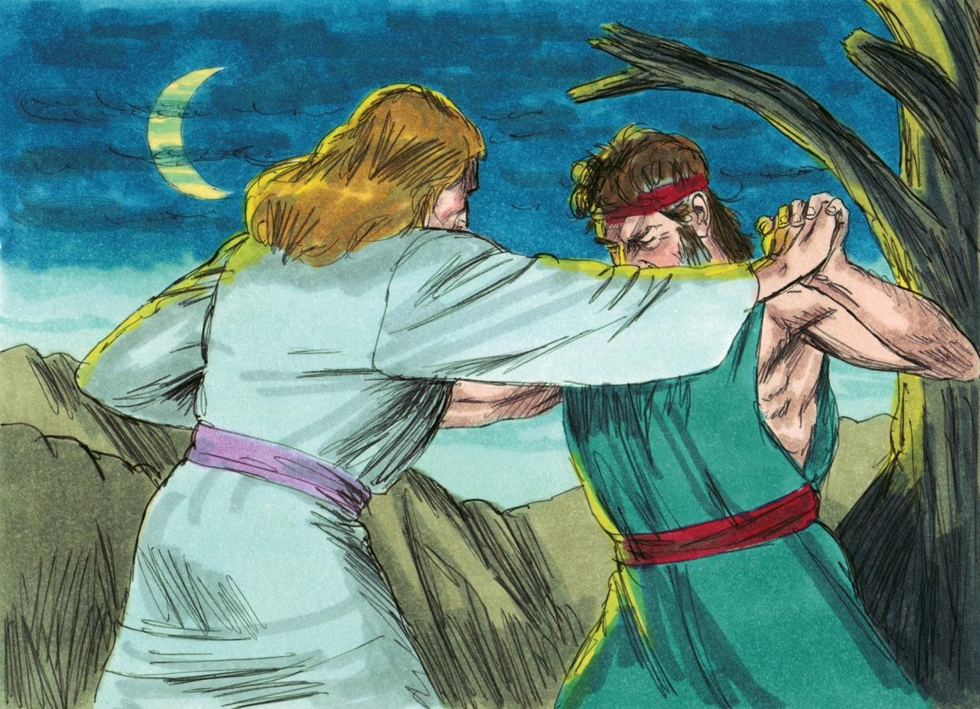
Source: Sweet Publishing - for illustration purposes of Genesis 32:24 only

LESSON 8 – WORKSHEET
Colossians 3:9,10 teaches us that we, believers in Christ, have laid aside the Old Self (old nature) with its evil and that we have put on the New Self (new nature) who is being renewed to a true knowledge according to the image of the One who created him. The old nature or the flesh is always trying to gain control of the new nature or the Spirit. We can tell by the deeds of the flesh or by the fruit of the Spirit, which nature is controlling people. Take the words written below and write them under the nature which they indicate. Galatians 5:19-23.
歌罗西书 3:9,10 教导我们，我们这些在基督里的信徒，已经放下了旧我（旧本性）及其邪恶，并且我们穿上了新我（新本性），他正在根据 以创造他的那一位的形象。 旧本性或肉体总是试图控制新本性或圣灵。我们可以通过肉体的行为或圣灵的果子来判断，是哪个自然在控制人。 把下面写的字写在它们所指示的性质下。 加拉太书 5:19-23。
Love, Drunkenness, Enmities, Faithfulness, Strife,
爱情、醉酒、 仇恨、 忠诚、 纷争、
Peace, Gentleness, Jealousy, Envying, Joy, Immorality, Self-control
和平、温柔、 嫉妒、 嫉妒、 喜乐、不道德、自制
OLD SELF NEW SELF
旧我 新我
- _____________________________ ________________________________
- _____________________________ ________________________________
- _____________________________ ________________________________
- _____________________________ ________________________________
- _____________________________ ________________________________
- _____________________________ ________________________________

- Those who belong to Christ Jesus have _______________ the flesh/Old Self with its passions and desires. Galatians 5:24. That is the only way to have victory over the Old Self.
那些属于基督耶稣的人有_______________肉体/旧我及其激情和欲望。 加拉太书 5:24。 这是战胜旧我的唯一方法。
- Ephesians 6:12 tells us that our struggle is not against flesh and blood but against:
以弗所书 6:12 告诉我们，我们的争战不是与属血气的争战，而是与：
- ___________________________________________________________________
- ___________________________________________________________________
- ___________________________________________________________________
- ___________________________________________________________________

- If we want to be able to stand firm against the schemes of the devil, we must put on the full _________________ of God. Ephesians 6:11.
如果我们想要能够坚定地反对魔鬼的计划，我们必须穿上上帝的完整_______。 以弗所书 6:11。

- Write Ephesians 6:13: ____________________________________________________
______________________________________________________________________
______________________________________________________________________
______________________________________________________________________
写下以弗所书 6:13

