LESSON 7 – A MARRIAGE ON PROMISE ROAD
第 7 课 – 诺言路上的婚姻
Genesis 24
创世纪 24
THEME: To show the closeness of the believer with Christ now and forever.
主题： 展示信徒从现在直到永远与基督的亲密关系。
We all like to attend weddings. At a wedding we rejoice with the two people who are so happy to unite their hearts and lives in love. In this age of Grace, the apostle Paul instructs us that we should not marry those who are unbelievers.
我们都喜欢参加婚礼。在婚礼上，看到两个人因着爱而将他们的心和生命联结在一起让我们感觉很喜悦。 在这个恩典时代，使徒保罗教导我们不要嫁给不是信徒的人。
“Do not be unequally yoked together with unbelievers. For what fellowship has righteousness with lawlessness? And what communion has light with darkness? And what accord has Christ with Belial? Or what part has a believer with an unbeliever?” (2 Corinthians 6:14-15). And He promises us in Romans 8:28: “And we know that all things work together for good to those who love God, to those who are the called according to His purpose.”
“不要与不信的人不平等地同负一轭。 公义与不法有什么相交呢？ 光明与黑暗的共通是什么？ 基督与彼列有何一致？ 或者信徒和不信的人有什么关系？” （2 哥林多前书 6:14-15）。 他在罗马书 8 章 28 节向我们应许：“我们知道万事互相效力，叫爱神的人得益处，就是照着祂旨意蒙召的人。”
Today as we journey on PROMISE ROAD we are going to see how God selected a wife for Isaac. We'll see how different it was back then from our weddings today.
今天，当我们踏上应许之路时，我们将看到上帝如何为以撒挑选妻子。 我们将看到它与今天的婚礼有多么不同。
After Sarah died, Abraham decided it was time for Isaac to get married. Abraham asked his most trusted servant to swear by the Lord, the God of heaven and the God of earth, that he would not take a wife for Isaac from the heathen Canaanites (idol worshippers). Instead, he would go to Abraham’s own people (Genesis 24:2-4).
撒拉死后，亚伯拉罕决定是时候让以撒结婚了。亚伯拉罕要求他最信任的仆人向上帝——天地之主起誓，他不会从异教徒迦南人（偶像崇拜者）那里为以撒娶妻。 相反，他会去找亚伯拉罕自己的子民（创世记 24:2-4）。
The servant departed with ten camels for carrying supplies and gifts for the woman who was to marry Isaac (Genesis 24:10). When he arrived outside the city of Nahor, in Mesopotamia, he stopped beside a well of water. It was the time when women came out to draw water. The servant prayed for guidance, asking God to show him the right woman for Isaac. He asked that it be the woman who would draw water for him and for his camels as well. Then he waited for God’s answer.
仆人带着十只骆驼离开，上面驮着为以撒未来妻子准备的礼物（创世记24:10）。 当他到达美索不达米亚的拿鹤城外时，他停在一口水井旁。 那是妇女出来打水的时候。 仆人祈求指引，祈求上帝为他指明适合以撒的女人。 他祈求让那个女人为他和他的骆驼打水。 然后他等待上帝的答复。
Immediately, Rebekah came and she was asked to give him a drink. She gave water to him and she also drew water for all the camels. Rebekah said that she was a relative of Abraham’s brother Nahor, and so she fulfilled the requirements. The servant bowed his head and worshiped the Lord. Then he was invited by Laban, Rebekah’s brother, to enter their house. The servant then explained his mission for finding a wife for Isaac.
马上，丽贝卡来了，那仆人请丽贝卡给他一杯水喝。 她给他水，还为所有的骆驼打水。 利百加说她是亚伯拉罕兄弟拿鹤的亲戚，所以她是合格的人选。 仆人低头敬拜主。 利百加的兄弟拉班邀请他进入他们家。 然后仆人解释了他为以撒寻找妻子的使命。
Laban and Bethuel, Rebekah’s father, replied: “The thing comes from the Lord; we cannot speak to you either bad or good. Here is Rebekah before you; take her and go, and let her be your master’s son’s wife, as the Lord has spoken” (Genesis 24:50-51). The servant gave gifts to Rebekah’s family to demonstrate Isaac’s wealth. Then he, and the men who were with him, ate and drank and spent the night.
拉班和利百加的父亲贝土利回答说：“这事是出于耶和华； 我们不能对你好或者不好。 丽百加就在你面前，照耶和华所说的，带她去，让她做你主人的儿子的妻子”（创世记 24:50-51）。 仆人将礼物给送给利百加的家人，以证明以撒的财富。 然后他和跟随他一起来的人吃喝完后在那里过了夜。
The next day, the servant wanted to go back to his master. However, Laban and Rebekah’s mother wanted Rebekah to stay for about ten days. They asked Rebekah, “Will you go with this man?” And she said, “I will go” (Genesis 24:58). She was not afraid to go to a strange land. She believed that the God who led the servant would also care for her. Rebekah was not worried about her own discomfort during the long journey. She anticipated meeting the one whose wife she was to become.
第二天，仆人想回到他的主人那里。 然而，拉班和利百加的母亲想要利百再加住十天左右。 他们问丽百加：“你愿意和这个人一起去吗？” 她说：“我想去”（创世记 24:58）。 她不怕去陌生的土地。 她相信带领仆人的神也会眷顾她。 在漫长的旅途中，丽贝卡并不担心自己的不适。 她期待见到即将成为她丈夫的人。

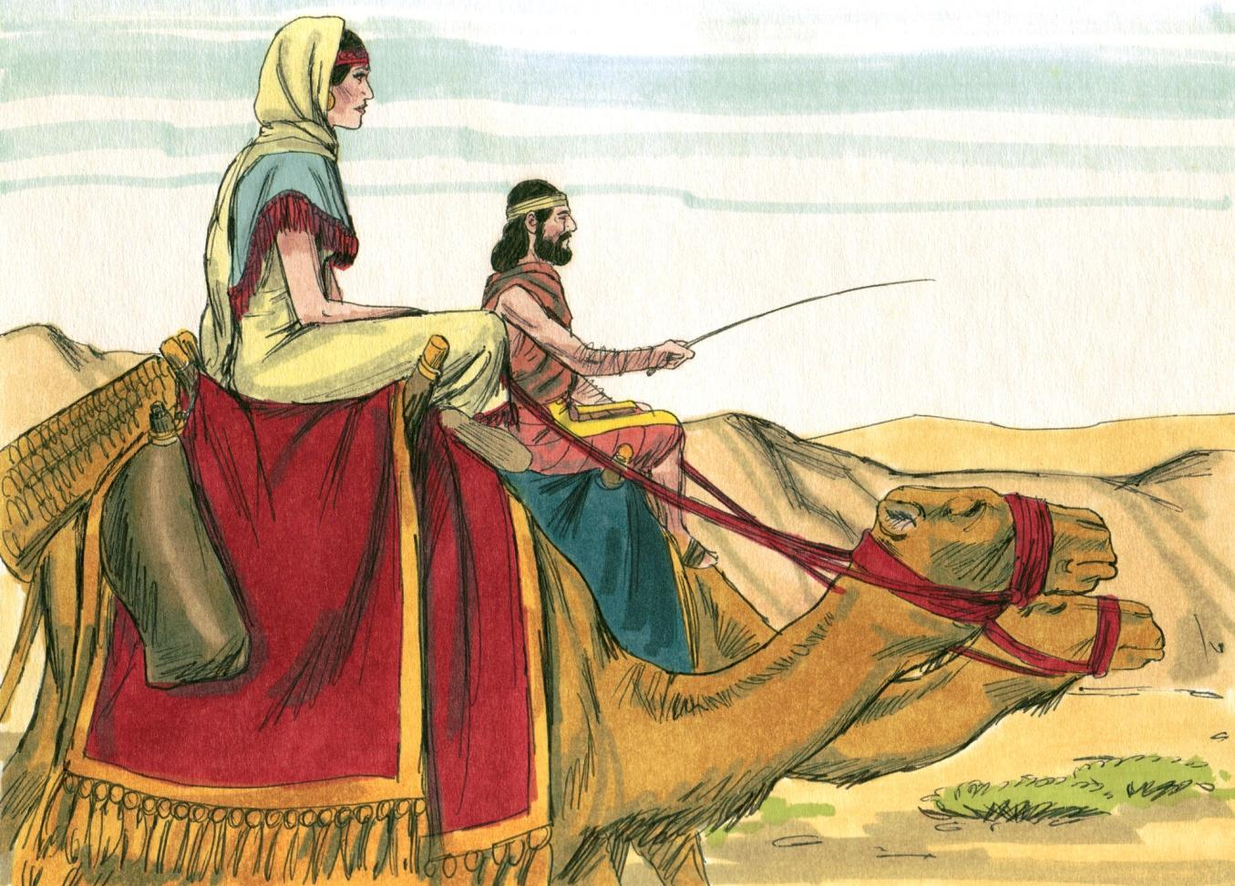
Source: Sweet Publishing - for illustration purposes of Genesis 24:61 only

Then one evening Isaac went out into the field to meditate. He lifted up his eyes and he saw the camels coming. The servant told Isaac everything. Then Isaac brought Rebekah into his mother Sarah’s tent where she became his wife on their wedding day. Isaac loved her. He knew that God had given him Rebekah for his wife.
一天晚上，以撒出去到田里冥想。 他抬起眼睛，看到驼队来了。 仆人把一切都告诉了以撒。 然后以撒把利百加带到他母亲莎拉的帐篷里，在他们结婚的那天，她成为了他的妻子。 以撒爱她。 他知道是上帝给了他利百加作妻子。
In one way we are like Rebekah. We are also on a journey toward meeting with the One whom we have never seen before. But our meeting will be in the air. SALVATION LINER represents all those who have trusted in Jesus Christ as their personal Saviour. We are waiting for His shout from heaven (1 Thessalonians 4:16).
从某方面将，我们就像丽贝卡。 也正行在与我们从未见过的那一位会面的旅程中。 但我们的相会将在空中举行。救赎的班轮代表所有相信耶稣基督是每个人的救主的人。 我们正在等待他从天上呼唤我们（帖撒罗尼迦前书 4:16）。
We have not seen Him, but we love Him. We love to talk about Him and we love to read His guidebook -the Bible. He tells us about our spiritual blessings and our position with Him in the heavenly places. We shall be united with Him forever (Ephesians 1 and 2). Meanwhile, we can talk to Him in prayer, and we can be His ambassadors by proclaiming the gospel of the grace of God to others.
我们没有见过他，但我们爱他。 我们喜欢谈论他，我们喜欢阅读他的指南——圣经。 他告诉我们那些的属灵祝福以及我们在天上与他在一起的位置。 我们将永远与祂联合（以弗所书 1 和 2）。 同时，我们可以在祷告中与他交谈，也可以通过向他人宣讲神恩惠的福音，成为他的使者。
Isaac and Rebekah’s wedding was unusual. Most people want a big celebration. However, the key to a happy marriage is love and respect. Following God’s Word should always be the priority.
以撒和丽贝卡的婚礼不同寻常。 大多数人都想要一个盛大的庆祝活动。 然而，幸福婚姻的关键是爱和尊重。 遵循上帝的话语应该始终是首要任务。

MEMORY VERSE: “And we know that all things work together for good to those who love God, to those who are the called according to His purpose” (Romans 8:28).
背诵经文：“我们知道万事互相效力，叫爱神的人得益处，就是照祂旨意蒙召的人”（罗马书 8:28）。

LESSON 7 – WORKSHEET
第 7 课 – 工作表
Answer the questions:
回答问题：
- What means of travel did Rebekah use? Genesis 24:61. _________________________
丽贝卡使用什么旅行方式？ 创世记 24:61

- What kind of home did Isaac and Rebekah have? Genesis 24:67. _________________
以撒和丽贝卡有什么样的家？ 创世纪 24:67

- What gifts did Rebekah receive? Genesis 24:22. ______________________________
______________________________________________________________________
丽贝卡收到了什么礼物？ 创世纪 24:22

- Where did the servant meet Rebekah? Genesis 24:13. __________________________
仆人在哪里遇见丽贝卡？ 创世记 24:13。
Fill in the spaces below to show how the experience of Isaac and Rebekah is like our experience today in the dispensation of Grace.
请填写下面的空格，说明以撒和丽贝卡的经历与我们今天在恩典时代的经历有何相似之处。
- Isaac went out to meet Rebekah. Christ will come out of _________________________ to meet us. 1 Thessalonians 4:16.
以撒出去见丽贝卡。 基督会从 _________________________ 出来迎接我们。 1 帖撒罗尼迦前书 4:16。
- Rebekah always stayed with Isaac. We will be with Christ _______________________. 1 Thessalonians 4:17.
丽贝卡总是和以撒在一起。 我们将与基督同在 _____________。 1 帖撒罗尼迦前书 4:17。
- Rebekah was a comfort to Isaac. We are to ________________________ one another with the promise to meet the Lord in the air. 1 Thessalonians 4:18.
丽贝卡是以撒的安慰。 我们要互相______________，承诺在空中与主相遇。 1 帖撒罗尼迦前书 4:18。
- Isaac loved Rebekah and the Lord Jesus Christ ______________ us. Romans 8:37.
以撒爱丽贝卡和主耶稣基督______________我们。 罗马书 8:37。
- Rebekah looked forward to meeting Isaac as she journeyed. We must ________________ _______________ to meet our Lord Jesus Christ as we journey on THE HIGHWAY OF LIFE. Titus 2:13.
丽百加期待在旅途中见到以撒。当我们在生命的大道上旅行时，我们必须 _________________ 与我们的主耶稣基督相遇。 提多书 2:13。

- Write Romans 8:28: _____________________________________________________
______________________________________________________________________
______________________________________________________________________
______________________________________________________________________
写下罗马书 8:28：

