LESSON 6 – TRAVELING ON PROMISE ROAD
第 6 课 – 在承诺的道路上旅行
Genesis 12-22
创世纪12-22
THEME: To show the faithfulness of God and the reward of believing God’s promises.
主题：展示上帝的信实和相信上帝应许的奖赏。
Do you always keep the promises you make? Probably not – but God always does. In fact, there is one thing He cannot do: He cannot lie (Titus 1:2). If God promised something, then it will happen (Hebrews 6:13-18).
你是否始终信守承诺？ 可能不会——但上帝总是这样。 事实上，只有一件事他不会做：他不会说谎（提多书 1:2）。 如果上帝应许某事，那么它一定会发生（希伯来书 6:13-18）。
Remember at the beginning of THE HIGHWAY OF LIFE that God made a promise to Adam and Eve (Genesis 3:15). He said that one day a great Redeemer would overcome satan. Since there were no righteous people, it seemed that satan won. By turning left at CONFUSION CORNERS on our chart, we can see what happened.
还记得生命大道开始的时候吗？上帝向亚当和夏娃作出了应许（创世记 3:15）。 他说有一天一位伟大的救赎主会战胜撒旦。因为这世上一个义人都没有，看上去好像撒旦赢了。在我们航程表上困惑的拐点向左转，我们会看到发生了什么。
God chose one man named ABRAM to accomplish His purpose:
神拣选了一个名叫亚伯兰的人来完成祂的旨意：
- Abram was a Gentile, (a non-Jew), when God spoke to him in *Ur of the Chaldeans (Acts 7:2-4) and in *Haran (Genesis 12:1-3).
亚伯兰是外邦人（非犹太人），当上帝在迦勒底人的*吾珥（使徒行传 7:2-4）和在*哈兰（创世记 12:1-3）对他说话时。
- Abram believed God, “...and He accounted it to him for righteousness” (Genesis 15:6; Romans 4:3, 4:22).
亚伯兰相信上帝，“……他就以此算作他的义”（创世记 15:6；罗马书 4:3, 4:22）。
- God promised a son to Abram (Genesis 15:2-6).
神应许给亚伯兰一个儿子（创世记 15:2-6）。
In obedience to God, Abram traveled from Haran to the land of Canaan (Genesis 12:5). Abram’s name was changed to Abraham because he became a father of many nations (Genesis 17:4-5). And the name of Abraham’s wife Sarai was changed to Sarah (Genesis 17:15).
因为顺服上帝，亚伯兰从哈兰前往迦南地（创世记 12:5）。 亚伯兰的名字改为亚伯拉罕，因为他会成为万国之父（创世记17:4-5）。亚伯拉罕的妻子撒莱的名字改为撒拉（创世记 17:15）。
Although Abraham and Sarah were too old to have a child, God did not forget His promise. Sarah delivered the promised son Isaac. God had waited to fulfill His promise so that Isaac would be a miracle child. At the same time God was also testing Abraham’s faith. Abraham passed the test (Romans 4:20). Then God gave Abraham the greatest test of all. God tested Abraham to see if he loved God even more than his own son Isaac (Genesis 22:12).
虽然亚伯拉罕和撒拉的年纪已经太老，不能生育，但神没有忘记他的应许。莎拉生了应许的儿子以撒。 上帝一直在等待实现他的应许，让以撒成为一个奇迹般的孩子。 与此同时，神也在考验亚伯拉罕的信心。 亚伯拉罕通过了考验（罗马书 4:20）。 然后上帝给了亚伯拉罕最大的考验。 上帝考验亚伯拉罕，看他是否爱上帝甚于爱自己的儿子以撒（创世记 22:12）。
God said, “Take now your son, your only son, Isaac, whom you love, and go to the land of Moriah, and offer him there as a burnt offering on one of the mountains of which I shall tell you” (Genesis 22:2). Abraham remembered God’s promise that He was going to bless the world through Abraham’s seed. Abraham also knew that God was able to raise up Isaac from the dead (Hebrews 11:17-19). When Abraham took the knife to kill his son, the Angel of the Lord called to him from heaven. He said, “Abraham, Abraham!” So he said, “Here I am.” Then He said, “Do not lay your hand on the lad, or do anything to him; for now I know that you fear God, since you have not withheld your son, your only son, from Me” (Genesis 22:10-12).
上帝说：“现在带你的儿子，你唯一的儿子，你所爱的以撒，往摩利亚地去，在我要告诉你的其中一座山上把他献为燔祭”（创世记 22 :2)。 亚伯拉罕记得上帝的应许，他将通过亚伯拉罕的后裔祝福世界。 亚伯拉罕也知道上帝能够使以撒从死里复活（希伯来书 11:17-19）。 当亚伯拉罕拿起刀要杀死他的儿子时，主的天使从天上召唤了他。他说：“亚伯拉罕，亚伯拉罕！” 于是他说：“我在这里。” 然后他说：“不要把手放在孩子身上，也不要对他做任何事； 现在我知道你敬畏上帝，因为你没有将你的儿子，你的独生子留下不给我”（创世记 22:10-12）。

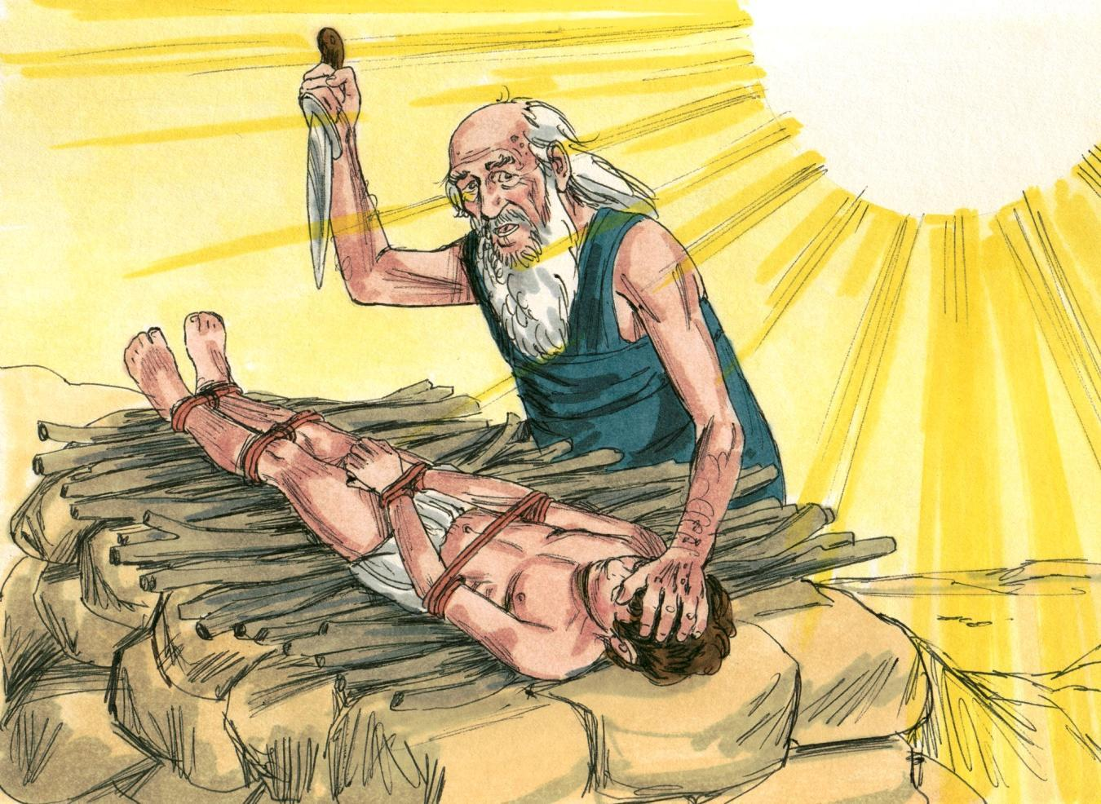
Source: Sweet Publishing - for illustration purposes of Genesis 22:10-12 only
Abraham looked behind him and he saw a ram caught in the bushes. He took it and he sacrificed it as a burnt offering instead of his son (Genesis 22:13). Abraham called the name of the place The Lord will provide (Genesis 22:14).
亚伯拉罕向身后望去，他看到一只公羊被夹在灌木丛中。 他接过它，代替他的儿子献为燔祭（创世记 22:13）。 亚伯拉罕给那地方起名叫“耶和华以勒”（创世记 22:14）。
Through the difficult test, God teaches two beautiful truths:
通过艰难的考验，上帝教导了两个美丽的真理：
- He gives us a picture of His own great love for us in giving His only Son, the Lord Jesus Christ, to die on the cross for our sins. The story of Isaac is a picture of Christ’s submission unto the Father. Christ became the ram, the sin-offering to God. Isaac was also submissive unto his father.
他向我们描绘了他对我们的大爱，将他的独生子，主耶稣基督给予我们 ，为我们的罪死在十字架上。以撒的故事是基督顺服天父的映射。基督成了公羊，是献给上帝的赎罪祭。 以撒也顺从他的父亲。
- God proves to us His great faithfulness in keeping His promises. Abraham’s test was given for our learning (Romans 4:13-25). We must believe in Him, and our faith is accounted for as righteousness (Romans 4:5). We must believe that Christ died for our sins, that He was buried, and that He was raised from the dead on the third day (1 Corinthians 15:1-4).
上帝向我们证明了他信守承诺的伟大信实。 亚伯拉罕的考验是为了让我们的学习（罗马书 4:13-25）。 我们必须相信他，而我们的信心也算为义（罗马书 4:5）。 我们必须相信基督为我们的罪而死，他被埋葬，并在第三天从死里复活（哥林多前书15:1-4）。
Abraham received great rewards and more promises after he passed this test (Genesis 22:15-18). We receive the promise of all things in Christ when we trust Him and believe God. God will provide (Romans 8:28-39).
亚伯拉罕通过这个考验后得到了丰厚的回报和更多的应许（创世记 22:15-18）。 当我们相信祂并相信上帝时，我们就会在基督里得到一切的应许。 神会供应一切（罗马书 8:28-39）。
Let’s follow the example of Abraham by growing strong in our faith, by giving glory to God, and by believing in God’s promises. In the next lesson we will attend a wedding on PROMISE ROAD.
让我们效法亚伯拉罕的榜样，在我们的信仰中变得更加坚强，将荣耀归给上帝，并相信上帝的应许。 在下一课中，我们将参加在 承诺道路上 举行的婚礼。
MEMORY VERSE: “He did not waver at the promise of God through unbelief, but was strengthened in faith, giving glory to God, and being fully convinced that what He had promised He was also able to perform.” Romans 4:20-21.
背诵经文：“他没有因不信而对神的应许动摇，反倒信心大增，将荣耀归给神，深信他所应许的，他必成就。” 罗马书 4:20-21。
*Ur was a city in southern Babylonia (modern-day Iraq).
乌尔是巴比伦南部（今伊拉克）的一座城市。
*Haran was a city in the northeast of Israel (modern-day Turkey).
*哈兰是以色列（今土耳其）东北部的一座城市。

LESSON 6 – WORKSHEET
第六课--联系
- Fill in the spaces to name these places on the chart:
a. ____________________ Road b. _____________________ Byway
c. ____________________ Corners
- GREAT FLOOD -
d. Garden of ________________ e. _____________________ Liner
填写空格以命名图表上的这些位置：
a ____________________ 路
b. _____________________ 小路
c ____________________ 拐角
- 大洪水 -
d ________________ 花园
e _____________________ 班轮

- After the tower of Babel, God called _____________to begin a new plan. Genesis 12:1.
在巴别塔之后，上帝呼召_____________开始一个新的计划。 创世记 12:1。

- God promised 7 things to Abram. Read Genesis 12:1-3 and tell what they were.
神应许亚伯兰七件事。 阅读创世记 12:1-3 并说出它们是什么。
- I will make you into a great ______________________;
我会让你成为一个伟大的____________;
- I will __________________ you;
我会__________________你；
- I will make your ____________________ great;
我会让你的____________________很棒；
- You will be a ____________________________;
您将成为 ____________________________;
- I will bless them that ______________________ you;
我会祝福他们____________你；
- I will curse them that ______________________ you;
我会诅咒他们____________你；
- In you shall all the _________________ of the ___________________ be blessed.
___________________ 中的所有 _________________ 都将在你身上得到祝福。
- Abraham believed God and it was credited to him as ___________________________. Genesis 15:6.
亚伯拉罕相信上帝，这被认为是_______________。 创世记 15:6。
- God told Abraham to offer his _________________ as a burnt __________________ Genesis 22:2.
上帝吩咐亚伯拉罕将他的 _________________ 献为烧焦的 __________________ 创世记 22:2。

- Abraham believed that God was able to _________________ up Isaac, even from the dead. Hebrews 11:19.
亚伯拉罕相信，即使从死里，上帝也能_____以撒。 希伯来书 11:19。

- Isaac was a type or picture of our _______________________________. John 3:16
以撒是我们 _______________________________ 的一种类型或图片。 约翰福音 3:16

- Abraham was a type of _______________ the Father. John 3:16.
亚伯拉罕是_______________父的预表。 约翰福音 3:16。

- God gives us many precious promises. Two of them are:
上帝给了我们许多宝贵的应许。 其中两个是：
- Acts 16:31 – Believe in the Lord Jesus, and you will be _________________.
使徒行传 16:31 – 相信主耶稣，你就会成为_________________。
- Philippians 4:19 – And my God will supply _________________________ according to His riches in glory in Christ Jesus.
腓立比书 4:19 – 我的神必照着祂在基督耶稣里荣耀的丰富供应___________。

- Write Romans 4:20-21: ___________________________________________________
______________________________________________________________________
写下罗马书 4:20-21:

