LESSON 5 - THE HIGHWAY DIVIDES AT CONFUSION CORNERS
第 5 课 - 高速公路在困惑的拐角处分道扬镳
Genesis 11
创世记 11
THEME: To show the importance of walking in the light and restoration of fellowship with one another.
主题：展示走在光明中并恢复彼此相爱的重要性。
Which do you like better: night or day? Why do most of us like daytime the best? We like to see where we are going, what we are doing, what others are doing.
你更喜欢哪一个：晚上还是白天？ 为什么我们大多数人最喜欢白天？ 我们喜欢看到我们要去的地方，我们在做的事和别人在做的事。
The Bible says that “God is light and in Him is no darkness at all” (1 John 1:5). Light always speaks of God and righteousness, while darkness speaks of Satan and evil. God wants His children to walk in His light.
圣经说“上帝是光，在他里面没有黑暗”（约翰一书 1:5）。 光总是在代表上帝和公义，而黑暗总是代表撒旦和邪恶。 神要他的儿女行在他的光中。
Now we will study whether God’s children walked in light or darkness after the great flood. The great flood had destroyed all the unrighteous people. God started with Noah and He gave him some new travel laws (Genesis 9:1-19). Noah was told to be fruitful and multiply (Genesis 9:1,7). Noah could also eat meat, whereas, before it had only been fruit and vegetables (Genesis 9:3). Murder was punishable by death, too (Genesis 9:6).
现在我们要研究大洪水之后神的儿女是在光明中行走还是在黑暗中行走。大洪水摧毁了所有不义的人。 神从挪亚开始，他给了他一些新的旅行法则（创世记 9:1-19）。 诺亚被告知要生养众多（创世纪 9:1,7）。 挪亚也可以吃肉，而以前只能吃水果和蔬菜（创世纪 9:3）。 谋杀也可判处死刑（创世纪 9:6）。
Then God established a covenant with Noah that He would never flood the entire earth again. God gave the rainbow as the sign of the covenant. Noah and his sons Shem, Ham and Japheth, together with their wives, continued on THE HIGHWAY OF LIFE. Noah’s family multiplied very rapidly. Everyone spoke one language (Genesis 11:1).
然后上帝与挪亚立约，他将不再淹没整个地球。 上帝赐下彩虹作为立约的记号。 挪亚和他的儿子闪、含和雅弗，连同他们的妻子，继续走在生命的大道上。 挪亚的家族迅速增加。 每个人都说同一种语言（创世记 11:1）。
The people journeyed from the east and they discovered that *Shinar had flat land. They said, “Come, let us make bricks and bake them thoroughly...Come, let us build ourselves a city, and a tower whose top is in the heavens; let us make a name for ourselves, lest we be scattered abroad over the face of the whole earth” (Genesis 11:3,4).
人们从东方出发，发现*Shinar有平坦的土地。 他们说：“来吧，让我们把砖块烧透……来吧，让我们为自己建造一座城市，一座顶在天上的塔； 让我们为自己扬名，免得我们分散在全地”（创世记 11:3,4）。
When the Lord came down to see the tower and the city, He was greatly displeased. Noah’s family was not filling the earth as God had commanded them in Genesis 9:1. God said: “Indeed, the people are one and they all have one language, and this is what they begin to do; now nothing that they propose to do will be withheld from them. Come, let Us go down and there confuse their language, that they may not understand one another’s speech” (Genesis 11:5-7).
当主下来看到塔和城市时，他非常不高兴。 挪亚一家并没有按照上帝在创世记 9 章 1 节中的吩咐充满地球。 上帝说：“的确，人们是一体的，他们有着同一种语言，这就是他们开始做的事情； 现在他们可以做到任何他们想做的事。 来吧，让我们下去，使他们的语言混乱，使他们彼此不明白对方的话”（创世记 11：5-7）。
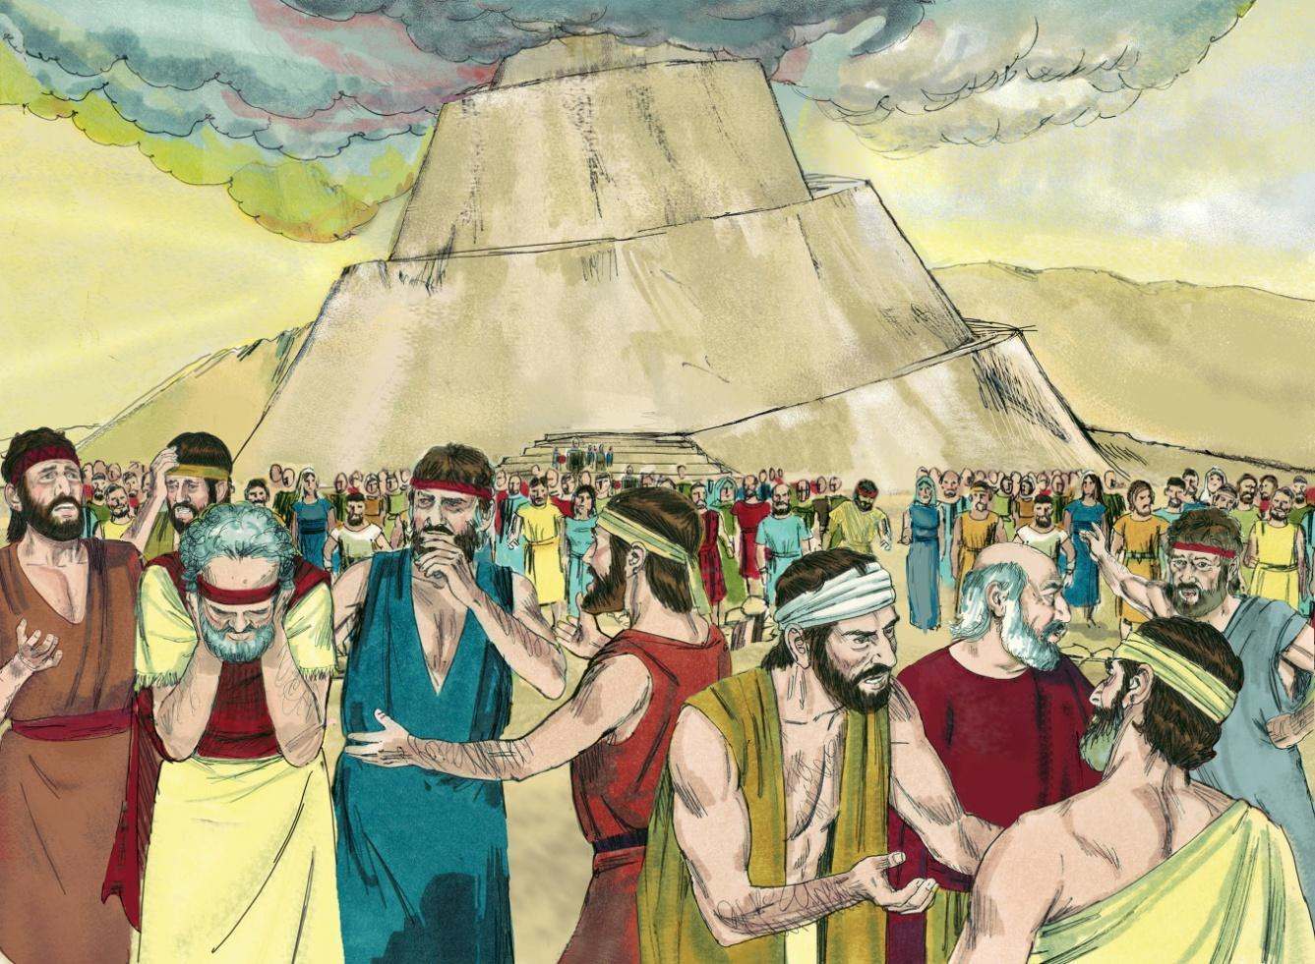
Source: Sweet Publishing - for illustration purposes of Genesis 11:7-8 only

“So the Lord scattered them abroad from there over the face of all the earth; and they ceased building the city” (Genesis 11:8). The place was called Babel (Balel), which means to confuse or confound (Genesis 11:9). On our chart we call this intersection CONFUSION CORNERS.
于是耶和华把他们从那里分散在全地； 他们就停止建造那城”（创世记 11:8）。 这个地方被称为巴别（Balel），意思是困惑或混乱（创世记11：9）。在我们的航程图上，我们将此交叉点称为 困惑的拐角处。
The Tower of Babel occured about 100 years after the great flood. We know this is true because Shem became the father of Arphaxad 2 years after the flood (Genesis 11:10); Arphaxad became the father of Salah 37 years after the flood (Genesis 11:12); Salah became the father of Eber 67 years after the flood (Genesis 11:14) and Eber became the father of Peleg (which means split in Hebrew) 101 years after the flood (Genesis 11:16). Genesis 10:25 states that the earth was divided during Peleg’s lifetime.
巴别塔出现在大洪水之后大约 100 年。 我们知道这是真的，因为闪在洪水后 2 年生了亚法撒（创世记 11:10）； 洪水后 37 年，亚法撒生撒拉（创世记 11:12）； 洪水后 67 年，萨拉赫生了希伯（创世记 11:14），洪水后 101 年（创世记 11:16），希伯生了法勒（希伯来语意为分裂）。 创世记 10 章 25 节说，法勒在世时地球分裂了。
Mankind was given another opportunity to do well, but they failed again. The people, called nations or Gentiles (non-Jews), all went off in the direction of the GENTILE BYWAY on the chart. The whole human race had chosen the way that was right in their own eyes, which proved to be the way of eternal death.
人类又获得了一次做好的机会，但他们又一次失败了。 这些人，称为国家或外邦人（非犹太人），都朝着航程图上的外邦人歧路的方向前进。 整个人类都选择了自己眼中正确的道路，而这条道路被证明是永死的道路。
Humans disobeyed God’s way of faith. They wanted to build a tower for their own glory and not for the glory of God. Many people today are building towers with bricks of good works. They are relying on those good works to take them to heaven. God is only pleased with our faith in Jesus Christ.
人类违背了上帝的信仰之道。 他们想为自己的荣耀而不是为上帝的荣耀建造一座塔。 今天有很多人用善行的砖砌塔楼。 他们想依靠那些善行将他们带到天堂。 神只喜悦我们对耶稣基督的信心。
When the people said, “Let us make a name for ourselves...” they did not want to honour God (Genesis 11:4). When humans worship themselves and others, it causes confusion. When they said, “…lest we be scattered abroad...” they rebelled against God’s commandment to fill the earth. Disobedience causes confusion and God’s judgment.
当人们说：“让我们为自己起名……”时，他们不想荣耀神（创世记 11:4）。 当人类崇拜自己和他人时，它会引起混乱。 当他们说：“……免得我们分散在国外……”时，他们违背了上帝要遍满地球的诫命。 不顺服会导致混乱和上帝的审判。
In our next journey we will take the turn to the left at CONFUSION CORNERS. Let’s see how God called out one man to make a fresh start on PROMISE ROAD.
在我们的下一段旅程中，我们将在 困惑的拐角处 左转。 让我们看看上帝如何呼召一个人在应许之路上重新开始。
Are you walking in the light? If you have never trusted Jesus Christ as your personal Saviour, trust Him now. The blood of Jesus Christ, God’s Son, cleanses us from all sin (Colossians 2:13). So if you walk in the light, you will always be a light in the darkness here on earth.
你在光中行走吗？ 如果你从未相信耶稣基督是你个人的救主，现在就相信他。 上帝的儿子耶稣基督的宝血洗净了我们一切的罪（歌罗西书 2:13）。 因此，如果你行在光明中，你将永远是地球上黑暗中的一盏灯。

MEMORY VERSE: “But if we walk in the light as He is in the light, we have fellowship with one another, and the blood of Jesus Christ His Son cleanses us from all sin” (1 John 1:7).
背诵经文：“但如果我们行在光中，就像他在光中一样，我们就会彼此相交，他儿子耶稣基督的宝血洗净我们一切的罪”（约翰一书 1：7）。

*Shinar was the southern region of Mesopotamia (modern-day Iraq).
*希纳尔是美索不达米亚（今伊拉克）的南部地区。

LESSON 5 – WORKSHEET
- Write down 3 new travel laws that God gave to Noah. Genesis 9:1-7.
写下上帝赐给挪亚的 3 条新的旅行法则。 创世纪 9:1-7。
a)____________________________________________________________________b)____________________________________________________________________c)____________________________________________________________________
- Soon the earth was filled with people again. How many languages did they speak? Genesis 11:1. ____________
很快，大地又充满了人。 他们会说多少种语言？ 创世记 11:1。

- What did Noah’s family do when they found the plain in the land of Shinar? Genesis 11:2-4.________________________________________________________________
______________________________________________________________________
当挪亚一家在示拿地发现平原时，他们做了什么？ 创世记 11:2-4

- What did God do when He came down to see the city and the tower? Genesis 11:5-8.
______________________________________________________________________
______________________________________________________________________
当上帝下来看城和塔时，他做了什么？ 创世记 11:5-8
- Why was God displeased when Noah’s family said, “Let us build for ourselves a city and a tower?” Genesis 11:4. __________________________________________________
______________________________________________________________________
当挪亚的家人说：“让我们为自己建造一座城和一座塔”时，为什么上帝不悦？ 创世记 11:4。

- They also said, “Let us make for ourselves ____________________” Genesis 11:4.
他们还说：“让我们为自己做____________________” 创世记 11:4。

- The name of the city Noah’s people stopped building is called ___________. This name is attributed to the verb balal, which means to confuse or confound in Hebrew. Genesis 11:9.
挪亚人停止建造的城市的名字叫___________。 这个名字归因于动词balal，意思是在希伯来语中困惑或混淆。 创世记 11:9。

- Noah’s family was not walking in God’s light and therefore could not have ____________________ with God or with one another. 1 John 1:7.
挪亚一家没有行走在上帝的光中，因此无法与上帝或与另一个 。 约翰一书 1:7。

- Read Romans 1:24 and write down what God did to the Gentiles (non-Jews) after this great rebellion. _________________________________________________________
阅读罗马书 1:24 并写下在这场大反叛之后上帝对外邦人（非犹太人）所做的事。

- Write 1 John 1:7: ________________________________________________________
______________________________________________________________________
写下约翰一书 1:7：

