LESSON 4 - THE GREAT FLOOD ON THE HIGHWAY OF LIFE
第 4 课 - 生命大道上的大洪水
Genesis 6-8
创世纪6-8
THEME: To show the security of believers in Christ.
主题：显示信徒在基督里的安全感。
Have you ever experienced a flood? A flood can be caused by heavy rains, tropical cyclones, tsunamis, dam breakage, etc. When we hear of a flood, we know that it is a terrible thing for people to endure. In this lesson we are coming to the great flood over THE HIGHWAY OF LIFE.
你经历过洪水吗？ 大雨、热带气旋、海啸、大坝溃坝等都可能引发洪水。当我们听到洪水时，我们知道对人们来说它是一件可怕的事情。在本课中，我们将来到生命大道上的大洪水。
After Enoch was taken away, the people became more wicked. Satan was busy leading men in his way, and he was trying to keep God from bringing forth the Redeemer promised in Genesis 3:15. There was only evil continually.
以诺被带走后，人们变得更加邪恶。 撒但忙着让人跟随他的道路，他试图阻止上帝在创世记 3:15 中应许的救赎主。 只有邪恶不断。
God declared: “I will destroy man whom I have created…” Genesis 6:7.
上帝宣布：“我要毁灭我所造的人……”创世记 6:7。
The Bible says that there was one man who walked with God. His name was Noah. He walked in the way of faith and he pleased God (Genesis 6:8). Noah was a righteous man. God told him to make an ark which was a very large boat.
圣经说有一个人与神同行。 他的名字叫挪亚。 他走在信心的道路上，并且讨神喜悦（创世记 6:8）。 挪亚是个义人。 神吩咐他造一艘方舟，那是一艘很大的船。
God said: “Make yourself an ark of gopherwood; make rooms in the ark, and cover it inside and outside with pitch. And this is how you shall make it: the length of the ark shall be three hundred cubits, its width fifty cubits, and its height thirty cubits. You shall make a window for the ark, and you shall finish it to a cubit from above; and set the door of the ark in its side. You shall make it with lower, second, and third decks. And behold, I, Myself, am bringing floodwaters on the earth, to destroy from under heaven all flesh in which is the breath of life; everything that is on the earth shall die” (Genesis 6:14-17).
上帝说：“为自己做一个地鼠木的方舟； 在方舟里建造房间，内外都用沥青覆盖。 方舟要这样造：长三百肘，宽五十肘，高三十肘。 你要为方舟做一个窗子，从上面做一肘； 把方舟的门放在旁边。 你要造上中下三层。 看啊，我，我自己，正在将洪水带到地球上，从天上摧毁所有有生命气息的肉体； 地上的一切都要死”（创世记 6:14-17）。
Assuming the cubit to be 1.5 feet, the ark would be 450 feet (137,16 m.) long, 75 feet (22,86 m.) wide, and 45 feet (13,72 m.) high. Note that this is exactly three times the length of the tabernacle’s outer court, the width of the tabernacle’s outer court and three times the height of the tabernacle itself.
假设肘长为 1.5 英尺，方舟长 450 英尺（137.16 米），宽 75 英尺（22.86 米），高 45 英尺（13.72 米）。 请注意，这正好是帐幕外院子长度的三倍，帐幕外院子的宽度和帐幕本身高度的三倍。
Noah obeyed God even though he had never seen rain. According to Genesis 2:6, only a mist was used to water the earth until this time. Noah began building the ark and he warned the world of God’s righteous judgment (2 Peter 2:5).
挪亚虽然从未见过雨，但他还是顺服了上帝。 根据创世记 2:6，直到这个时候，只有雾被用来浇灌地球。 挪亚开始建造方舟，他警告世人上帝的公义审判（彼得后书 2:5）。
When the ark was finished, God told Noah: “Come into the ark, you and all your household, because I have seen that you are righteous before Me in this generation” (Genesis 7:1). Then the Lord shut the door (Genesis 7:16). Noah and his family were safe inside. When the worldwide flood came, God did not forget Noah (Genesis 8:1-14).
方舟造好后，神对挪亚说：“你和你全家都上方舟吧，因为我看见在这一代人中你在我面前是公义的”（创世记7：1）。 然后主关上了门（创世记 7:16）。 诺亚和他的家人在里面很安全。 当全球洪水来临时，上帝并没有忘记挪亚（创世记 8:1-14）。
Everyone outside the ark died. The ark floated safely on top of the flood waters. The rain continued for 40 days and 40 nights, but the ark was safe.
方舟外的人都死了。 方舟安全地漂浮在洪水之上。 雨持续了40天40夜，但方舟是安全的。
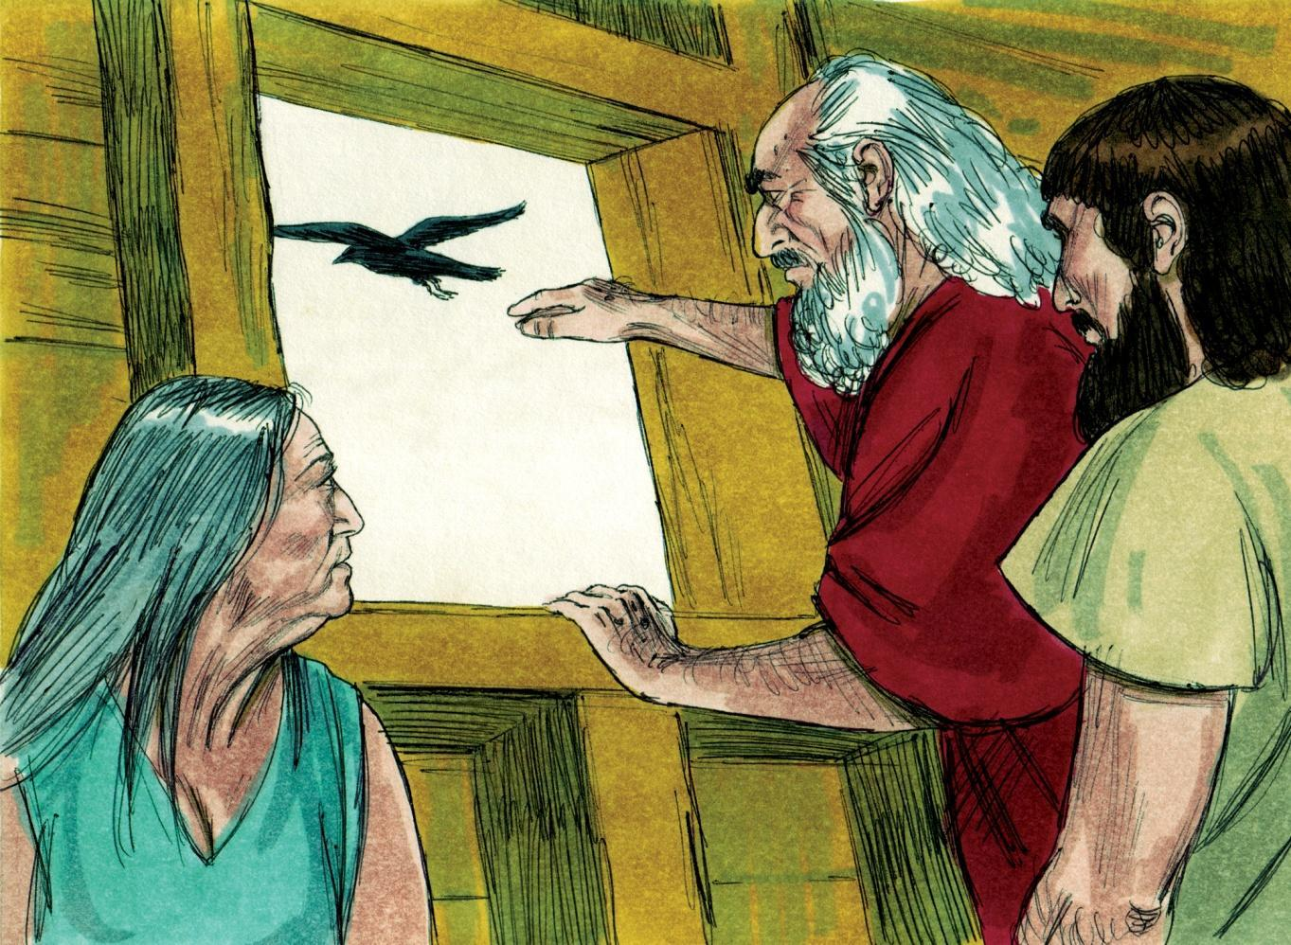
Source: Sweet Publishing - for illustration purposes of Genesis 8:6-7 only
About a year after God had said, “Come into the ark,” He said, “Go out of the ark...” (Genesis 8:16). As soon as they were outside the ark on dry land, Noah built an altar and worshiped God (Genesis 8:20). God made the rainbow as a sign that He will never destroy the world again with a great flood (Genesis 9:9-17). We may have floods in many countries in the world today. Yet, never again will God cover the entire earth with a destroying great flood as He did in the days of Noah.
在上帝说“进人方舟”后大约一年，他说，“出方舟……”（创世记 8:16）。 他们一到方舟外的旱地上，挪亚就筑了一座祭坛敬拜神（创世记8:20）。上帝创造彩虹作为一个标志，表明他不会再用大洪水毁灭世界（创世记 9:9-17）。 今天，世界上许多国家可能发生洪水。 然而，上帝再也不会像挪亚时代那样用毁灭性的大洪水淹没整个地球了。
Noah and the ark show us the spiritual meanings of SAVED & LOST:
诺亚和方舟向我们展示了得救和失去的属灵意义：
- Outside the ark Noah would have been lost. Inside the ark he was saved.
在方舟之外，诺亚会失去（生命）。 在方舟里他得救了。
- The ark was made of gopher wood and covered with pitch to seal it. The pitch kept out the water and it kept Noah safe. It’s a beautiful picture or type of the Lord Jesus Christ.
方舟由歌斐木制成，并用沥青覆盖以密封它。 沥青挡住了水，它保证了诺亚的安全。 这是一幅美丽的图画或主耶稣基督的预表。
- Trees gave life to make the ark. Christ gave His body by death in order to save us from the judgment of sin.
树木献出生命造方舟。 基督借着死舍弃了祂的身体，以拯救我们脱离罪的审判。
- There was only one door in the side of the ark, and all had to enter through that door to be saved. And so it is now. There is only eternal life for those who know Jesus Christ as their personal Redeemer from eternal death.
方舟的一侧只有一扇门，所有人都必须从那扇门进去才能得救。 现在就是这样。 那些知道耶稣基督是他们个人的救赎主脱离永死的人，只有永生。
- As Noah had faith in God’s Word and built an ark, so we should have faith in God’s Word and trust in the death, burial and resurrection of Jesus Christ to be saved from God’s judgment.
正如挪亚对神的话有信心，造了方舟一样，我们也应该对神的话有信心，相信耶稣基督的受死、埋葬和复活，才能免于神的审判。
We have learned about the great flood which took away all the unrighteous people in judgment. God’s book, the Bible, says there is another judgment coming on the earth. Are you safe in Christ today? Jesus Christ asks us to trust Him. He will keep you safe. He loves you and He died for your sins.
我们已经了解到大洪水在审判中带走了所有不义的人。 上帝的书，圣经，说地球上还有另一个审判。你今天在基督里安全吗？ 耶稣基督要我们信靠他。 他会保守你的安全。 他爱你，他为你的罪而死。
Jesus Christ is the Ark, and He is also the Door. He says: “I am the Door. If anyone enters by Me, he will be saved...” (John 10:9). Will you trust Him today as your Saviour from eternal death?
耶稣基督是方舟，祂也是门。 他说：“我是门。 人若从我进来，就必得救……”（约翰福音 10：9）。 今天你会相信祂是你脱离永死的救主吗？
MEMORY VERSE: “I am the Door. If anyone enters by Me, he will be saved, and will go in and out and find pasture” (John 10:9).
背诵经文：“我就是门。人若从我那里进去，就必得救，并且出入得草吃”（约翰福音 10：9）。

LESSON 4 – WORKSHEET
第四课--练习
Fill in the spaces in the following statements:
填写下列语句中的空格：
- God saw that the ____________________ of man was great. Genesis 6:5.
上帝看到人的 很多。创世纪6：5

- God said, “I will _______________________ whom I have created.” Genesis 6:7.
上帝说“我要 我创造的那些人”。创世纪6：7

- But Noah found _________________ in the eyes of the Lord. Genesis 6:8.
但是在上帝眼中诺亚 。创世纪6：8

- Noah was a _____________ man, ________________ in his time. Genesis 6:9.
诺亚是一个 人，在当时的时代是个 人。

- God told Noah to make an ________________ of gopher wood. Genesis 6:14.
上帝告诉诺亚用地鼠木建造一个 。创世纪6;14

- God told Noah to bring clean animals by __________ of every kind, and to bring unclean animals by _________ of every kind, male and female. Genesis 7:2-3.
上帝告诉诺亚凡洁净的畜类，每种带 ，
不洁净的动物每种带 ，公和母，创世纪7：2-3

- When Noah and his family were safely in the ark, the Lord _____________________. ____________ Genesis 7:16.
当诺亚和他的家人在方舟里很安全时，上帝 。创世纪7：16

- After the great flood Noah built _____________ and offered _____________________. ____________ Genesis 8:20.
在大洪水过后，诺亚建造了一个 ，并且 。创世纪8：20

- Judgment for sin is coming upon our world one day, but we need not fear if our life is ______________________________________. Colossians 3:3.
有一天，对罪的审判将临到我们的世界，但如果我们的生活是________________________，我们不必害怕。 歌罗西书 3:3
- The ark had only one door by which Noah and his family could enter into safety. There is only one door by which we may enter into safety from God’s judgment. The Lord Jesus Christ is that Door.
Write John 10:9
方舟只有一扇门可以让挪亚和他的家人安全进入。只有一扇门可以让我们进入安全的地方，免受上帝的审判。 主耶稣基督就是那扇门。
写下约翰福音 10:9

