LESSON 3 - THE FIRST PILOT
第 3 课 - 第一位飞行员
Genesis 5:1-32
创世记 5:1-32

THEME: To warn the unsaved.
To prepare the believers for their catching up to heaven.
主题：警告未得救的人。
为信徒被提升到天堂做准备

How would you like to travel in the air without getting into an aircraft? There was a man in the book of Genesis who was traveling on THE HIGHWAY OF LIFE, and he travelled up in the air without using an airplane.

你想不搭乘飞机在空中旅行吗？ 创世记里有一个人在生命的高速公路上旅行，他不用乘坐飞机就可以在空中旅行。

After Cain killed Abel, God gave Eve another son and she called his name Seth. God promised a Redeemer. He wanted a godly line of men through which Jesus would be born. As the years passed, the people multiplied on the earth and their wickedness increased. Each person had to make a choice of the way he would go. Most chose the way that seemed right, and a few chose the way of faith.

该隐杀死亚伯后，上帝给了夏娃另一个儿子，她给他起名叫塞特。上帝应许了一位救赎主。 他想要一个敬虔的人，耶稣将通过这个人出生。 岁月流逝，人们在地上繁衍，他们的邪恶也增加了。 每个人都必须选择他要走的路。 大多数人选择了看起来正确的方式，少数人选择了信仰的方式。

The people lived a long time (Genesis 5:6-32). The oldest person was Methuselah and he lived to be 969 years old (Genesis 5:27). Methuselah was the son of Enoch whom we call ‘the first pilot’.
人们曾经很长寿（创世记5：6-32）。创世纪里最年长的人是玛土撒拉，他活到 969 岁（创世记 5:27）。 玛土撒拉是以诺的儿子，我们称他为“第一飞行员”。
Notice that the history of each man, except one, ended with the three words: “and he died.” Remember, the wages of sin is death. In this lesson, we will learn that there is a way of overcoming the fear of death. It’s possible that some of us may never die a physical death.
注意，除了一个人之外，每个人的历史都以三个词结束：“他死了”。 记住，罪的代价就是死。 在本课中，我们将了解到有一种方法可以克服对死亡的恐惧。 我们中的一些人可能永远不会经历肉体死亡。

Enoch walked with God (Genesis 5:24). Enoch had fellowship with God because he walked by faith. Enoch must have brought God the right sacrifice. His faith must have been well-pleasing to God.
以诺与神同行（创世记 5:24）。 以诺与神相交，因为他凭信仰而行。 以诺一定给上帝带来了正确的祭牲。 他的信仰一定很讨神喜悦。

Enoch was always preaching or witnessing to the people (Jude 14-15). They had become very ungodly. They were walking in their own ways, and they were complaining about God. Enoch warned them that the LORD was coming one day, but they only mocked him.
以诺总是向人们传道或作见证（犹大书 14-15）。 他们变得非常不敬虔。 他们以自己的方式行事，他们在抱怨上帝。以诺警告他们耶和华有一天会来，但他们只是嘲笑他。

One day, when Enoch was 365 years old, he disappeared! By faith he was taken away (Hebrews 11:5,6). We don't understand how Enoch was taken by God.
有一天，当以诺365岁时，他消失了！ 因着信，他被带走了（希伯来书 11:5,6）。 我们不明白以诺是如何被上帝带走的。
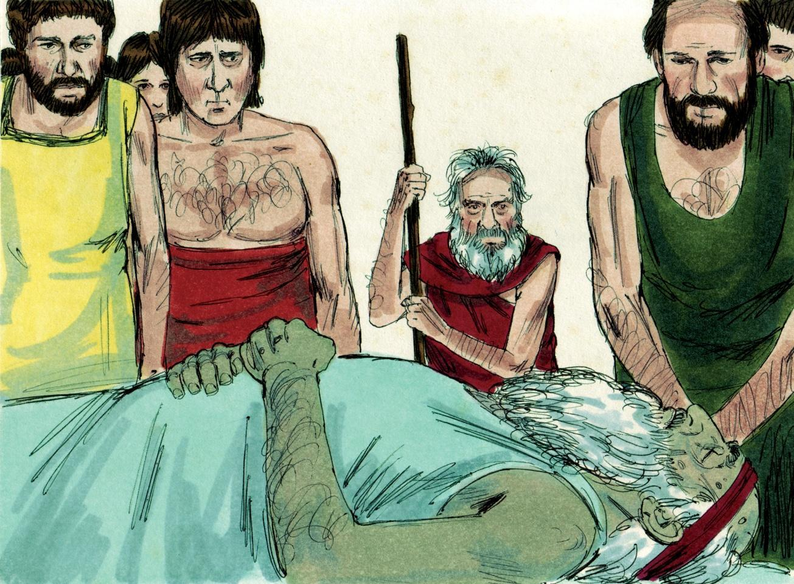
Source: Sweet Publishing - for illustration purposes of human death only

However, it makes us very sure of what is going to happen to the believers over in GRACE AIRPORT one day. God revealed a secret to the apostle Paul when He told him that one day the Lord Jesus Christ will come down from heaven with the trumpet call of God. And the dead in Christ shall rise first.
然而，它让我们非常确定有一天在恩典里的信徒身上会发生什么。上帝向使徒保罗透露了一个秘密，他告诉他有一天主耶稣基督会带着上帝的号角从天而降。在基督里死去的人会首先复活。

Those who are alive at that exact time will be caught up with them to meet the Lord in the air (1 Thessalonians 4:13-17). This is often called The Rapture. This means the catching up to heaven by God of the believers in the Body of Christ. The believers in this Church are pictured on the chart by SALVATION LINER.
那些在那个时间还活着的人将被与他们一起被提升并在空中与主相遇（帖撒罗尼迦前书 4:13-17）。 这通常被称为提升。表示在基督身体里的信徒被神带到天堂，用这样的图片向这个教会的信徒展示被救赎班轮带走的场景。

Paul calls this great event our blessed hope (Titus 2:13). There is no need to fear death since we have this hope. There is no need to mourn for Christians who die because we will be caught up together with them in the air. It is such a comfort to know this truth. God wants us to be sharing the Gospel with others as we wait for The Rapture / catching up. He wants us to warn everyone of the wages of sin and to tell them of eternal life in Christ.
保罗称这件大事是我们蒙福的盼望（提多书 2:13）。 没有必要害怕死亡，因为我们有这个希望。 没有必要为死去的基督徒哀悼，因为我们将与他们一起被提到空中。 知道这个真相真是一种安慰。 上帝希望我们在等待被提升时与他人分享福音。 他要我们警告每一个人罪的代价，并告诉他们在基督里的永生。

After Christians are caught up out of this world, then a terrible time of judgment will come. It will be sad if your loved ones are left behind. Have you faithfully told them about Jesus Christ dying for their sins? We must live a clean, pure life at all times and share God’s love with others.
在基督徒离开这个世界之后，一个可怕的审判时刻就会到来。如果你的亲人被抛下，那将是悲伤的。 你有没有忠实地告诉他们耶稣基督为他们的罪而死？ 我们必须时刻过着干净、纯洁的生活，并与他人分享上帝的爱。

In Lesson 4 we will learn about the great judgment which came upon the world after Enoch was caught up. Are you safely aboard SALVATION LINER waiting for Jesus to return and catch us up to be with Him?
在第 4 课中，我们将了解以诺被提后对世界的大审判。 您是否安全地登上救世班轮等待耶稣回来并提升我们与他同在？

MEMORY VERSE: “Then we who are alive and remain shall be caught up together with them in the clouds to meet the Lord in the air. And thus we shall always be with the Lord” (1 Thessalonians 4:17).
背诵经文：“以后我们这活着的还存留的人，要和他们一起被提到云端，在空中与主相遇。 因此，我们将永远与主同在”（帖撒罗尼迦前书 4:17）。

LESSON 3 – WORKSHEET
第 3 课 – 练习
Draw a line under the correct word or phrase to complete the statements:
在正确的单词或短语下画一条线以完成陈述：
- Adam lived (100 years / 530 years / 930 years). Genesis 5:5.
亚当活了（100 岁/530 岁/930 岁）。 创世记 5:5。
- Methuselah lived (559 years / 969 years / 150 years). Genesis 5:27.
玛土撒拉活了（559 岁 / 969 岁 / 150 岁）。 创世记 5:27。
- The father of Methuselah was (Noah / Enoch / Moses). Genesis 5:21.
玛土撒拉的父亲是（诺亚/以诺/摩西）。 创世记 5:21。
- Enoch walked with God and one day (he died and was taken / he was taken without dying). Hebrews 11:5.
以诺与上帝同行，有一天（他死了被带走/他被带走但没有死）。 希伯来书 11:5。
- Paul told the Thessalonian believers (everybody will die / some will not die).
1 Thessalonians 4:16-17.
保罗告诉帖撒罗尼迦的信徒（每个人都会死/有些人不会死）。
1 帖撒罗尼迦前书 4:16-17。

- Paul called this event (a fearful thing / a blessed hope). Titus 2:13.
保罗称这一事件为（可怕的事情/有福的希望）。 提多书 2:13。
- We can be sure we will be caught up to be with the Lord when He comes (if we pray every day / if we do good works / if we believe that Jesus died and rose again). 1 Thessalonians 4:14.
我们可以肯定，当主来的时候，我们会被赶上来与主同在（如果我们每天祈祷/如果我们行善/如果我们相信耶稣死而复生）。 帖撒罗尼迦前书 4:14。
- We will meet the Lord (on the earth / on a mountain / in the air).
1 Thessalonians 4:17.
我们会遇见主（在地上/在山上/在空中）。帖撒罗尼迦前书 4:17。

- Make two lists below: one list of the things you want to be doing when Jesus comes, and the other list of things you do not want to be doing when Jesus comes.
在下面列出两份清单：一份列出耶稣来时你想做的事情，另一份列出耶稣来临时你不想做的事情。
I want to be doing: I do not want to be doing:
我想做： 我不想这样做：
a)____________________________ _________________________ b)____________________________ _________________________ c)____________________________ _________________________ d)____________________________ _________________________

- Write 1 Thessalonians 4:17 _______________________________________
____________________________________________________________________________________________________________________________
写出帖撒罗尼迦前书 4:17

