LESSON 24 – PAUL, THE PILOT OF SALVATION LINER
第 24 课 – 救世航班飞行员保罗
Epistles of Paul
保罗书信
THEME: To show the responsibility of the believer to make plain to everyone what is the fellowship of the mystery of Ephesians 3:9.
主题： 表明信徒有责任向每个人说明什么是以弗所书 3:9 所说的同道奥秘。
What makes GRACE HIGHWAY different from the other roads on THE HIGHWAY OF LIFE? Paul was chosen to write about secrets or mysteries as God revealed them to him. His letters are called the Pauline epistles. They are named for areas where believers were located or the names of individual believers.
是什么让 恩典大道与生命大道上的其他道路不同？ 当上帝向他揭示秘密或奥秘时，保罗选择将这些写出来。他的书信被称为保罗书信。它们以信徒所在的地区或个别信徒的名字命名。
One day, a man named Tychicus arrived at the church in the city of Ephesus. He had a letter from the Apostle Paul who was in prison. “But that you also may know my affairs and how I am doing, Tychicus, the beloved brother and faithful minister in the Lord, will make all things known to you; whom I have sent to you for this very purpose, that you may know our affairs, and that he may comfort your hearts” (Ephesians 6:21-22).
有一天，一个名叫推基古的人来到了以弗所城的教会。他有一封来自狱中的使徒保罗的信。“但为了让你也知道我的事情和我的所作所为，推基古，敬爱的兄弟和在主里忠心的仆人，会把一切都告诉你；我派他到你们这里来，就是要叫你们知道我们的事，也叫他安慰你们的心”（以弗所书 6：21-22）。
When the believers read this epistle, they found new and wonderful truths revealed in it. Paul writes about the SEVEN “ONES” which are very important for all believers in Christ to know. We should remember all seven ones as they are found in Ephesians 4:4-6:
信徒阅读这封书信时，发现其中揭示了新奇的真理。 保罗写了七个“一”，这对所有在基督里的信徒来说都非常重要。 我们应该记住以弗所书 4:4-6 中的所有七个：
- ONE BODY. No longer is there Jew first. Now Jews and Gentiles become members of one Church, one Body with Christ as the Head when they are saved. On the chart the BODY OF CHRIST is in the heavenly places where Christ is seated. When believers in Christ become a part of His Body, they are seated in the heavenly places with Him (Ephesians 2:6, 13-16).
一个身体。 不再是犹太人。 现在犹太人和外邦人在得救时成为一个教会的成员，成为一个以基督为首的身体。 在航程表上，基督的身体是在天上基督所坐的地方。 当在基督里的信徒成为祂身体的一部分时，他们就与祂一同坐在天上（以弗所书 2：6、13-16）。
- ONE SPIRIT. The Holy Spirit baptized us into Christ’s death when we believed in the death, burial and resurrection on the third day of our Lord and Saviour Jesus Christ. He also raised us up with Christ to sit in the heavenly places. He sealed us securely and eternally in Christ so that nothing can separate us from Him (Romans 8:38-39; Ephesians 1:13). We have these spiritual blessings even though we still live here on earth in our physical bodies .
一个圣灵。当我们相信我们的主和救主耶稣基督第三天的死亡、埋葬和复活时，圣灵将我们洗入基督的死。他也使我们与基督一同复活，坐在天上。他在基督里将我们牢牢地、永远地印在了基督里，以致没有什么能使我们与他隔绝（罗马书 8：38-39；以弗所书 1：13）。 即使我们仍然生活在地球上，我们仍然拥有这些属灵的祝福。
- ONE HOPE OF OUR CALLING. The “blessed hope” is that the Lord Himself will call up all the members of His Body, dead and alive, to be with Him forever. An airplane at GRACE AIRPORT represents THE BODY OF CHRIST. We will one day be caught up to be with Christ forever. Our bodies will be changed to be like our glorious Lord Jesus Christ (1 Corinthians 15:51-54; 1 Thessalonians 4:13-17; Titus 2:13).
我们呼唤同一个希望。 “有福的盼望”是主会亲自召唤他身体的所有肢体，无论是死的还是活的，永远与他同在。 恩典机场的飞机代表基督的身体。 我们有一天会被提到永远与基督同在。我们的身体将被改变，变得像我们荣耀的主耶稣基督（哥林多前书 15:51-54；帖撒罗尼迦前书 4:13-17；提多书 2:13）。
- ONE LORD. Our Lord Jesus Christ is the One who loved us and gave Himself for our sins. He prays and mediates for us. We should glorify Him in all things (Romans 8:34; 1 Corinthians 10:31; Galatians 1:4).
一位主。我们的主耶稣基督是爱我们并为我们的罪舍己的那一位。他为我们祈祷和调解。 我们应该在所有事情上荣耀他（罗马书 8:34；哥林多前书 10:31；加拉太书 1:4）。
- ONE FAITH. This is the body of truth which was delivered unto Paul by the Lord Jesus Christ for THE BODY OF CHRIST (1 Corinthians 12:27; Ephesians 3:2-10).
一种信仰。这是主耶稣基督为基督的身体而交付给保罗的真理的身体（哥林多前书 12:27；以弗所书 3:2-10）。
- ONE BAPTISM. This is the baptism of the Spirit who baptizes believers into THE BODY OF CHRIST (1 Corinthians 12:13). Christ has many members of His Body. All members work together directed by Christ the Head (Romans 12:5; Colossians 1:18).
一次洗礼。 这是圣灵的洗礼，将信徒洗入基督的身体（哥林多前书 12:13）。 基督的身体有许多肢体。 所有成员在元首基督的指导下一起工作（罗马书 12：5；歌罗西书 1：18）。
- ONE GOD AND FATHER OF ALL. God becomes our Father because we are one with His Son the Lord Jesus Christ. We are also fellow heirs with Him (Ephesians 1:11, 3:6).
独一的上帝和万有之父。 神成为我们的父，因为我们与他的儿子主耶稣基督合而为一。 我们也是他的继承人（以弗所书 1:11, 3:6）。
Therefore, to be one with Christ, and to become a part of Him by grace is something that none of the saints in other dispensations knew (Ephesians 3:5).
因此，与基督合一，并因恩典成为他的一部分，是其他时代的圣徒都不知道的（以弗所书 3:5）。

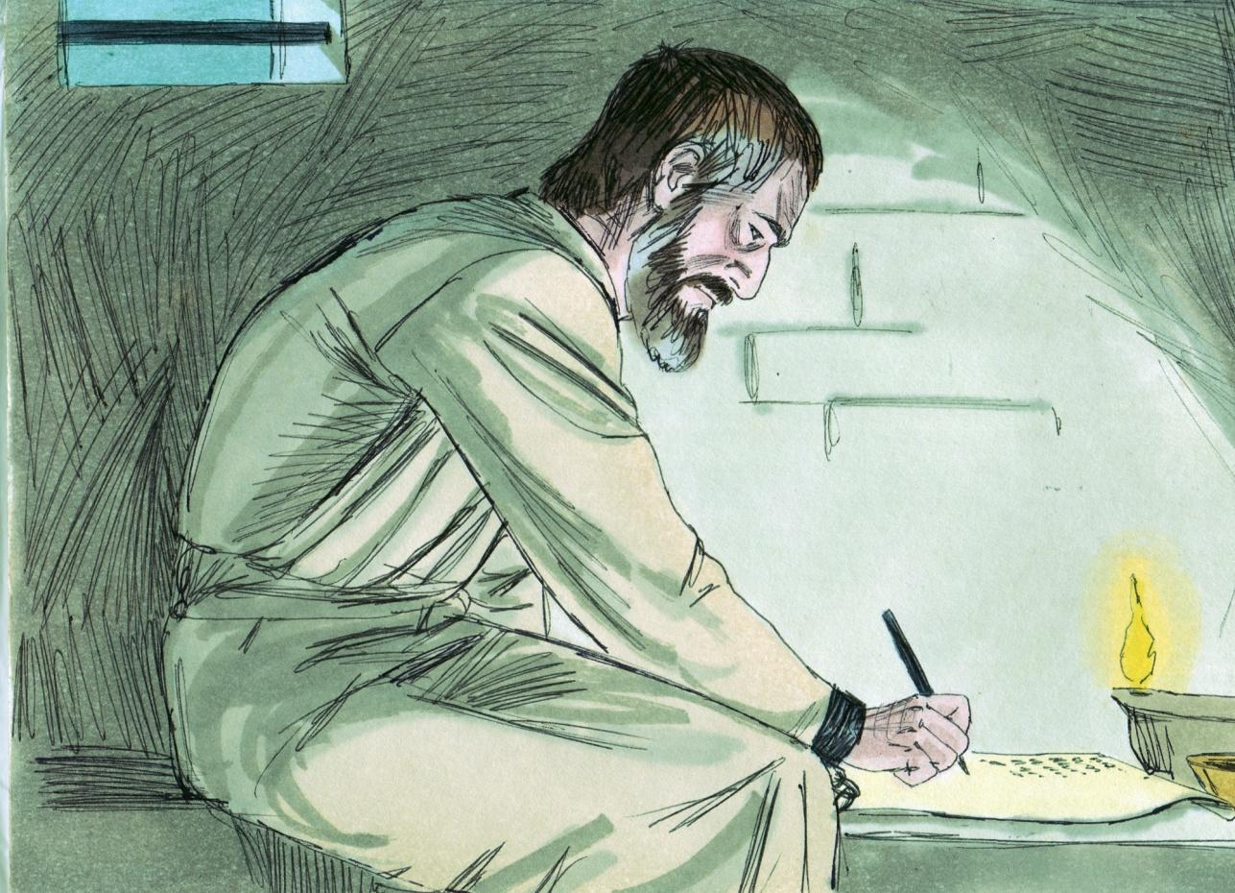
Source: Sweet Publishing - for illustration purposes of Paul writing from prison only
How should people act who are sons of God (Galatians 3:26)? Paul tells us that we should walk like saints. We should focus our mind on things above (Ephesians 4:17-32; Colossians 3:2).
身为神的儿子的人应该如何行事（加拉太书 3:26）？ 保罗告诉我们，我们应该像圣徒一样行事。 我们应该专注于天上的事情（以弗所书 4:17-32；歌罗西书 3:2）。
We should walk so that others know that we are the sons of God (Genesis 5:2). Our stand for the truth will mean little if our conduct does not reflect our testimony. The apostle Paul says that you were once “dead in trespasses and sins, in which you once walked according to the course of this world…” (Ephesians 2:1-2). We have been raised to “walk in newness of life” (Romans 6:4). There should be a radical change in our conduct after we are saved.
我们应该行走，让别人知道我们是神的儿子（创世记 5：2）。如果我们的行为不能反映我们的见证，我们对真理的立场将毫无意义。使徒保罗说，你曾经“死在过犯罪恶之中，你从前随从这世界的行径……”（以弗所书 2:1-2）。 我们已经被提升要“过新生命的生活”（罗马书 6:4）。 在我们得救之后，我们的行为应该有根本的改变。
We are debtors to the Spirit, who indwells us, not to the flesh. With the Spirit in us, there is no justification for complaining about our weakness, nor for excusing our sins. Deliverance is by grace through faith. It is not true that it is not possible for the believer to sin. It is true that it is possible for him/her not to sin. If we desire to be delivered from sin in any temptation, then the Spirit is there to help (Romans 8:12-15).
我们是住在我们里面的圣灵的债务人，而不是肉体的债务人。有了圣灵在我们里面，我们就没有理由抱怨我们的软弱，也没有理由为我们的罪开脱。 得救是本乎恩，因着信。 信徒不可能犯罪的说法是不正确的。 的确，他/她有可能不犯罪。 如果我们希望在任何试探中脱离罪，那么圣灵就在那里帮助我们（罗马书 8:12-15）。
Today, Jews and Gentiles are equal. They must enter into the fellowship of God as one, having no difference. Salvation is a free gift of God. You must believe in the Lord Jesus Christ as the only Saviour from eternal death and sin. Upon trusting Jesus Christ as your personal Saviour from going to hell, you are baptized by the Holy Spirit to become a member of this heavenly BODY OF CHRIST.
今天，犹太人和外邦人是平等的。他们必须作为一体进入神的同道，没有分别。救恩是上帝的免费礼物。你必须相信主耶稣基督是脱离永恒死亡和罪恶的唯一救主。相信耶稣基督是你免于下地狱的个人救主，你就接受了圣灵的洗礼，成为这个天上基督身体的一员。

MEMORY VERSE: “For by grace you have been saved through faith, and that not of yourselves; it is the gift of God, not of works, lest anyone should boast” (Ephesians 2:8-9).
背诵经文：“因为你们得救是本乎恩，也因着信，不是出于自己； 这是神的恩赐，不是出于行为，免得有人自夸”（以弗所书 2:8-9）。
LESSON 24 – WORKSHEET
1.-3. Give a brief summary of our journey thus far:
简要总结一下我们迄今为止的旅程：__________________________________ ___________________________________________________________________________________________________________________________________________________________________________________________________________________________________________________________________________________________________________________________________________________________________________________________________________________________________________________________________________________________________________________________________________________________________________________________________________________________________________________________________________________________________________________________.
4.-6. What are the SEVEN ONES which characterize believers in Christ today? Ephesians 4:4-6. 今天信基督的人所具有的七个特征是什么？ 以弗所书 4:4-6。 _________________________________________________________________________________________________________________________________________________________________________________________________________________________________________________________________________________________________________________________________________________________________________________________________________________________________________________________________________________________________________.
7.-9. Find 6 things in Colossians, chapter 3, which the believer in Christ is told to do if he/she will live as one who is risen with Christ. 找出歌罗西书第 3 章中的 6 件事，如果他/她将作为与基督一起复活的人生活，他/她就被告知要这样做。 ___________________________________________________________________________________________________________________________________________________________________________________________________________________________________________________________________________________________________________________________________________________________________________________________________________________________________________________________________________________________________________________________________________________________________________________________________________________________________________________________________________________________________________________________.
10. Write Ephesians 2:8,9:____________________________________
写以弗所书 2:8,9:_

