LESSON 23 – THE DOUBLE ROAD FROM GENTILE BYWAY TO GRACE HIGHWAY
第 23 课 – 从 外邦人小路 到恩典大路的双车道
Acts 13 - 28
使徒行传13-28
THEME: To show that rejection of God’s light brings darkness.
主题： 表明拒绝上帝的光会带来黑暗。
The biblical importance of the word separate means that God separates both things and people for His special purposes. Israel was set apart as a witness of the living God. Today we will study how Israel failed. We will learn how Saul was separated by God for a new purpose.
分开这个词在圣经中的重要性意味着上帝为了他的特殊目的而将事物和人分开。以色列被分别出来作为永生上帝的见证人。今天我们将研究以色列是如何失败的。我们将学习扫罗是如何被上帝分开，以达到一个新的目的。
After Saul’s conversion in Damascus, he went into Arabia. Then he returned to Damascus. Afterwards, he went up to Jerusalem where he became acquainted with Peter. It was in Jerusalem that the Hellenistic Jews attempted to put Saul to death. When the brethren learned of it, they brought Saul down to Caesarea. They sent him away to Tarsus (Acts 9:28-30).
扫罗在大马士革信主后，就去了阿拉伯。然后他回到大马士革。后来，他上耶路撒冷去，在那里结识了彼得。正是在耶路撒冷，希腊化的犹太人企图处死扫罗。弟兄们知道了，就带扫罗下到该撒利亚。他们把他送到大数（使徒行传 9:28-30）。
Later, when the news about the growing church in Syrian Antioch reached the ears of the church in Jerusalem, they sent Barnabas off. After encouraging them, Barnabas left for Tarsus to look for Saul. When he found Saul, he brought him to Antioch to minister with him. The disciples in Antioch were first called Christians (Galatians 1:17-18, Acts 9:29-30, 11:19-26).
后来，当叙利亚安提阿教会不断壮大的消息传到耶路撒冷教会耳中时，他们就把巴拿巴打发走了。巴拿巴鼓励他们后，就动身前往大数寻找扫罗。当他找到扫罗时，他带他到安提阿和他一起事奉。安提阿的门徒是最早被称为基督徒的人（加拉太书 1:17-18，使徒行传 9:29-30，11:19-26）。
As the leaders of the church in Syrian Antioch ministered and fasted, the Holy Spirit said, “Now separate to Me Barnabas and Saul for the work to which I have called them” (Acts 13:2). “So, being sent out by the Holy Spirit, they went down to Seleucia, and from there they sailed to Cyprus” (Acts 13:4). While they were in Salamis (Cyprus), they preached the Word of God in the synagogues.
当叙利亚安提阿教会的领袖们服侍和禁食时，圣灵说：“现在巴拿巴和扫罗分给我，去做我呼召他们做的工作”（使徒行传 13:2）。“于是，他们被圣灵差遣，下到西琉西亚，从那里航行到塞浦路斯”（使徒行传 13:4）。当他们在萨拉米斯（塞浦路斯）时，他们在会堂里传讲神的道。
At Paphos in Cyprus, they found a magician who was a Jewish false prophet. His name was Bar-Jesus, and he was with a Roman official named Sergius Paulus. This man summoned Barnabas and Saul to hear the word of God. But Bar-Jesus (a “type” of Israel) opposed them. He wanted to turn Sergius Paulus (a “type” of the Gentiles) away from the faith.
在塞浦路斯的帕福斯，他们找到了一位魔术师，他是一位犹太假先知。 他的名字叫巴尔-耶稣，他和一位名叫塞尔吉乌斯·保卢斯的罗马官员在一起。 这个罗马召唤巴拿巴和扫罗来宣讲神的话。 但是巴耶稣（以色列意为“典型”）反对他们。 他想让塞尔吉乌斯·保卢斯（外邦人的“典型”）远离信仰。
“Then Saul, who also is called Paul, filled with the Holy Spirit, looked intently at him and said, ‘O full of all deceit and all fraud, you son of the devil, you enemy of all righteousness, will you not cease perverting the straight ways of the Lord?’” (Acts 13:9-10). Paul said that Bar-Jesus would be blind, and then the proconsul believed (Acts 13:4-12). This is a picture of Israel being partially blinded “until the fullness of the Gentiles has come in” (Romans 11:25-36). The Gentiles are now saved through the fall of Israel.
“扫罗，又名保罗，被圣灵充满，定睛注视着他，说：‘你这充满诡诈和诡诈的恶魔之子，你是所有公义的仇敌，你还不停止歪曲主的正道吗？'”（使徒行传 13:9-10）。保罗说巴耶稣是瞎眼的，于是总督相信了（使徒行传 13:4-12）。这是一幅以色列被部分弄瞎的画面，“等到外邦人的数目满了进来”（罗马书 11:25-36）。外邦人现在因以色列的陷落而得救。
After Paul and Barnabas left Cyprus, they traveled to Perga and then further north to Pisidian Antioch. On the Sabbath day, they went into the synagogue, and they sat down. After the reading of the Law and the Prophets, they were invited to speak.
保罗和巴拿巴离开塞浦路斯后，他们前往佩尔加，然后再向北到达皮西迪亚安提阿。在安息日，他们进了会堂，坐下。 在阅读了律法和先知书之后，他们被邀请发言。
Paul stood up and preached forgiveness of sins through Jesus Christ (Acts 13:38). He also said that everyone who believes is justified from all things “from which you could not be justified by the Law of Moses” (Acts 13:39). As they left, the people begged for them to speak during the next Sabbath.
保罗站起来宣讲借着耶稣基督赦罪（使徒行传 13:38）。他还说，每一个相信的人都可以从“摩西律法不能称义的事”（使徒行传 13:39）中称义。当他们离开时，人们请求他们在下一个安息日发言。
“On the next Sabbath almost the whole city came together to hear the word of God” (Acts 13:44). When the Jews saw the crowds, they were jealous. They contradicted Paul, and they blasphemed God. Paul and Barnabas spoke boldly saying, “It was necessary that the word of God should be spoken to you first; but since you reject it, and judge yourselves unworthy of everlasting life, behold, we turn to the Gentiles” (Acts 13:46). Therefore, Paul crossed over from the Jewish side of DOUBLE HIGHWAY to the Gentile side.
“在下一个安息日，几乎合城的人都聚集在一起，要听上帝的话”（使徒行传 13:44）。 当犹太人看到人群时，他们很嫉妒。 他们反驳保罗，亵渎神。 保罗和巴拿巴大胆地说：“神的话必须先告诉你们；但你们既弃绝它，自认不配得永生，看啊，我们就转向外邦人”（使徒行传 13:46）。 因此，保罗从高速公路的犹太人一侧越过转向外邦人一侧。
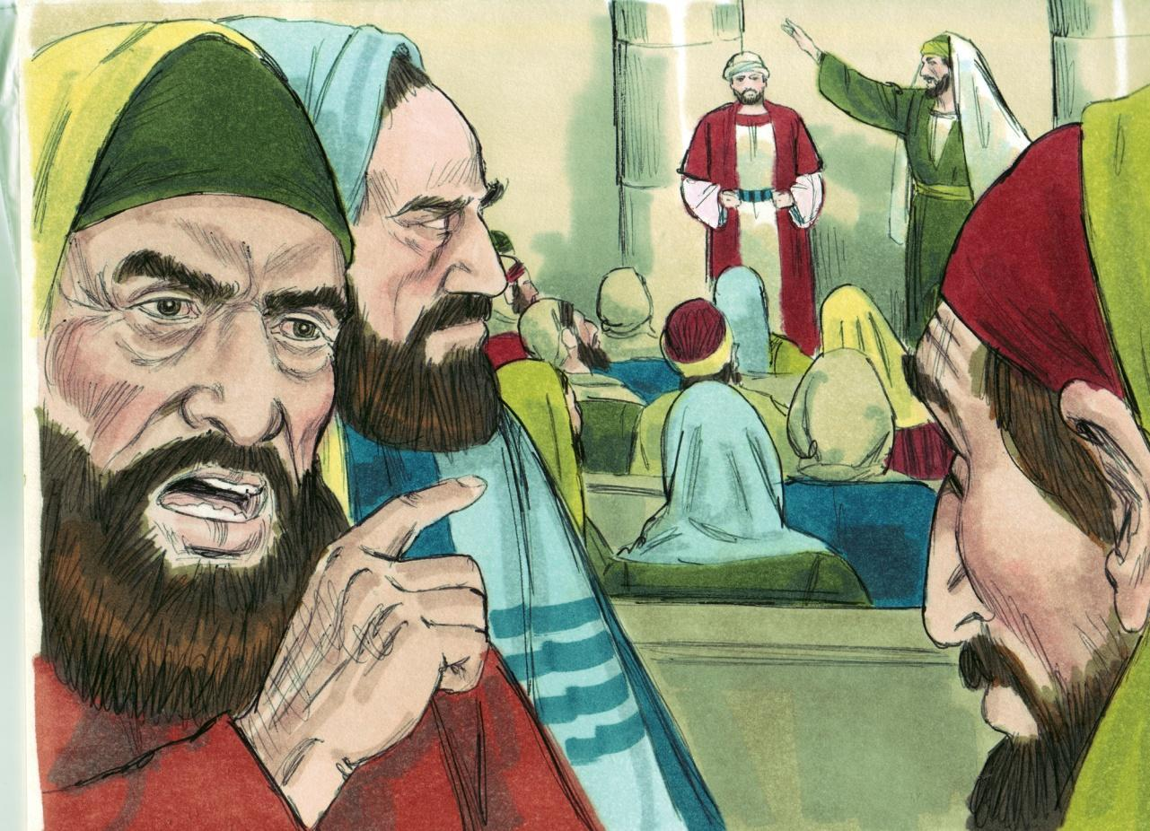
Source: Sweet Publishing - for illustration purposes of Acts 13:45 only

During Paul’s second missionary journey, he went to Corinth. There he testified to the Jews that Jesus is the Christ, the Messiah, the Anointed. When they resisted him and blasphemed God, he said, “Your blood be upon your own heads; I am clean. From now on I will go to the Gentiles,” (Acts 18:1-6). Paul had crossed back again to the Gentile side of DOUBLE HIGHWAY.
在保罗的第二次宣教旅程中，他去了哥林多。他在那里向犹太人证明耶稣是基督、弥赛亚、受膏者。 当他们抗拒他并亵渎神时，他说：“你的血归到你自己的头上；我很干净。 从今以后我要往外邦人那里去”（使徒行传 18:1-6）。 保罗再次穿越到双高速公路的外邦人一侧。
After Paul’s third missionary journey, he arrived as a prisoner at Rome. There he was allowed to stay by himself with the soldier who was guarding him. When the leaders of the Jews visited him, he explained to them about the kingdom of God. He tried to persuade them concerning Jesus from both the Law of Moses and from the Prophets. Some were persuaded, but others would not believe.
保罗在第三次宣教之旅后，作为囚犯抵达罗马。在那里，他被允许独自和守卫他的士兵呆在一起。 当犹太人的领袖拜访他时，他向他们解释了上帝的国度。 他试图从摩西律法和先知书中说服他们关于耶稣的事情。 有些人被说服了，但有些人不相信。
They did not agree with one another. Paul said, “The Holy Spirit spoke rightly through Isaiah…Therefore let it be known to you that the salvation of God has been sent to the Gentiles, and they will hear it” (Acts 28:23-28). With these words, a great STOP sign was placed across KINGDOM HIGHWAY. Israel is blinded. The KINGDOM is postponed while God works out His new, secret purpose.
他们彼此不同意。 保罗说：“圣灵借着以赛亚说的话一点都不错……所以你们要知道，神的救恩已经传给外邦人，他们也必听见”（使徒行传 28:23-28）。 随着这些话，一个伟大的停车标志被放置在王国公路的对面。 以色列被蒙蔽了。 当上帝完成他新的秘密目的时，天国被推迟了。
The nation of Israel chose darkness instead of light. How can the world be blessed if Israel, God’s chosen nation, is blinded? However, there is a turn on the chart at the end of DOUBLE HIGHWAY. There is another glorious part of THE HIGHWAY OF LIFE. We call it GRACE HIGHWAY. Grace means unmerited favour which God is now showing to both Jews and Gentiles.
以色列国选择了黑暗而不是光明。如果上帝所拣选的国家以色列失明了，世界怎能蒙福呢？ 然而，在 双路 的尽头，航程表上有一个转折点。生命的高速公路还有另一个辉煌的部分。 我们称它为 恩典大道。 恩典意味着上帝现在向犹太人和外邦人显示他们本不配得到的恩惠。
There is a terrible consequence for rejecting God’s Word. Could you be guilty? When you do not obey the Word, you are rejecting it. Continued rejection of light brings darkness. The whole world today needs to be brought back to the light of God’s Word.
拒绝上帝的话语有一个可怕的后果。你可能有罪吗？当你不遵守神的道时，你就是在拒绝它。 继续拒绝光会带来黑暗。 今天整个世界都需要重新回到上帝话语的光照下。
All sinners who die without Christ have an eternal spiritual death and a physical death (Romans 6:23). The good news is that “Christ died for our sins…was buried, and that He rose again the third day...” (1 Corinthians 15:1-4). Then, believers are indwelt by the Holy Spirit of God until eternity (Romans 8:9-11; 2 Timothy 1:14).
所有不相信基督的罪人死后都进入永恒的灵性和肉体的死亡（罗马书 6:23）。好消息是“基督为我们的罪而死……被埋葬了，第三天又复活了……”（哥林多前书 15:1-4）。然后，信徒被上帝的圣灵内住直到永恒（罗马书 8：9-11；2 提摩太后书 1：14）。
MEMORY VERSE: “In everything give thanks; for this is the will of God in Christ Jesus for you. Do not quench the Spirit” (1 Thessalonians 5:18-19).
背诵：“凡事谢恩； 因为这是神在基督耶稣里对你们的旨意。不要熄灭圣灵”（帖撒罗尼迦前书 5:18-19）。

LESSON 23 – WORKSHEET
- Where was Saul when the Holy Spirit said: “Set apart for Me Barnabas and Saul for the work to which I have called them”? Acts 13:2. _________________________________.
当圣灵说：“为我分派巴拿巴和扫罗去做我呼召他们去做的工作”时，扫罗在哪里？ 使徒行传 13:2。
- To what island did they go? Acts 13:4. ______________________________________.
他们去了哪个岛？ 使徒行传 13:4。
- What were the two names of the Jewish magician they found in the town of Paphos? Acts 13:6, Acts 13:8. ______________________________________________.
他们在帕福斯镇发现的犹太魔术师的两个名字是什么？ 使徒行传 13:6，使徒行传 13:8。
4.-6. Show that Saul’s experience with Bar-Jesus was a type/picture of what God’s dealings with Israel are today. Read Acts 13:7-11. Fill in the spaces and you will see the answer.
表明扫罗与巴耶稣的经历是上帝今天与以色列打交道的一个典型/图画。
阅读使徒行传 13:7-11。 填写空格，您将看到答案。
- Bar-Jesus _____________________ them (Paul and Barnabas). Acts 13:8.
巴-耶稣 _____________________ 他们（保罗和巴拿巴）。 使徒行传 13:8。
- The Jews (Israel) were filled with jealousy and ______________________________ the things spoken by Paul. Acts 13:45.
犹太人（以色列）充满了嫉妒，并________________保罗所说的话。使徒行传 13:45。
- Bar-Jesus was seeking to ________ the proconsul ________ from the faith. Acts 13:8.
巴-耶稣 试图从信仰中找寻 ________ 总督 ________。 使徒行传 13:8
- Israel tried to keep Paul from ____________ to the Gentiles. 1 Thessalonians 2:15,16.
以色列试图阻止保罗对外邦人____________。帖撒罗尼迦前书 2:15,16。
- Bar-Jesus was made ______________ for a time. Acts 13:11.
巴-基督 一度被造为______________。 使徒行传 13:11。
- Israel will be ________________________ until the fullness of the Gentiles has come in. Romans 11:25.
以色列将是______________，直到外邦人的数目满了。罗马书 11:25。
- Then the proconsul Sergius Paulus ______________________________. Acts 13:12.
然后是总督塞尔吉乌斯·保卢斯 _____________________________。 使徒行传 13:12。 - The Gentiles will also _________________________________________. Acts 28:28.
外邦人也将_________________________________________。 使徒行传 28:28。
7.-8. Write the verses that show what Paul said when he crossed over from KINGDOM HIGHWAY to GENTILE BYWAY on DOUBLE HIGHWAY.
写下几节经文，说明保罗在双路公路上从王国公路到外邦人支路时所说的话。
- Acts 13:46: ___________________________________________________________ _____________________________________________________________________.
- Acts 18:6: ____________________________________________________________.
- Acts 28:28: ___________________________________________________________.
- 使徒行传 13:46：- 使徒行传 18:6：- 使徒行传 28:28：
9. According to 2 Thessalonians 2:10,12 what happens to those who do not receive the love of the truth to be saved? _________________________________________.
根据帖撒罗尼迦后书 2:10,12，那些没有接受真理之爱而得救的人会怎样？
- Write 1 Thessalonians 5:18,19: ____________________________________________ ___________________________________________________________________________________________________________________________________________.
写 帖撒罗尼迦前书 5:18,19：

