LESSON 22 – PETER CROSSES OVER TO GENTILE BYWAY
第 22 课 – 彼得跨过外邦人的小路
Acts 10
使徒行传 10
THEME: To show the differences and the similarities in Peter’s and Paul’s gospels.
主题： 显示彼得和保罗福音书的异同。

Today we are going to see how Peter’s gospel (law) differed from Paul’s gospel (grace). We shall also see that they were alike in some ways.
今天我们要看看彼得的福音（律法）与保罗的福音（恩典）有何不同。 我们还将看到它们在某些方面是相似的。
As Traffic Director on KINGDOM HIGHWAY, the Apostle Peter was under the Law. He directed only one kind of people into the Kingdom: the Jews (Acts 2:36). He and the other apostles were proving their authority by signs and wonders (Acts 3:1-10, 5:12-16).
作为王国大道的交通主管，使徒彼得受法律约束。他只引导一种人进入天国：犹太人（使徒行传 2:36）。他和其他使徒正在用神迹奇事证明他们的权威（使徒行传 3:1-10, 5:12-16）。
In Acts 9:43 we read that Peter stayed many days in Joppa with a tanner named Simon. There was also a man at Caesarea named Cornelius. He was a Gentile centurion who feared God, and he gave many alms to the Jewish people. He prayed to God continually. His prayers and alms ascended as a memorial before God. Therefore, an angel of God instructed Cornelius to have Peter come to his house to hear a message.
在使徒行传 9:43 中，我们读到彼得在约帕和一个名叫西门的制革匠住了很多天。 在该撒利亚还有一个人名叫哥尼流。他是一个敬畏上帝的外邦百夫长，他多次施舍给犹太人。他不断地向上帝祈祷。他的祈祷和施舍升上了天，作为在上帝面前的纪念。因此上帝的一位天使指示哥尼流让彼得到他家听一个信息。
Before Peter went to Cornelius’ home, he had a vision. God showed him that he should not call any man unholy or unclean. When Peter entered Cornelius’ home, he said that it was unlawful for a Jew to associate with a foreigner or to visit him. Peter said, “But God has shown me that I should not call any man common or unclean” (Acts 10:1-33).
在彼得去哥尼流家之前，他有一个异象。上帝向他表明，他不应该称任何人为不圣洁或不洁净。当彼得进入哥尼流的家时，他说犹太人与外国人交往或拜访是非法的。彼得说：“但上帝已指示我，我不可称任何人为普通人或不洁净人”（使徒行传 10:1-33）。
By visiting Cornelius, Peter crossed over to GENTILE BYWAY. Peter explained that God does not show partiality. “But in every nation whoever fears Him and works righteousness is accepted by Him” (Acts 10:35). Then he preached peace through Jesus Christ, and how He went about doing good and healing all who were oppressed by the devil (Acts 10:3-38). Peter preached that the Jews put Christ to death by hanging Him on a cross. He preached how God raised Him up on the third day. He preached that through His name everyone who believes in Him receives forgiveness of sins (Acts 10:37-43).
通过访问哥尼流，彼得越过了外邦人的小路。 彼得解释说，上帝没有偏袒。 “但在各国中，凡敬畏他行义的，就为他所悦纳”（使徒行传 10:35）。然后他通过耶稣基督宣讲和平，以及他如何行善，医治所有被魔鬼压制的人（使徒行传 10:3-38）。 彼得宣扬犹太人将基督挂在十字架上，将他置于死地。 他传讲神在第三天如何使他复活。 他宣讲通过他的名，每一个相信他的人都会得到赦罪（使徒行传 10:37-43）。
While Peter was still speaking, the Holy Spirit fell upon all those who were listening to the message. The circumcised believers (Jewish Christians) who came with Peter were amazed. The gift of the Holy Spirit was poured out on the Gentiles because they were speaking with tongues and exalting God (Acts 10:45-46).
彼得还在说话的时候，圣灵降在所有听道的人身上。和彼得一起来的受割礼的信徒（犹太基督徒）都很惊讶。圣灵的恩赐浇灌在外邦人身上，因为他们说方言并称颂神（使徒行传 10:45-46）。
Peter said, “Can anyone forbid water, that these should not be baptized who have received the Holy Spirit just as we have?” (Acts 10:47). Then, the Gentiles were baptized in the name of Jesus Christ. Therefore, Peter was used by God to cross over to GENTILE BYWAY. The other disciples knew that God approved of them sharing the good news to the Gentiles.
彼得说：“这些人既然领受了圣灵，跟我们一样，谁能禁止他们受水的洗礼呢？” （使徒行传 10:47）。 然后，外邦人奉耶稣基督的名受洗。因此，彼得被神使用，越过了外邦人的路。其他门徒也知道上帝赞成他们向外邦人分享好消息。
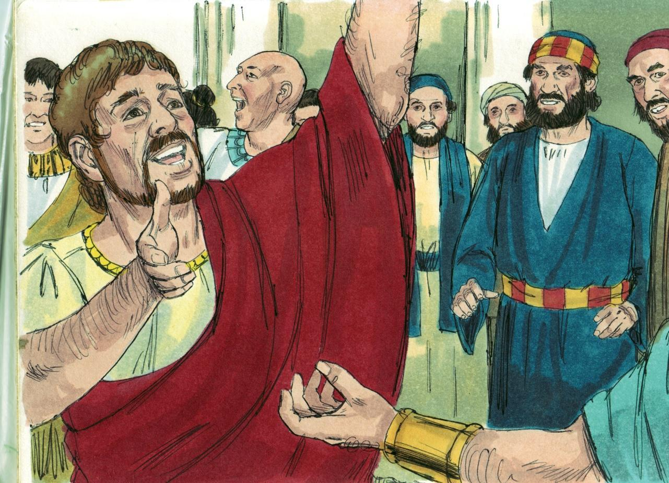
Source: Sweet Publishing - for illustration purposes of Acts 10:45 only

In this age of Grace, we live at GRACE AIRPORT. There are some things that are different in the messages of Peter and Paul. We are to make distinctions with the things that differ. We are told to rightly divide the Word of Truth (2 Timothy 2:15).
在这个恩典时代，我们住在恩典机场。彼得和保罗的信息有些不同。我们要区别不同的事物。 我们被告知要正确地划分真理之道（提摩太后书 2:15）。
DIFFERENCES 区别
- Peter was sent to Cornelius because Cornelius feared God; he was righteous. However, Paul was given the gospel of the Grace of God because we are all sinners (Acts 20:24; Romans 3:10-18, 5:8,10).
彼得被派到哥尼流家是因为哥尼流敬畏上帝。他是正义的。然而，保罗得到了上帝恩典的福音，因为我们都是罪人（使徒行传 20:24；罗马书 3:10-18, 5:8,10）。
- Those who were saved by Peter’s gospel spoke in tongues as a sign to the Jews (1 Corinthians 1:22). Paul said that tongues would cease (1 Corinthians 13:8).
那些因彼得福音而得救的人说方言是对犹太人显的神迹（哥林多前书 1:22）。 保罗说方言应该停止（哥林多前书 13:8）。
- Peter baptized people with water in order for them to be saved (Mark 16:15-16). Paul says, “For Christ did not send me to baptize...” (1 Corinthians 1:17). *Paul practiced a number of things connected with Israel’s Kingdom gospel. As revelation progressed, Paul finally declared in Ephesians 4:5, “There is one Lord, one faith and ONE baptism.” First Corinthians 12:13 says believers are put into the Body of Christ by the baptism of the Holy Spirit.
彼得用水给人们施洗以使他们得救（马可福音 16:15-16）。 保罗说，“因为基督没有差我来施洗……”（哥林多前书 1:17）。 *保罗实践了许多与以色列王国福音有关的事情。 随着启示不断推进，保罗最终在以弗所书 4:5 中宣告：“只有一位主，一位信，一位洗礼。” 哥林多前书 12:13 说信徒借着圣灵的洗，进入基督的身体。
- Peter preached the Law. Paul preached that Gentiles were not under law, but under grace (Romans 6:14).
彼得传讲律法。 保罗宣讲外邦人不在律法之下，而是在恩典之下（罗马书 6:14）。

SIMILARITIES相似之处

- Both Peter and Paul preached forgiveness of sins through faith in Christ (Acts 10:43; Romans 3:22-26).
彼得和保罗都宣扬因信基督而赦罪（使徒行传 10:43；罗马书 3:22-26）。
- Both apostles had worldwide ministries: Peter - proclaiming an earthly hope (Kingdom); Paul - proclaiming a heavenly hope (Body of Christ): Acts 1:8, 2 Corinthians 5:19; Titus 2:13.
两位使徒都有世界性的事工：彼得——宣扬地上的希望（王国）； 保罗 - 宣告属天的希望（基督的身体）：使徒行传 1:8, 哥林多后书 5:19； 提多书 2:13。
- Both apostles promise the return of Christ: Peter - Christ’s return to earth as King; Paul - Christ’s coming in the air to gather the Body of Christ (Acts 3:20-21; 1 Thessalonians 4:16-17).
两位使徒都应许基督的再来：彼得——基督以君王的身份回归地球； 保罗 - 基督在空中降临，聚集基督的身体（使徒行传 3:20-21；帖撒罗尼迦前书 4:16-17）。
Peter only preached to the Jews until God revealed his vision (Acts 10:1-33). Paul preached the truth of breaking down all differences (Ephesians 2:14-18). Now God wants us to see that people of all colours and races need to be saved without religious works (Ephesians 2:8-9). They need to be saved through personal faith in the death, burial and resurrection of our Lord and Saviour Jesus Christ.
彼得只向犹太人传道，直到上帝向他显明异象（使徒行传 10:1-33）。保罗宣讲打破一切分歧的真理（以弗所书 2:14-18）。 现在上帝希望我们看到，所有肤色和种族的人都需要在没有宗教行为的情况下得救（以弗所书 2:8-9）。他们需要通过个人对我们的主和救主耶稣基督的死亡、埋葬和复活的信心而得救。
MEMORY VERSE: “Be diligent to present yourself approved to God, a worker who does not need to be ashamed, rightly dividing the word of truth” (2 Timothy 2:15).
背诵经文：“努力将自己呈献给上帝，做一个不需羞愧的工人，正确地分解真理之道”（提摩太后书 2:15）。
LESSON 22 – WORKSHEET
Peter preached the Gospel (good news) of the KINGDOM, whereas Paul was called to preach the Gospel (good news) of the BODY OF CHRIST. The aim of this lesson is to show the differences and the similarities of the two messages. Fill in the references given. It is important to rightly divide the word of truth.
彼得传讲天国的福音（好消息），而保罗被呼召传讲基督身体的福音（好消息）。本课的目的是展示这两种信息的不同之处和相似之处。填写给出的参考资料。正确地划分真理的话语是很重要的。
DIFFERENCES
PETER彼得 PAUL 保罗
1.-2. Sent to Cornelius because he Sent to the Gentiles because they
派给哥泥流，因为他__________________. 派给外邦人，因为他们__________. Acts 10:35 使徒行传 10:35 Romans 5:8罗马书 5:8
3.-4. Those saved spoke with得救的人说 Says that tongues 说方言 ________________. ______________________
Acts 10:46 使徒行传10：46 1 Corinthians 13:8 哥林多前书 13:8
5.-6. Baptized with受洗用 __________________. Says he was not sent to
说他没有被派到____________.
Acts 10:47 使徒行传10：47 1 Corinthians 1:17哥林多前书1：17
SIMILARITIES相似之处
7.-8. Fill in the blanks below and you will see how the messages of Peter and Paul were alike in many ways.填上下面的空白，你会看到彼得和保罗的信息在很多方面是相似的。
Both preached forgiveness of sins through ________________ in the Lord Jesus Christ. Acts 10:43, Romans 3:22.
两人都在主耶稣基督里借着______宣扬罪的赦免。使徒行传 10:43，罗马书 3:22
Both had a ministry for all the ______________________. Acts 1:8, 2 Corinthians 5:19. Peter for establishing the Kingdom; Paul for the calling out of the Body of Christ.
两人都有为所有 ____________ 人服务的事工。 使徒行传 1:8, 哥林多后书 5:19
彼得建立王国； 保罗呼召基督的身体。
Both have a ministry of the __________________ of Christ. Acts 3:20, 1 Thessalonians 4:16-17. Peter tells of Christ’s coming as King; Paul tells of Christ’s coming as the Head to catch away the Body of Christ.
两者都有基督的________的事工。 使徒行传 3:20，帖撒罗尼迦前书 4:16-17。 彼得讲述基督作为君王降临； 保罗说到基督来作元首，要夺去基督的身体。
9. You are an Ambassador for Christ. How do you tell people to be saved? Write the Scripture references you would use:
你是基督的大使。你如何告诉人们得救？写下你会使用的圣经参考资料__________________________________________________
10. Write 2 Timothy 2:15. 写 提摩太后书 2:15。
____________________________________________________

