LESSON 21 – SAUL’S AMAZING CONVERSION
第 21 课 – 扫罗的惊人转变
Acts 8 and 9
使徒行传 8 和 9
THEME: To present the call of Christ to service.
主题： 呈现基督服侍的呼召。
Before we begin our journey today, we must look back at CONFUSION CORNERS. Humans did not obey God, so God gave them up to vile passions (Romans 1:24-28). Then He chose one man named Abram to begin a new covenant (Genesis 12:1-3). Mankind turned away to GENTILE BYWAY. Only Abraham followed God on PROMISE ROAD (Acts 7:2-8).
在我们开始今天的旅程之前，我们必须回顾一下困惑的拐角。人类不服从上帝，所以上帝任凭他们放纵情欲（罗马书 1:24-28）。 然后他选择了一个名叫亚伯兰的人来开始一个新的盟约（创世记 12:1-3）。 人类转身转向外邦人的小路。 只有亚伯拉罕在应许路上跟随神（使徒行传 7:2-8）。
Today’s lesson begins on KINGDOM HIGHWAY. Israel rejected God’s offer of the Kingdom. Therefore, God called a new apostle (not one of the 12 apostles) to begin a new program that includes Jews and Gentiles (1 Corinthians 12:12-14).
今天的课程从王国公路 开始。 以色列拒绝了上帝对王国的提议。 因此，上帝召唤了一位新使徒（不是 12 位使徒中的一位）来开始一项包括犹太人和外邦人的新计划（哥林多前书 12:12-14）。
Recall that there was a man guarding the robes of the men who were throwing stones at Stephen. His name was Saul (Acts 7:58). Saul was a Hebrew of the tribe of Benjamin (Philippians 3:5). He was from Tarsus (Acts 9:11). Saul was both a Hebrew and a Roman. He lived in Jerusalem, and he was educated by Gamaliel (Acts 22:3). He was the son of a Pharisee (Acts 23:6).
回想一下，有一个看守向司提反扔石头的人的长袍的人。他的名字叫扫罗（使徒行传 7:58）。 扫罗是便雅悯支派的希伯来人（腓立比书 3:5）。 他来自大数（使徒行传 9:11）。 扫罗既是希伯来人又是罗马人。 他住在耶路撒冷，受迦玛列教育（使徒行传 22:3）。 他是一个法利赛人的儿子（使徒行传 23:6）。
After Stephen's death, a great persecution began against the church in Jerusalem. The believers (except the apostles) scattered throughout the regions of Judea and Samaria. Some devout men buried Stephen, and they cried loudly over his death. Yet, Saul persecuted the church. He dragged Christian men and women, and he put them in prison (Acts 8:1-3).
司提反死后，一场针对耶路撒冷教会的大迫害开始了。信徒（使徒除外）分散在犹太和撒玛利亚地区。一些虔诚的人埋葬了斯蒂芬，他们为他的死大声哭泣。然而，扫罗迫害教会。 他把基督徒男女从屋里拖出来，把他们关进监狱（使徒行传 8:1-3）。
Then Saul had an amazing conversion on the long journey to Damascus in Syria (Acts 9:1-16). The Lord told Ananias in Damascus, “Go, for he is a chosen vessel of Mine to bear My name before Gentiles, kings, and the children of Israel. For I will show him how many things he must suffer for My name’s sake” (Acts 9:15-16). Saul was chosen by Christ to witness among the Gentiles, kings, and the children of Israel. He would suffer many things for the Lord’s name. He counted it a privilege to suffer for Christ’s sake (Philippians 1:29, 3:8). Do you consider it a privilege to suffer for Christ’s sake?
然后扫罗在前往叙利亚大马士革的漫长旅程中发生了惊人的转变（使徒行传 9:1-16）。 主在大马士革对亚拿尼亚说：“去吧，因为他是我拣选的器皿，要在外邦人、君王和以色列人面前宣扬我的名。 因为我要告诉他，他必须为我的名受多少苦”（使徒行传 9:15-16）。 扫罗被基督拣选到外邦人、君王和以色列人中间作见证。 他会为主名受许多苦。 他认为为基督受苦是一种特权（腓立比书 1:29, 3:8）。 你认为为基督受苦是一种特权吗？
After Saul received his sight, he immediately preached Jesus in the Damascus synagogues saying, “He is the Son of God” (Acts 9:20). All those who heard him were amazed saying, “Is this not he who destroyed those who called on this name in Jerusalem, and has come here for that purpose, so that he might bring them bound to the chief priests?” (Acts 9:21). But Saul proved that Jesus is the Christ (Acts 9:20-22).
扫罗眼睛复明后，立即在大马士革的会堂里传讲耶稣说：“他是神的儿子”（使徒行传 9:20）。 凡听见的人都希奇说：“这不是在耶路撒冷消灭那些呼求这个名的人吗？他是特地来到这里，要把他们捆绑带到祭司长那里的吗？” （使徒行传 9:21）。 但扫罗证明了耶稣是基督（使徒行传 9:20-22）。
However, the unbelieving Jews in Damascus did not receive Saul’s testimony. “Now after many days were past, the Jews plotted to kill him” (Acts 9:23). They watched the city gates night and day. Then some disciples let him down through an opening in the wall, and they lowered him in a basket (Acts 9:23-25). He traveled south to Arabia.
然而，大马士革不信的犹太人并没有接受扫罗的见证。“过了许多日，犹太人密谋要杀他”（使徒行传 9:23）。 他们日夜守望着城门。 然后一些门徒把他从墙上的一个洞里放了下来，他们把他放在一个篮子里（使徒行传 9:23-25）。 他向南前往阿拉伯。
During his three years in Arabia, the Apostle Paul received revelations from the risen Jesus (Acts 13:9; 2 Corinthians 12:1-10). These revelations concerned the gospel of grace that he preached (Galatians 1:11-17). After he returned to Damasus, he headed south to Jerusalem (Galatians 1:15-17). He tried to associate with the disciples, but they were afraid of him. They did not believe that he was a disciple (Acts 9:26-30).
使徒保罗在阿拉伯的三年中，从复活的耶稣那里得到了启示（使徒行传 13:9；哥林多后书 12:1-10）。 这些启示与他所传讲的恩典福音有关（加拉太书 1:11-17）。 返回大马苏后，他向南前往耶路撒冷（加拉太书 1:15-17）。 他试图与门徒交往，但他们害怕他。 他们不相信他是门徒（使徒行传 9:26-30）。

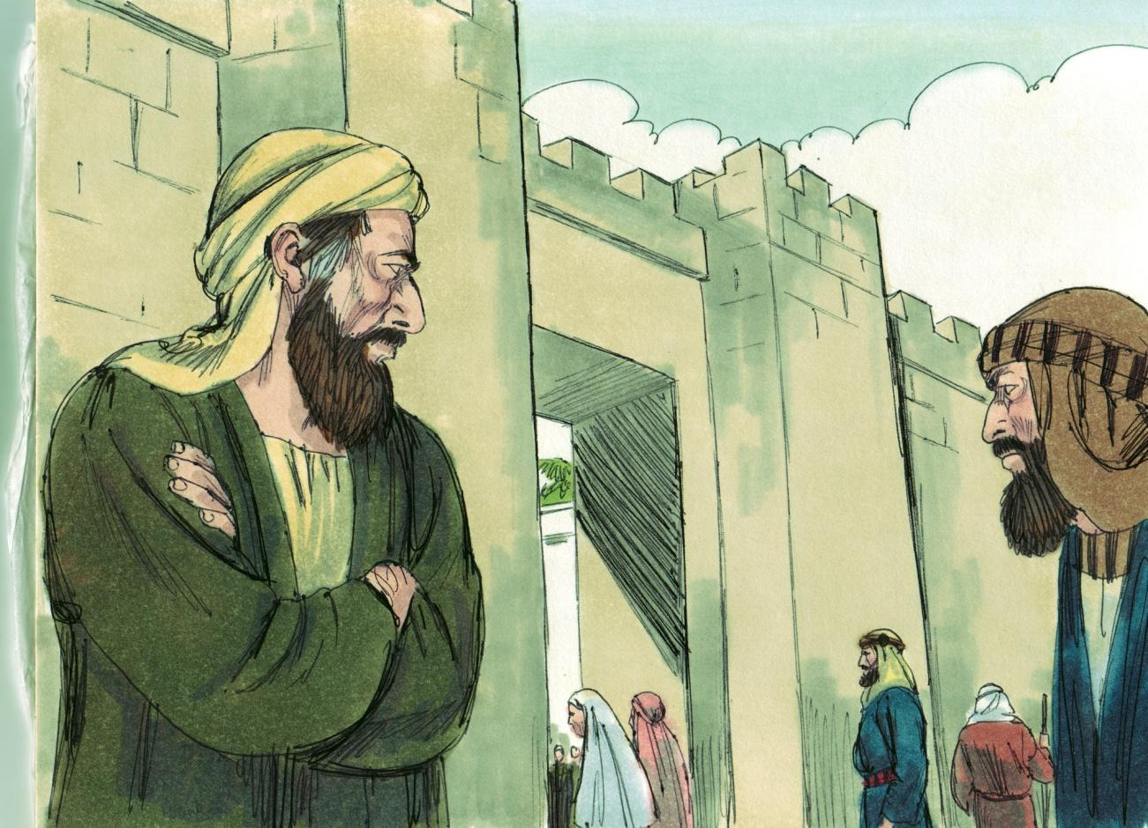
Source: Sweet Publishing - for illustration purposes of Acts 9:24 only

Barnabas, a Levite, brought him to the apostles in Jerusalem. The apostles were away except Peter and James (the Lord’s brother). Although James was not one of the twelve disciples, he held a position as an apostle. Then Barnabas described to them how Saul had seen the Lord on the road to Damascus (Acts 9:26-28). He told them that Paul preached boldly in the name of Jesus.
利未人巴拿巴把他带到耶路撒冷的使徒那里。除了彼得和雅各（主的兄弟）外，使徒们都走了。虽然雅各不是十二门徒之一，但他担任使徒的职位。然后巴拿巴向他们描述了扫罗如何在去大马士革的路上看到了主（使徒行传 9:26-28）。 他告诉他们，保罗奉耶稣的名大胆传道。
It was on the road to Damascus that Saul first saw the glorified Lord. He heard, “Saul, Saul, why are you persecuting Me?” (Acts 9:4). The Lord revealed Himself to Saul from heaven, and He revealed Himself to the world through Paul (Galatians 1:12-17).
扫罗在去大马士革的路上第一次见到了荣耀的主。他听到：“扫罗，扫罗，你为什么要逼迫我？” （使徒行传 9:4）。主从天上向扫罗显明自己，并通过保罗向世界显明自己（加拉太书 1:12-17）。
God saved His enemy Saul! He wanted all to be reconciled, “...that He might have mercy on all” (Romans 11:32). The Beloved Son had been rejected, but God postponed the day of judgment. He revealed Christ in matchless grace through the conversion of Saul.
神拯救了他的仇敌扫罗！他希望所有人都和好，“……好怜悯所有人”（罗马书 11:32）。 爱子已被弃绝，但上帝推迟了审判的日子。 他借着扫罗的悔改，以无比的恩典显明了基督。
Now that Saul had tasted of the riches of His grace, he was a new man. God no longer saw him as the wicked blasphemer and murderer (2 Corinthians 5:17-20). Christ was in Paul! Paul says in Galatians 1:15,16: “…God…was pleased TO REVEAL HIS SON IN ME.”
现在扫罗尝到了祂丰富的恩典，他是一个新人。上帝不再将他视为邪恶的亵渎者和杀人犯（哥林多后书 5:17-20）。 基督在保罗里面！ 保罗在加拉太书 1:15,16 中说：“……上帝……很高兴在我里面展示他的儿子。”
The Apostle Paul wrote, “...We implore you on Christ's behalf, be reconciled to God” (2 Corinthians 5:20). Saul the persecutor became Saul the persecuted. He called it “the fellowship of His sufferings” (Philippians 3:10).
使徒保罗写道：“……我们为基督恳求你们，与神和好”（哥林多后书 5:20）。迫害者扫罗变成了被迫害者扫罗。 他称其为“与 他一起受苦”（腓立比书 3:10）。
Paul, the new man in Christ, reminds us of the “one new man” which is the Body of Christ (Ephesians 2:14-16). Reconciled Jews and Gentiles form the Body of Christ (Ephesians 2:14-16). Paul is the pattern (Philippians 3:17).
保罗，基督里的新人，我们想起“一个新人”，即基督的身体（以弗所书2：14-16）。使犹太人和外邦人在基督的身体的身体里和好。（以弗所书 2:14-16）。 保罗是榜样（腓立比书 3:17）。
Like Paul, we are “complete in Him” (Colossians 2:10). We stand before God in Christ. Indeed, God still reveals His Son to the world through sinners saved by grace.
像保罗一样，我们“在他里面得完全”（歌罗西书 2:10）。 我们在基督里站在上帝面前。 事实上，上帝仍然通过因恩典得救的罪人向世人展示他的儿子。

MEMORY VERSE: “Now then, we are ambassadors for Christ, as though God were pleading through us: we implore you on Christ’s behalf, be reconciled to God” (2 Corinthians 5:20).
背诵经文：“那么，我们是基督的使者，好像上帝通过我们恳求：我们为基督恳求你，与上帝和好”（哥林多后书 5:20）。
LESSON 21 – WORKSHEET
- Back at the tower of Babel called CONFUSION CORNERS on our chart, something happened to the Gentiles because they rebelled against God. Look up the following Scriptures:
回到我们图表上称为混乱角落的巴别塔，外邦人发生了一些事情，因为他们背叛了上帝。 查考以下经文：
Romans 1:24: _________________________________________________________. Romans 1:26: _________________________________________________________. Romans 1:28: _________________________________________________________.
罗马书 1:24: 罗马书 1:26: 罗马书 1:28:
- Stephen said that Israel was guilty of what three things? Acts 7:51-52
司提反说以色列犯了哪三件事？ 使徒行传 7:51-52。
You always ________________________________________________________.
Your __________________________________________ announced the coming of the Righteous One. They were now the _______________ and ______________ of Christ.
你一直 _______________。你的 ___________ 宣告了正义者的来临。 他们现在是基督的_______________和______________。
- Israel quickly became as bad as the Gentiles, so God prepared to do a new thing. His first step was to conclude or shut up all _________________ that He may ____________________ all. Romans 11:32.
以色列很快变得和外邦人一样坏，所以上帝准备做一件新事。他的第一步是结束或关闭所有_____，以便他可以__________所有。 罗马书 11:32。
- The man at whose feet the killers laid their robes while they stoned Stephen was ___________. Acts 7:58.
杀手在用石头砸斯蒂芬时把长袍放在他脚下的那个人是___________。 使徒行传 7:58。
- Christ told Ananias that Saul was to bear His name to three groups of people. Name them. Acts 9:15-16. _____________________________________________________.
基督告诉亚拿尼亚，扫罗要以他的名字传给三类人。 命名它们。 使徒行传 9:15-16。
- Not only was Paul now in Christ, but Christ was in Paul! Paul says in Galatians 1:15,16:
现在不仅保罗在基督里，基督也在保罗里面！ 保罗在加拉太书 1:15,16 中说：_____________________________________________________________________.
- God spoke to Saul from Heaven. How does He speak to us who live over at GRACE AIRPORT? Romans 10:17. _______________________________________________.
神从天上对扫罗说话。 他是如何对住在恩典机场的我们说话的？ 罗马书 10:17
- What is an AMBASSADOR? Look up the word in a dictionary and write a brief definition.
什么是大使？在字典中查找这个词并写一个简短的定义。_____________________________________________________________________.

- According to 2 Corinthians 5:20 what should we be doing?
根据哥林多后书5:20，我们应该做什么？______________________ _____________________________________________________________________.

- Write 2 Corinthians 5:20: _________________________________________________
______________________________________________________________________
写下哥林多后书5：20

