LESSON 20 – PETER DIRECTS TRAFFIC ON KINGDOM HIGHWAY
第 20 课——彼得指挥王国大道的交通
Acts 1 - 7
使徒行传 1 - 7
THEME: To teach the responsibility of believers to witness for Christ.
主题： 教导信徒为基督作见证的责任。
What a joyful day it must have been when the disciples learned that Jesus was alive. He appeared to more than 500 brethren at one time besides His apostles and James (1 Corinthians 15:5-7). Over a period of forty days, He spoke to them of the things concerning the kingdom of God.
当门徒得知耶稣还活着时，那该是多么快乐的一天。除了使徒和雅各之外，他同时向 500 多名弟兄显现（哥林多前书 15:5-7）。 在四十天的时间里，他向他们讲论神国的事。
He commanded them not to leave Jerusalem, but they had to wait for the baptism with the Holy Spirit. The apostles asked Him, “Lord, will You at this time restore the kingdom to Israel?” He said, “It is not for you to know times or seasons which the Father has put in His own authority. But you shall receive power when the Holy Spirit has come upon you; and you shall be witnesses to Me in Jerusalem, and in all Judea and Samaria, and to the end of the earth” (Acts 1:3-8).
他命令他们不要离开耶路撒冷，但他们必须等待圣灵的洗礼。使徒问他：“主啊，你会在这个时候恢复以色列的国度吗？” 他说：“父凭自己的权柄所定的时间，你们必不知道。 但当圣灵降临在你身上时，你就必得着能力；你要在耶路撒冷、犹太全地和撒玛利亚，直到地极，为我作见证”（使徒行传 1:3-8）。
God gave Israel an opportunity to receive their risen Lord. God was gracious by giving Israel another chance to repent after they had crucified His Son. It was because:
上帝给了以色列一个机会来接受他们复活的主。上帝很仁慈地给了以色列人在将他的儿子钉死在十字架上之后再次悔改的机会。 这是因为：
- Christ prayed on the cross: “Father, forgive them” (Luke 23:34).
基督在十字架上祈祷：“父啊，赦免他们”（路加福音 23：34）。
- It is recorded in Luke 13:6-9 that for three years Christ came to Israel (the fig tree) to find fruit. He found none. Israel got another year to bear fruit.
路加福音 13 章 6-9 节记载，三年来，基督来到以色列（无花果树）寻找果子。 他没有找到。 以色列还有一年结出果实。
- God gave Israel a final test to prove their hearts. They permitted the murder of John the Baptist, and they demanded the Crucifixion of Christ. The third test proved how they treated the Holy Spirit.
上帝给了以色列一个最后的考验来证明他们的心。 他们允许谋杀施洗约翰，并要求将基督钉十字架。 第三个试验证明了他们是如何对待圣灵的。
After the Ascension, the apostles returned to Jerusalem to an upper room. They chose Matthias to replace Judas Iscariot (Acts 1:15-26). When the day of *Pentecost had come, they were all together in Jerusalem. Suddenly, there came from heaven a noise like a rushing wind. It filled the whole house. They were all filled with the Holy Spirit. They spoke of the mighty deeds of God in different languages. There were devout Jews from every nation who were amazed and astonished that they could hear them in their own language (Acts 2:1-13).
升天后，使徒们回到耶路撒冷的楼上。他们选择马提亚代替加略人犹大（使徒行传 1:15-26）。 五旬节到了，他们都聚集在耶路撒冷。 突然，从天上传来一阵狂风般的声音。 它填满了整个房子。 他们都被圣灵充满。 他们用不同的语言谈论上帝的大能。 来自各个国家的虔诚的犹太人对他们能用自己的语言听到他们的声音感到不解和惊讶（使徒行传 2:1-13）。
Then the Apostle Peter raised his voice. He said, “But this is what was spoken by the prophet Joel” (Joel 2:28-32, Psalms 16:8-11, 110:11, 132:11). Peter explained that they crucified Jesus who was also their Lord and Christ. When they heard this, they were convicted of their sins. They said, “Men and brethren, what shall we do?” Peter said, “Repent, and let every one of you be baptized in the name of Jesus Christ for the remission of sins; and you shall receive the gift of the Holy Spirit” (Acts 2:14-38). Those who had received his word were baptized. About three thousand souls were saved that day (Acts 2:40-41).
然后使徒彼得提高了声音。他说：“但这是先知约珥所说的话”（约珥书2:28-32，诗篇 16:8-11, 110:11, 132:11）。 彼得解释说，他们把耶稣钉在十字架上，耶稣也是他们的主和基督。 他们听了这话，就认罪了。 他们说：“弟兄们，我们该怎么办？” 彼得说：“你们各人悔改，奉耶稣基督的名受洗，使罪得赦； 你们就必领受圣灵的恩赐”（使徒行传 2:14-38）。 那些接受了他的话的人都受了洗。 那天大约有三千人得救（使徒行传 2:40-41）。

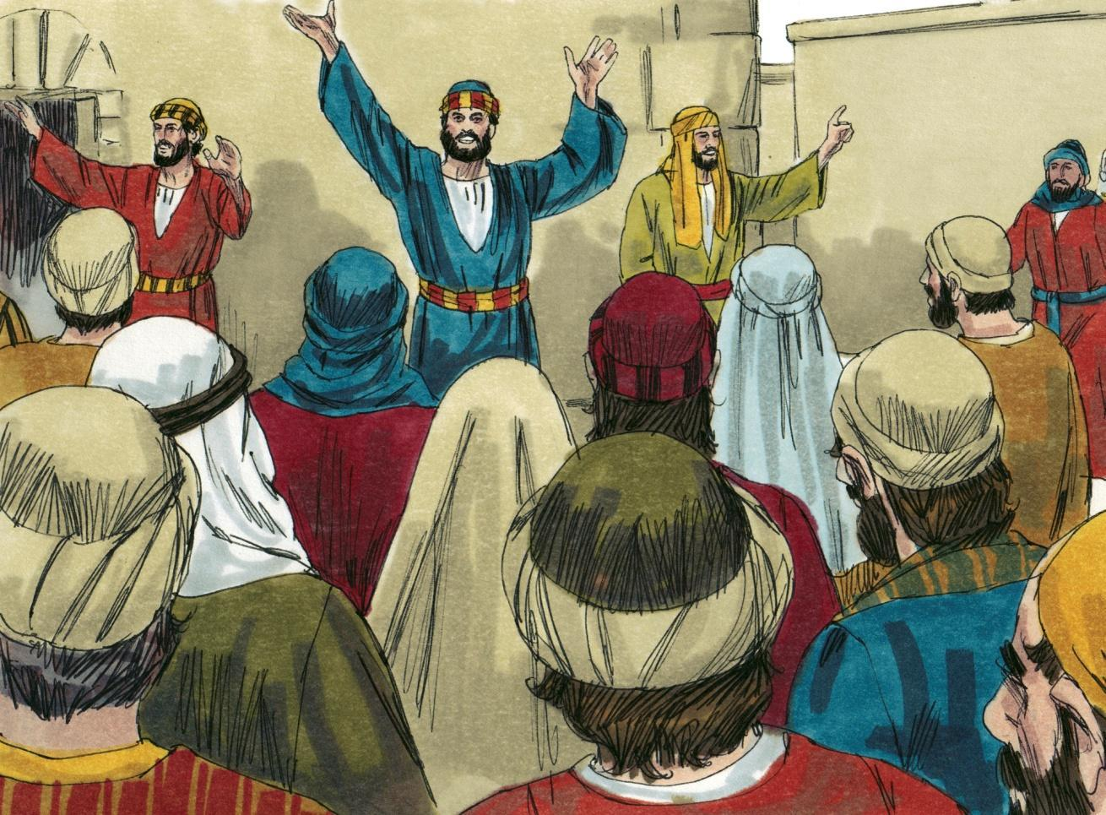
Source: Sweet Publishing - for illustration purposes of the Day of Pentecost only

As they devoted themselves to the apostles’ teaching, they also broke bread and prayed together. The apostles did many wonders and signs. The believers shared everything with one another. They sold their property and possessions so that everyone had plenty (Acts 4:32-35). Everyday they worshiped together in the temple. They broke bread together and they joyfully shared their meals together. They continually praised God, and many people were saved (Acts 2:42-47).
当他们全身心投入使徒的教导时，他们还一起擘饼祈祷。 使徒行了许多奇事和神迹。 信徒们彼此分享一切。 他们变卖了自己的财产，好让每个人都充足（使徒行传 4:32-35）。 他们每天都在圣殿里一起敬拜。 他们一起掰面包，一起快乐地分享饭菜。 他们不断地赞美神，许多人得救（使徒行传 2:42-47）。
However, the rulers of Israel did not want to repent of their sins. The healing of the lame beggar at the gate of the temple caused them to persecute the apostles (Acts 3:1-10). The priests and the Sadducees put Peter and John in jail (Acts 4:1-3). After threatening them, they let them go (Acts 4:21). But Peter and John could not stop speaking about what they saw, and many people were saved (Acts 4:14-21. The high priest and the Sadducees were jealous, and they put them in a public jail. During the night, an angel of the Lord let them out (Acts 5:17-19).
然而，以色列的统治者并不想悔改他们的罪。当他们听说使徒在圣殿门口治好了跛脚的乞丐，他们便迫害使徒（使徒行传 3:1-10）。 祭司和撒都该人把彼得和约翰关在监狱里（使徒行传 4:1-3）。 威胁了他们之后，便放他们走了（使徒行传 4:21）。但彼得和约翰不能停止谈论他们所看到的，许多人都得救了（使徒行传 4:14-21。大祭司和撒都该人嫉妒，把他们关在公共监狱里。夜间，主派一位天使把他们放了出来（使徒行传 5:17-19）。
Finally, Israel failed the third test when they stoned a Spirit-filled Stephen. The witnesses laid aside their robes at the feet of a young man named Saul. Falling on his knees, Stephen cried out with a loud voice, “Lord, do not charge them with this sin” (Acts 7:54-60).
最后，以色列在第三次考验中失败了，他们用石头打死了被圣灵充满的司提反。见证人把他们的袍子放在一个名叫扫罗的年轻人脚前。司提反跪倒在地，大声喊道：“主啊，不要把这罪归给他们”（使徒行传 7:54-60）。
Thus the rulers of Israel have rejected the risen Lord and they have resisted His Holy Spirit. Jesus had predicted His rejection by Israel (Matthew 21:42-46). He had said in Matthew 12:31 that blasphemy against the Spirit shall not be forgiven. Unbelief blocks traffic on KINGDOM HIGHWAY. Unbelief always brings sorrow and trouble. The apostles saw the risen Christ, and they were His powerful witnesses.
因此，以色列的统治者拒绝了复活的主，他们抗拒了他的圣灵。耶稣曾预言他会被以色列拒绝（马太福音 21:42-46）。 他在马太福音 12 章 31 节中说过，亵渎圣灵的行为是不得赦免的。 不信阻碍了王国公路的交通。 不信总是带来悲伤和麻烦。 使徒们看到了复活的基督，他们是他有力的见证人。
Today we believers who live at GRACE AIRPORT have not seen the risen Christ. Yet, we have the record of His death, burial and resurrection on the third day in the Bible. God expects us to believe His Word (2 Timothy 2:15, 3:16; Hebrews 4:12).
今天我们住在恩典机场的信徒还没有看到复活的基督。然而，我们在圣经中有关于祂第三天受死、埋葬和复活的记载。上帝希望我们相信他的话语（提摩太后书 2:15, 3:16；希伯来书 4:12）。
Peter became a good traffic policeman. He pointed the Jews to Christ as the only way of salvation. What kind of traffic policeman are you? God wants each of us to direct people to get aboard SALVATION LINER. Peter preached, “Nor is there salvation in any other, for there is no other name under heaven given among men by which we must be saved” (Acts 4:12).
彼得成了一名优秀的交通警察。他向犹太人指出基督是唯一的救赎之道。你是怎样的交警？ 上帝希望我们每个人都引导人们登上救世班轮。彼得宣讲：“除此以外，别无拯救，因为在天下人间，没有赐下别的名，我们可以靠着得救”（使徒行传 4:12）。
MEMORY VERSE: “Nor is there salvation in any other, for there is no other name under heaven given among men by which we must be saved” (Acts 4:12).
背诵经文：“除此以外，别无拯救，因为在天下人间，没有赐下别的名，我们可以靠着得救”（使徒行传 4:12）。
*Pentecost- the 50th day after the Sabbath of Passover week (Leviticus 23:15-16). It is also called the Feast of Weeks and the Feast of the Harvest (Exodus 23:16; Deuteronomy 16:10).
*五旬节-逾越节安息日后的第 50 天（利未记 23:15-16）。 它也被称为七七节和丰收节（出埃及记 23:16；申命记 16:10）。

LESSON 20 – WORKSHEET
Look up the Scripture references and you will find the answers to the following WHAT questions.查阅圣经参考资料，您将找到以下 WHAT 问题的答案。
- WHAT did the apostles ask the Lord Jesus about the KINGDOM when He appeared to them after His resurrection? Acts 1:6. _______________________________________ ______________________________________________________________________
当主耶稣复活后向他们显现时，使徒们问了主耶稣什么关于天国的事？ 使徒行传 1:6。
- WHAT did the Lord Jesus answer? Acts 1:7. __________________________________ ______________________________________________________________________
主耶稣回答了什么？ 使徒行传 1:7。
- WHAT did the Lord Jesus tell the apostles they would receive when the Holy Spirit came upon them? Acts 1:8. _______________________________________________
当圣灵降临在使徒身上时，主耶稣对使徒说了什么？ 使徒行传 1:8。
- WHAT were the apostles to become? Acts 1:8. ________________________________ ______________________________________________________________________
使徒要成为什么？ 使徒行传 1:8。
- WHAT did Peter on the Day of Pentecost tell the Israelites to do? Acts 2:38. _________ ______________________________________________________________________
彼得在五旬节那天告诉以色列人做什么？ 使徒行传 2:38。
- WHAT was the reason that God gave the Israelites another opportunity to repent after they had crucified Christ? Luke 23:34 _______________________________________ ______________________________________________________________________
是什么原因让以色列人在把基督钉在十字架上之后，又给他们一次悔改的机会？ 路加福音 23:34
- WHAT promise was made to Peter? Matthew 16:19.
对彼得做了什么承诺？ 马太福音 16:19。
______________________________________________________________________
______________________________________________________________________

- WHAT promise should encourage us to labor for our Lord? 1 Corinthians 3:8.
什么应许可以鼓励我们为主作工？哥林多前书3:8。__________________________________________________________________________________________________________________

- WHAT is the message which we give out as we direct travel in GRACE AIRPORT, and invite people to get aboard SALVATION LINER? Romans 10:9,10. _______________________________________________________________ ______________________________________________________________________
我们在恩典机场 直接旅行，并邀请人们乘坐 救世班轮 时传递的信息是什么？ 罗马书 10:9,10。
- Write Acts 4:12: ________________________________________________________
______________________________________________________________________
写使徒行传 4:12

