LESSON 2 – THE FIRST CHILDREN ON THE HIGHWAY OF LIFE
第 2 课 – 生命大道上的第一个孩子
Genesis 4:1-16
创世记 4:1-16
THEME: To show that without faith it is impossible to please God.
主题：表明没有信仰就不可能取悦上帝。

What is the most wonderful gift that God can give to a family? It’s a baby! Only God can make this wonderful gift.

上帝能给一个家庭的最美妙的礼物是什么？ 是一个婴儿！ 只有上帝才能创造如此美妙的礼物。

As we travel along THE HIGHWAY OF LIFE we will see many babies. In this lesson, we are going to learn about the first children who were born into this world. Adam and Eve were never babies because God created them as adults.

当我们沿着生命大道旅行时，我们会看到许多婴儿。在本课中，我们将了解第一批出生在这个世界上的孩子。亚当和夏娃从来都不是婴儿，因为上帝把他们创造为成年人。

After Adam and Eve sinned, they were driven out from the Garden of Eden (Genesis 3:23-24). When Eve gave birth, she said, “I have acquired a man from the Lord” (Genesis 4:1). She may have thought that the baby was the One promised in Genesis 3:15 who was to conquer satan.

亚当和夏娃犯罪后，他们被赶出伊甸园（创世记 3:23-24）。当夏娃生产时，她说：“我从主那里得了一个男人”（创世记 4:1）。 她可能认为这个婴儿就是创世记 3:15 中应许要征服撒旦的那一位。

The first son was named Cain. The second son was called Abel. There were two children on THE HIGHWAY OF LIFE.

第一个儿子名叫该隐。 第二个儿子叫亚伯。 生命大道上有两个孩子。

Remember the verse from Lesson 1: “There is a way that seems right to a man…”? Which way do you think these two boys chose? Adam and Eve showed their sons the way of the blood sacrifice by which obedience to God was required. The only requirement was that they worship God in the way He had commanded.

还记得第 1 课中的经文：“有一条路，人觉得是对的……”？ 你认为这两个男孩选择了哪种方式？ 亚当和夏娃向他们的儿子展示了需要顺服上帝的血祭方式。唯一的要求是他们按照上帝所吩咐的方式敬拜上帝。

Abel became a shepherd, while Cain became a farmer. Each boy was old enough to make his own choice in the way he would go. This time comes to all of us. Our parents cannot make this choice for us.

亚伯成了牧羊人，该隐成了农夫。每个男孩都足够大，可以自己选择自己要走的路。 这一次轮到了我们。 我们的父母不能为我们做出这样的选择。

Cain probably thought, “See this beautiful fruit from the ground. I have worked hard to grow it, and God will be pleased with my offering.” He placed the fruit on an altar. Was God pleased with the works of the hands of Adam and Eve? No, God was not satisfied with their fig leaf covering. These offerings are called works.
该隐可能想：“看看这从地里长出来的美丽果实吧。 我一直在努力种植它，上帝会对我的奉献感到满意。” 他把水果放在祭坛上。上帝对亚当和夏娃的所作所为满意吗？不，上帝不满足于他们用无花果叶做的衣服。这些供品称为工作。
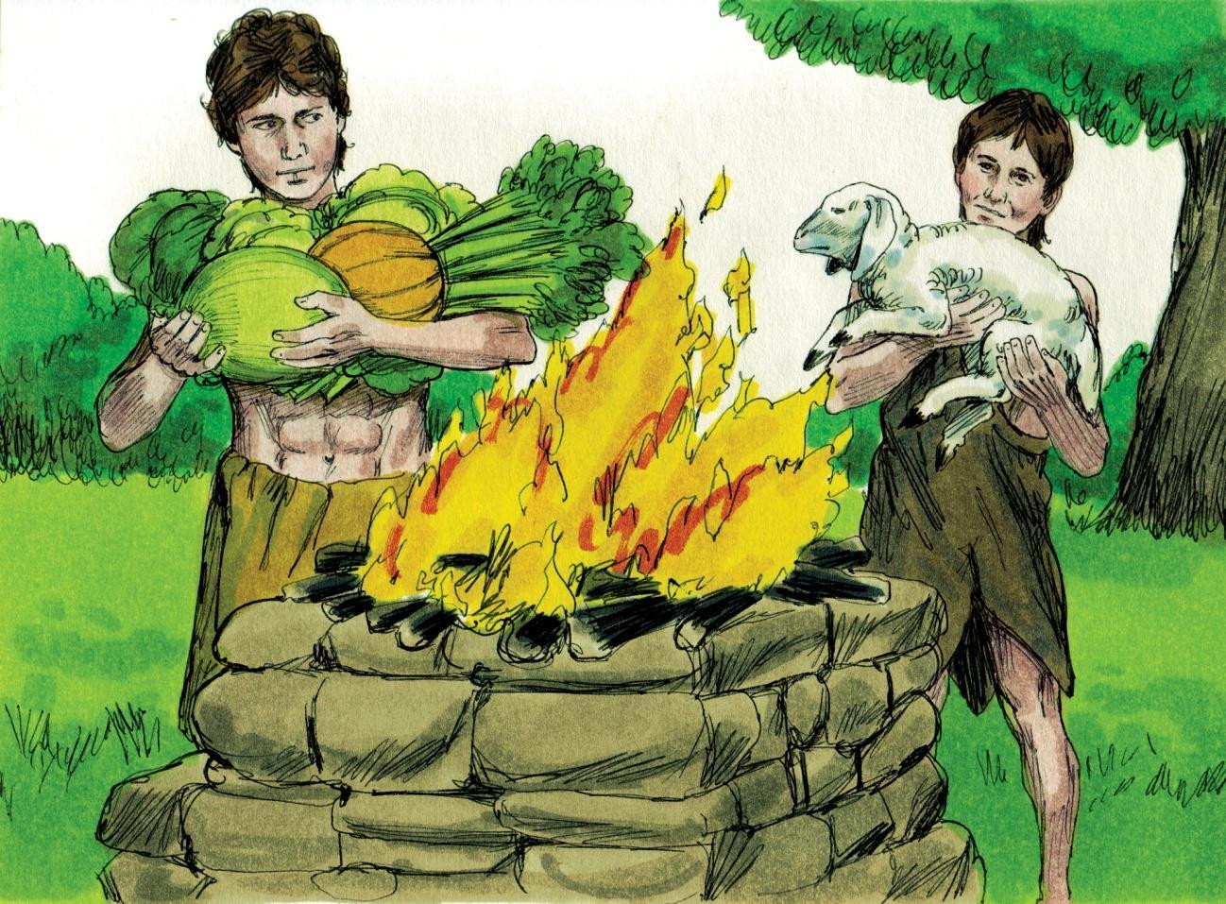
Source: Sweet Publishing - for illustration purposes of Genesis 4:3-4 only
However, Abel took one of his best lambs and he killed it. He placed it upon the altar as an offering to God. He offered God a blood sacrifice as God had demonstrated with Adam and Eve.

然而，亚伯献上他最好的羔羊并将其杀死。他把它放在祭坛上，作为献给上帝的祭品。他向上帝献上血祭，正如上帝向亚当和夏娃展示的那样。

Cain and Abel were born as sinners. God accepted Abel’s offering, but He did not accept Cain’s offering. Cain became very angry, and he killed his brother Abel. God was not pleased with the first murder in the world. God punished Cain and he had to wander in other lands (Genesis 4:6-16).

该隐和亚伯生来就是罪人。神接受了亚伯的供物，但他没有接受该隐的供物。该隐非常生气，他杀了他的兄弟亚伯。上帝对世界上第一次谋杀案很不高兴。 上帝惩罚了该隐，他不得不流落到其他地方（创世记 4:6-16）。

Cain and Abel were brought up in the same family and they were taught the same truths. The difference was that Abel believed in what he was taught. Cain did not have faith in what he was taught. Their actions showed what was in their hearts.
该隐和亚伯在同一个家庭长大b他们被教导同样的真理。不同的是，亚伯相信他所教的。 该隐并他被教导的事情，他们的行动表明了他们的内心。

Unbelief is a terrible thing. It led to anger, deceit, murder, lies and separation from God (Genesis 4:8-12). Belief/faith brought peace and righteousness to Abel. Hebrews 11:6 says: “But without faith it is impossible to please Him...”

不信是一件可怕的事情。它导致愤怒、欺骗、谋杀、谎言和与上帝分离（创世记 4:8-12）。 信仰/信仰给亚伯带来了和平与公义。 希伯来书 11:6 说：“但没有信心，就不可能取悦他……”

Whether we live in the age of Grace, or in any other dispensation, FAITH is required to be accepted by God. God saw Abel’s sacrifice and the animal’s shed blood. God saw the Lord Jesus Christ as the true Lamb Who was chosen before the foundation of the world (1 Peter 1:19-20). Today we do not show our faith by bringing a lamb to an altar. In this age of Grace, we come by faith in the Lord Jesus Christ and we trust Him as our Saviour.

无论我们生活在恩典时代，还是任何其他时代，信仰都需要被上帝接纳。 上帝看到了亚伯的牺牲和动物的血。 神视主耶稣基督为真羔羊，在创世之前就被拣选（彼得前书 1：19-20）。今天，我们不会通过将羊羔带到祭坛上来表明我们的信心。 在这个恩典时代，我们通过相信主耶稣基督而表明我们的信仰，我们信靠他为我们的救主。

We have seen the truth of the verse: “There is a way that seems right…” Abel chose the right way, and Cain took the wrong way on THE HIGHWAY OF LIFE. The Bible says that many went in Cain’s way (Jude 11). They are the ones who departed from God. They depended on their own works to save them. Nothing we do with our hands nor with our bodies can bring us eternal salvation.

我们已经看到了这节经文的真相：“有一条路似乎是对的……”亚伯选择了正确的路，而该隐在生命大道上选择了错误的路。 圣经说许多人走该隐的路（犹大书 11）。 他们是离开上帝的人。 他们依靠自己的作为来拯救他们。 我们用手和身体所做的任何事情都不能给我们带来永恒的救赎。

In this age of Grace, we prove our faith to the Lord Jesus and we tell Him: I believe You died for my sins and that You were buried and that You rose on the third day. I thank You for the sacrifice, and I believe that You give me Your wonderful righteousness as You have promised it.

在这个恩典的时代，我们向主耶稣表明我们的信仰，我们告诉他：我相信你为我的罪而死，你被埋葬了，你在第三天复活了。我感谢你的牺牲，我相信你将你所应许的奇妙公义赐给我。

MEMORY VERSE: “But without faith it is impossible to please Him: for he that comes to God must believe that He is, and that He is a rewarder of those who diligently seek Him” (Hebrews 11:6).

背诵经文：“但没有信心，就不可能取悦他：因为到上帝面前来的人必须相信他是，并且他是那些殷勤寻求他的人的奖赏”（希伯来书11：6）。

LESSON 2 – WORKSHEET
第 2 课 – 练习
- Write the names of the first two children on THE HIGHWAY OF LIFE.
写下生命大道上前两个孩子的名字。创世记 4:1-2
Genesis 4:1-2 ___________________ and _______________________________

- What work did Abel do? Genesis 4:2 ______________________________
亚伯做了什么工作？ 创世记 4:2
- What work did Cain do? Genesis 4:2 ______________________________
该隐做了什么工作？ 创世记 4:2
- Why was God not pleased with Cain’s offering? Hebrews 11:6
为什么上帝不喜欢该隐的供物？ 希伯来书11:6
______________________________________________________________

- Why was God pleased with Abel’s offering? Hebrews 11:4
为什么神喜欢亚伯的供物？ 希伯来书 11:4
_________________________________________________ _______

- Why was Abel’s offering better than Cain’s offering? Hebrews 9:22
为什么亚伯的供物比该隐的供物更好？ 希伯来书 9:22
____________________________________________________

- Abel proved his faith by the offering which he brought and he obtained witness from God that he was ____________________________________ Hebrews 11:4.
亚伯用他带来的祭品证明了他的信心，他从上帝那里得到了见证，他是____________________________________希伯来书 11:4。

- Abel’s offering was an example of the
亚伯的奉献就是一个_________________________________ ___例子
_________________________________________________________________.

- Today we receive righteousness by believing
今天我们因信_________________________________ ___而得义__________________________________________________________________1 Corinthians 15:1-41 哥林多前书 15:1-4

- Write Hebrews 11:6 写下希伯来书 11:6
____________________________________________________ ______

