LESSON 19 – CALVARY’S MOUNTAIN SHADOWS KINGDOM HIGHWAY
第 19 课 – 骷髅地山遮蔽了王国大道
Matthew – Mark – Luke - John
马太福音- 马可福音- 路加福音-约翰福音
THEME: To teach the identification of believers with Christ in death, burial and resurrection.
主题： 教导信徒在死亡、埋葬和复活中与基督相认。
We are coming closer to MOUNT CALVARY. In our last lesson, John the Baptist prepared the way for the King. He told the Israelites to repent of their sin and be baptized. When Jesus was baptized, He identified Himself with His people. Today we will see that Christ had another baptism. It was a baptism into death.
我们离骷髅地山越来越近了。在我们的最后一课中，施洗约翰为君王铺平了道路。他告诉以色列人要悔改他们的罪并受洗。当耶稣受洗时，他向他的子民展示了身份。今天我们将看到基督再次受洗。 这是对死亡的洗礼。
Before Jesus entered Jerusalem riding upon a colt, He asked His disciples: “Who do men say that I, the Son of Man, am?” (Matthew 16:13-19, 21:5) Christ called the believing Israelites His church (Matthew 16:18). The word ‘church’ means a called out group.
耶稣骑着驴驹进入耶路撒冷之前，他问门徒：“人说我，人子，是谁？”（马太福音16:13-19，21:5）基督称相信的以色列人为他的教会（马太福音16:18）。“教会”一词的意思是呼召的团体。
In the Millennial Kingdom, Israel will be a nation of priests to lead the Gentiles to Christ the King. This separated group will be the Kingdom Church. It will be built upon Christ Himself, as He is the chief cornerstone (Matthew 21:42). Peter was given the keys to first open the door of faith to the Jews (Matthew 16:19). Christ made this promise to Peter.
在千年国度中，以色列将成为一个祭司国度，带领外邦人归向君王基督。这个分离的团体将是王国教会。 它将建立在基督自己之上，因为他是房角石（马太福音 21:42）。 彼得得到了首先向犹太人打开信仰之门的钥匙（马太福音 16:19）。 基督向彼得作出了这个应许。
Then He told His disciples that He must suffer and die before the Kingdom could be established (Matthew 16:21). Christ explained that His suffering and death was His death baptism (Luke 12:50). He said, “You know that after two days is the Passover, and the Son of Man will be delivered up to be crucified” (Matthew 26:1-2).
然后他告诉他的门徒，在建立王国之前，他必须受苦受难（马太福音 16:21）。基督解释说，他的受苦和死是他的死亡洗礼（路加福音 12:50）。他说，“你们知道，过两天就是逾越节，人子要被交出来钉在十字架上”（马太福音26：1-2）。
As Jesus and the disciples ate the Passover feast, Jesus said: “Assuredly, I say to you, one of you will betray Me” (Matthew 26:21-25). After singing a hymn, they went out to the Mount of Olives. In the Garden of Gethsemane Jesus prayed, “O My Father, if it is possible, let this cup pass from Me; nevertheless, not as I will, but as You will” (Matthew 26:36-45).
当耶稣和门徒吃逾越节的筵席时，耶稣说：“我实在告诉你们，你们中间要有人出卖我”（马太福音 26:21-25）。 唱了一首赞美诗后，他们就去了橄榄山。 耶稣在客西马尼园祷告说：“我的父啊，如果可能的话，让这杯离开我吧！ 然而，不要照我的意思，只要照你的意思”（马太福音 26：36-45）。
While He was still speaking to the disciples, Judas Iscariot came up with a large crowd. They had swords and clubs. After Judas Iscariot kissed him, they arrested Him (Matthew 26:47-56).
当他还在对门徒说话的时候，加略人犹大带着一大群人走了过来。 他们有剑和棍棒。 加略人犹大吻了他之后，他们逮捕了他（马太福音 26:47-56）。
Then Jesus was brought before the high priest named Caiaphas, and He was falsely accused (Matthew 26:57-61). The high priest said to Him, “I put You under oath by the living God: Tell us if You are the Christ, the Son of God” (Matthew 26:63). Jesus said to him, “It is as you said. Nevertheless, I say to you, hereafter you will see THE SON OF MAN SITTING AT THE RIGHT HAND OF THE POWER and COMING ON THE CLOUDS OF HEAVEN” (Matthew 26:64). Then the high priest tore his clothes and said, “He has spoken blasphemy! What further need do we have of witnesses? Look, now you have heard His blasphemy! What do you think?” They answered, “He is deserving of death!” (Matthew 26:57-68).
然后耶稣被带到大祭司该亚法面前，他被诬告（马太福音 26:57-61）。 大祭司对他说：“我借着永生上帝向你起誓：告诉我们你是不是基督，是上帝的儿子”（马太福音 26:63）。 耶稣对他说：“正如你所说。 然而，我告诉你们，以后你们会看到人子坐在那掌权者的右边，驾着天上的云彩降临”（马太福音 26:64）。大祭司就撕破衣服说：“他说亵渎的话！我们还需要什么证人？看，现在你已经听到了他的亵渎！你怎么看？”他们回答说：“他该死！”（马太福音 26:57-68）。
Then Jesus stood before the governor of Judea named Pilate. He asked Him, “Are You the King of the Jews?” Jesus answered, “It is as you say” (Matthew 27:11). The soldiers stripped Him, and they put a scarlet robe on Him. After they put a crown of thorns on His head, they placed a reed in His right hand. They mocked Him, saying, “Hail, King of the Jews!” Then they spit on Him, and they hit Him on the head. This suffering happened just as the prophets had prophesied on MOUNT CALVARY (Matthew 27:27-30).
然后耶稣站在犹大省长彼拉多面前。 他问他：“你是犹太人的王吗？” 耶稣回答说：“正如你所说的”（马太福音 27:11）。 士兵们剥去他的衣服，给他穿上一件朱红色的长袍。 他们把荆棘冠冕戴在他头上之后，又把一根芦苇放在他的右手上。 他们嘲笑他说：“万岁，犹太人的王！” 然后他们朝他吐唾沫，打他的头。这种苦难发生了，正如先知在髑髅山上所预言的那样。（马太福音 27:27-30）。

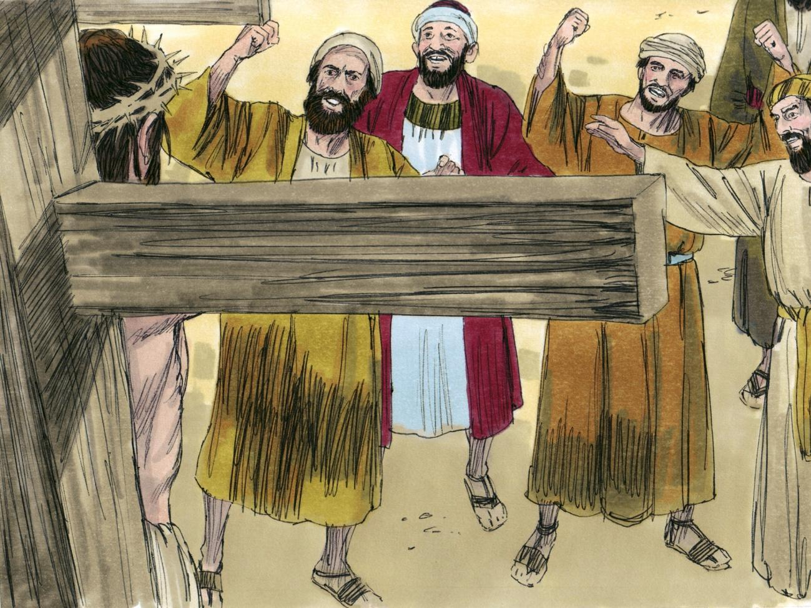
Source: Sweet Publishing - for illustration purposes of the crucifixion of the Lord Jesus Christ only

Next, they led Him to Golgotha which means, “Place of a Skull.” Then they nailed Him to the cross. The soldiers put above His head a sign which read: “THIS IS JESUS THE KING OF THE JEWS” (Matthew 27:33-37).
接下来，他们把他带到了骷髅地，意思是“骷髅之地”。 然后他们把他钉在十字架上。士兵们在他的头顶上放了一个牌子，上面写着：“这是犹太人的王耶稣”（马太福音 27:33-37）。
At that time, there were two thieves who were crucified with Jesus. One thief was on the right, and the other thief was on the left (Matthew 27:38). The one who chose the way of life said to Jesus, “Lord, remember me when You come into Your kingdom!” And He said to him, “Assuredly, I say to you, today you will be with Me in Paradise” (Luke 23:39-43).
那时，有两个小偷与耶稣同钉十字架。一个贼在右边，另一个贼在左边（马太福音 27:38）。 选择生命之道的人对耶稣说：“主啊，当你进入你的国度时，记得我！” 他对他说：“我实实在在地告诉你，今天你将在天堂与我同在”（路加福音 23:39-43）。
During the sixth hour (12 noon), darkness covered the whole land until the ninth hour (3:00 PM). Then the veil of the temple was torn in two (Luke 23:44-45). After Jesus had received the sour wine, He said, “It is finished!” (John 19:30). Then Jesus cried out with a loud voice, saying, “Father, into Your hands I commit My Spirit” (Luke 23:46).
在第六个小时（中午 12 点），黑暗笼罩了整个大地，直到第九个小时（下午 3:00）。 然后圣殿的幔子被撕成两半（路加福音 23:44-45）。 耶稣接过酸酒后，说：“成了！” （约翰福音 19:30）。 然后耶稣大声喊着说：“父啊，我将我的灵交在你手中”（路加福音 23:46）。
When it was evening, a follower of Jesus named Joseph from Arimathea, asked Pilate for the body of Jesus. Joseph took the body and he wrapped it in a clean linen cloth. Then he laid it in a new tomb. A large stone was rolled against the entrance of it (Matthew 27:57-60).
到了晚上，一个跟随耶稣的名叫约瑟的亚利马太人向彼拉多要耶稣的身体。约瑟运走尸体，用干净的亚麻布包裹起来。然后他把它放在一个新的坟墓里。用一块大石头挡住入口（马太福音 27：57-60）。
On the third day, our Saviour rose from the dead! (Matthew 28:1-8). Jesus did not deserve to die because He never sinned.
第三天，我们的救主从死里复活了！（马太福音 28:1-8）。耶稣不该死，因为他从未犯罪。
- It was our sins which nailed Jesus to the cross (1 Corinthians 15:3-4). He wore the scarlet robe of humility so that we might wear a robe of righteousness.
是我们的罪将耶稣钉在了十字架上（哥林多前书 15:3-4）。 他穿着谦卑的朱红色袍，好叫我们穿上公义的袍子。
- Jesus wore a crown of thorns so that we might wear a crown of righteousness (2 Timothy 4:8).
耶稣戴上荆棘冠冕，好让我们戴上公义的冠冕（提摩太后书 4:8）。
- Jesus died our death. Then He arose, and now He gives us His resurrection life (Romans 6:4). When we trust Jesus as our personal Saviour, the Holy Spirit baptizes us into the Body of Christ (Christ’s Church of today). Then we are identified with Christ so that His death baptism becomes our baptism, His burial our burial, and His resurrection our resurrection. As new creations in Christ, we should “walk in newness of life” (Romans 6:4).
耶稣替我们而死。然后他复活了，现在他给了我们他复活的生命（罗马书 6:4）。 当我们相信耶稣是我们个人的救主时，圣灵就会为我们受洗进入基督的身体（今天的基督教堂）。 然后我们与基督相认，使祂的死亡洗礼成为我们的洗礼，祂的葬礼成为我们的葬礼，祂的复活成为我们的复活。作为在基督里的新造，我们应该“行在新的生命里”（罗马书 6:4）。

MEMORY VERSE: “Therefore we were buried with Him through baptism into death, that just as Christ was raised from the dead by the glory of the Father, even so we also should walk in newness of life” (Romans 6:4).
背诵经文：“所以我们借着洗礼与祂一同埋葬到死里，正如基督借着父的荣耀从死里复活一样，我们也要照样行在新的生命里”（罗马书 6:4）。

LESSON 19 – WORKSHEET
The following statements are either True or False. Find the Bible references and write inside the brackets a (T) for those that are true, and a (F) for those that are false.
以下陈述为真或假。 找出圣经的参考文献，在括号内写上 (T) 代表正确的，而 (F) 代表错误的。
- ( ) The prophets saw Christ suffering for our sins on Mount Calvary. Psalm 22:16.
先知们看到基督在髑髅地为我们的罪受苦。 诗篇 22:16。
- ( ) Christ spoke of His coming death as a baptism. Luke 12:50.
基督谈到他即将到来的死亡是一个洗礼。 路加福音 12:50。
- ( ) Pilate asked Jesus if He was the King of the whole world. Matthew 27:11
彼拉多问耶稣他是不是全世界的王。 马太福音 27:11
- ( ) Christ had to die because He sinned. 1 Corinthians 15:3, Hebrews 7:26.
基督必须死，因为他犯罪了。哥林多前书15：3，希伯来书7：26。
- ( ) At the moment we trust Christ as Saviour, we are baptised into His death. Romans 6:3-4.
在我们相信基督为救主的那一刻，我们就受洗归入祂的死。 罗马书 6:3-4。
- ( ) Only the Spirit of Christ arose from the grave. Luke 24:37-39.
只有基督的灵从坟墓中升起。 路加福音 24:37-39
- ( ) We, believers in Christ, are not only baptised into Christ’s death, but we are raised up with Him in newness of life. Romans 6:4.
我们这些在基督里的信徒，不仅受洗归入基督的死，而且在新生命中与祂一同复活。 罗马书 6:4。
- ( ) The baptism of the Holy Spirit makes us, believers in Christ, members of a church here on the earth. 1 Corinthians 12:13.
圣灵的洗礼使我们这些相信基督的人成为地球上教会的成员。 哥林多前书 12:13。

- Write a brief description of the crucifixion of the Lord Jesus Christ.
写下主耶稣基督被钉十字架的简短描述。 ___________________________________________________________________________________________________________________________________________________________________________________________________________________________________________________________________________________________________________________________________________________________________________________________________________________________________________________________________________________________________________________________________________________________________________________________________________________________________________________________________________________________________________________________.

- Write Romans 6:4: ______________________________________________________ ______________________________________________________________________
写下罗马书 6:4：

