LESSON 18 – BEHOLD, YOUR KING IS COMING TO YOU
第 18 课 – 看哪，你的王要来找你了
Matthew – Mark – Luke - John
马太福音- 马可福音- 路加福音-约翰福音
THEME: To teach the identification of Christ with His people.
主题： 教导基督与祂子民的相认。
After the prophet Nehemiah rebuilt the walls of Jerusalem, God was silent for more than 450 years. Suddenly a voice spoke! It was the prophet John the Baptist. He said, “Repent, for the kingdom of heaven is at hand!” (Matthew 3:2).
先知尼希米重建耶路撒冷城墙后，神沉默了450多年。突然一个声音响起！ 是先知施洗约翰。 他说：“悔改吧，因为天国近了！” （马太福音 3:2）。
About thirty years before John spoke this message, a baby had been born in Bethlehem. His name was JESUS. It means “Yahweh is salvation” or “Yahweh saves.” He would save His people from their sins (Matthew 1:21-23).
大约在约翰讲这个信息的三十年前，一个婴儿在伯利恒出生。他的名字是耶稣。它的意思是“耶和华是拯救”或“耶和华拯救”。祂要将祂的子民从罪恶中拯救出来（马太福音 1:21-23）。
Very little was heard of the child born in Bethlehem until John the Baptist came preaching, “Repent!” “Then Jerusalem, all Judea, and all the region around the Jordan went out to him and were baptized by him in the Jordan, confessing their sins” (Matthew 3:5-6). The baptism with water was the way Israel was to prepare for their King.
直到施洗约翰来传道：“悔改！”之前，很少有人听到关于伯利恒出生的孩子的消息。 “于是耶路撒冷和犹太全地，并约旦河一带的全地，都出来到他那里去，在约旦河里受他的洗，承认自己的罪”（马太福音 3:5-6）。水洗礼是以色列为他们的君王做准备的方式。
When John saw Jesus coming to him, he said, “Behold! The Lamb of God who takes away the sin of the world!” (John 1:29). John did not want to baptize Jesus because Jesus was not a sinner. Baptism was a sign to Israel of washing away their sins (Acts 22:16). Yet, Jesus replied, “Permit it to be so now, for thus it is fitting for us to fulfill all righteousness...” (Matthew 3:15). Then Jesus saw the Spirit of God “...descending like a dove and alighting upon Him” (Matthew 3:16). God spoke from heaven saying, “This is My beloved Son, in whom I am well pleased” (Matthew 3:17). Thus, the Trinity was present at the baptism.
约翰看见耶稣来到他身边，就说：“看哪！除去世人罪孽的神的羔羊！”（约翰福音 1:29）。约翰不想为耶稣施洗，因为耶稣不是罪人。洗礼是以色列洗清罪孽的标志（使徒行传 22:16）。 然而，耶稣回答说：“现在就这样吧，因为我们应该圆满一切的公义……”（马太福音 3:15）。然后耶稣看到神的灵“……像鸽子一样降下，落在他身上”（马太福音 3:16）。神从天上说：“这是我的爱子，我所喜悦的”（马太福音 3:17）。 因此，三位一体在洗礼中出现了。
Then the Holy Spirit led Jesus into the wilderness to be tempted three times by the devil. For every temptation, Jesus quoted the Word of God. The devil finally left Him alone. Are you able to quote God’s Word to defeat temptations?
然后圣灵带领耶稣到旷野受魔鬼试探三次。对于每一个试探，耶稣都引用了上帝的话语。 魔鬼终于离开了他。 你能引用上帝的话语来战胜试探吗？
Jesus’ earthly ministry began when he was thirty years old. He preached, “Repent, for the kingdom of heaven is at hand!” (Matthew 4:17). Jesus proved Himself to be the Son of God. The prophets foretold that He would come. He did countless miracles including healing the sick and the blind. He calmed the waves and He walked on the sea. He also casted out demons, and He raised the dead.
耶稣在地上的事工从他三十岁开始。他宣讲：“悔改吧，因为天国近了！”（马太福音 4:17）。耶稣证明自己是神的儿子。先知预言祂会来。他创造了无数的奇迹，包括治愈病人和盲人。 他平息了波涛，他在海面上行走。 他也赶鬼，使死人复活。
Jesus chose twelve disciples to train. He gave them authority over unclean spirits to cast them out. They also healed people from disease and sickness (Matthew 10:1). Jesus gave them orders. “Do not go into the way of the Gentiles, and do not enter a city of the Samaritans. But go rather to the lost sheep of the house of Israel…saying, ‘The kingdom of heaven is at hand.’ Heal the sick, cleanse the lepers, raise the dead, cast out demons. Freely you have received, freely give…” (Matthew 10:5-10).
耶稣挑选了十二个门徒来训练。祂赐给他们管辖污灵的权柄，把他们赶出去。他们还治愈了人们的疾苦和病患（马太福音 10:1）。 耶稣吩咐他们。“不要走外邦人的道路，不要进入撒玛利亚人的城市而是去找以色列家迷失的羊……说：“天国近了。”医治病人，洁净麻风病人，使死人复活，赶鬼。 你白白地接受，也要白白地给予……”（马太福音 10:5-10）。
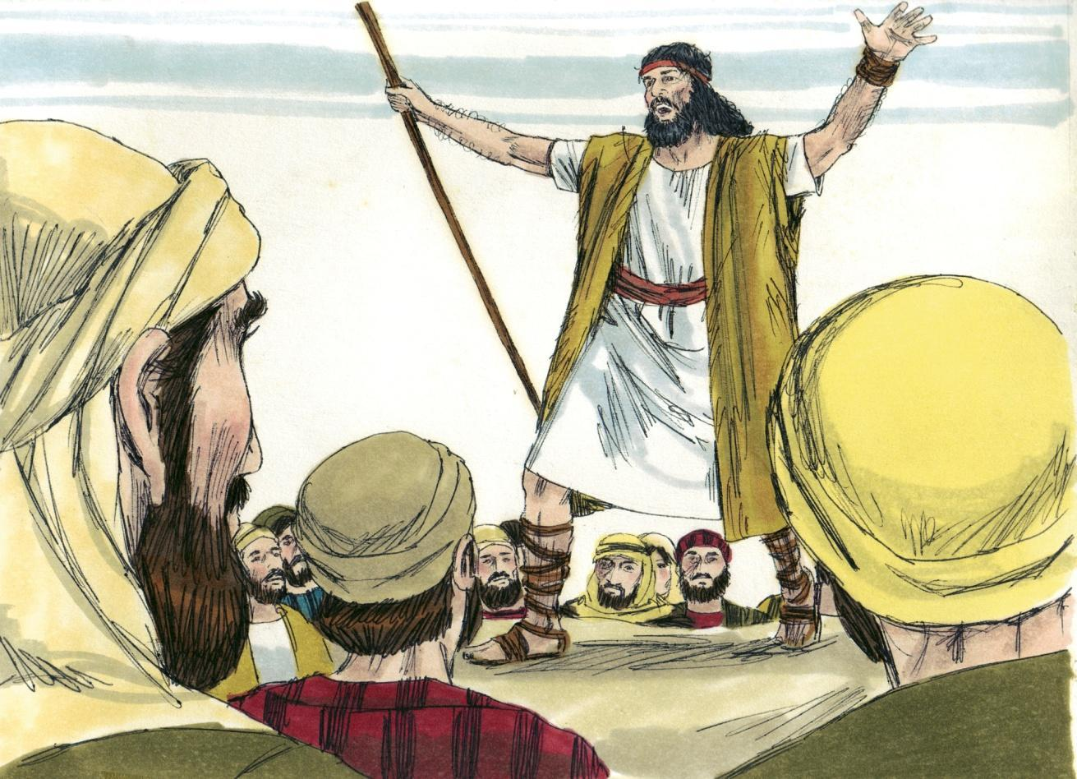
Source: Sweet Publishing - for illustration purposes of the preaching of John the Baptist only

On our chart we have been traveling KINGDOM HIGHWAY. Israel was God’s chosen nation. Recall that God gave up the Gentiles at the tower of Babel.
在我们的航程表上，我们一直在走王国大道上。 以色列是神所拣选的民族。 回想一下，上帝在巴别塔放弃了外邦人。
Jesus was in the district of Tyre and Sidon when a Canaanite (Gentile) woman said, “Have mercy on me, Lord, Son of David! My daughter is severely demon-possessed” (Matthew 15:22). After He didn’t reply, His disciples said, “Send her away, for she cries out after us.” He answered, “I was not sent except to the lost sheep of the house of Israel.” Then she worshiped Him saying, “Lord, help me!” He answered, “It is not good to take the children’s bread and throw it to the little dogs.” Then she said, “Yes, Lord, yet even the little dogs eat the crumbs which fall from their masters’ table.” Then Jesus said to her, “O woman, great is your faith! Let it be to you as you desire” (Matthew 15:23-28). And her daughter was healed at once.
耶稣在推罗和西顿地区，一个迦南（外邦）妇人说：“主啊，大卫的子孙，可怜我吧！ 我女儿被鬼附得很厉害”（马太福音 15:22）。 祂没有回答，门徒就说：“把她赶走，因为她跟在我们后面哭喊。” 他回答说：“我是被派到以色列家迷失的羊那里去的。” 然后她敬拜祂说：“主啊，帮助我！” 他回答说：“拿孩子们的面包丢给小狗是不好的。” 然后她说：“是的，主啊，但即使是小狗也吃掉主人桌子上掉下来的面包屑。” 耶稣对她说：“女人啊，你的信心真大！ 随你所愿吧”（马太福音 15:23-28）。 她的女儿立刻就痊愈了。
This Gentile woman had heard of the power of the Lord Jesus. She had come from GENTILE BYWAY to ask Him for a blessing. Jesus honoured her faith.
这位外邦妇人听说过主耶稣的大能。 她从外邦人小路上过来，向他祈求祝福。 耶稣尊重她的信仰。
The Scriptures teach that Jesus was a Prophet, a great Teacher, the King of Israel, the Messiah, and a High Priest to the kingdom of priests (Exodus 19:6; Isaiah 61:6; 1 Peter 2:9,12). When priests were ordained, the Law required them to obey rituals, including washing them with water (Exodus 29:4). That ceremonial washing was performed at Jesus’ baptism. All priests were required to be at least thirty years old (Read Numbers 4:30; Psalm 110:4; Hebrews 5:6-10).
圣经教导说，耶稣是先知、伟大的教师、以色列的国王、弥赛亚和祭司王国的大祭司（出埃及记 19:6；以赛亚书 61:6；彼得前书 2:9,12）。当祭司被受命时，律法要求他们遵守仪式，包括用水清洗（出埃及记29:4）。洗礼是在耶稣受洗时进行的。所有祭司都必须至少三十岁（请阅读民数记 4:30；诗篇 110:4；希伯来书 5:6-10）。
In our next lesson, we will see how Christ died on Calvary’s cross. He completed the work of becoming sin for us. That work is finished. You may be saved by simply believing that He died for your sins, He was buried and He was raised on the third day (1 Corinthians 15:3-4).
在下一课中，我们将看到基督如何死在髑髅地的十字架上。 他为我们完成了成为罪的工作。 那项工作就完成了。 你可以通过简单地相信他为你的罪而死，他被埋葬并在第三天复活（哥林多前书 15:3-4）而得救。
MEMORY VERSE: “For He made Him who knew no sin to be sin for us, that we might become the righteousness of God in Him” (2 Corinthians 5:21).
背诵经文：“因为祂使那无罪的，替我们成为罪，好叫我们在祂里面成为神的义”（哥林多后书 5:21）。
LESSON 18 – WORKSHEET
Fill in the blanks in the following statements.填写下列陈述中的空白。

- After more than 450 years of silence from God through His prophets, Israel heard the voice of _________________________ saying _______________________________. Matthew 3:1-3.
经过 450 多年的沉默，上帝通过他的先知们，以色列听到了____________ 说 ________ 的声音。 马太福音 3:1-3。
- Israel prepared for the coming King by _______________________________________ _________________________________. Matthew 3:6.
以色列为即将到来的君王作好准备，由 ________________________。 马太福音 3:6。
- John said that he baptised with water for repentance, but the One coming after him would baptise with __________________________________________. Matthew 3:11.
约翰说他用水施洗是为了悔改，但在他之后来的那一位会用 _______________ 施洗。 马太福音 3:11。
- Jesus said that He was baptised in order to fulfill all ____________________________ Matthew 3:15.
耶稣说他受洗是为了应验 ____________________________ 马太福音 3:15。
- Jesus gave His disciples power to perform miracles in order to prove that the King and the Kingdom of Heaven were truly at hand. Name these miracles from Matthew 10:8:
耶稣赋予祂的门徒行神迹的能力，以证明君王和天国真的近在咫尺。 说出马太福音 10:8 中的这些奇迹：__________________________________________________
___________________________________________________________
Look up the references and answer the following WHY questions?
查找参考资料并回答以下 为什么的 问题？
- WHY did Jesus tell His disciples not to go to the Gentiles? Mark 7:27.
为什么耶稣告诉他的门徒不要去外邦人那里？ 马可福音 7:27。
______________________________________________________________________
- WHY did Jesus finally honour the request of the Gentile woman? Matthew 15:28.
为什么耶稣最终答应了外邦妇女的要求？ 马太福音 15:28。
______________________________________________________________________
- WHY is this portion of THE HIGHWAY OF LIFE called KINGDOM HIGHWAY? Matthew 21:5
为什么生命大道的这一部分被称为王国大道？马太福音 21:5_____________________

- WHY is it not necessary for those who live in the Age of Grace to be baptised with water in order to receive righteousness? Acts 22:16.
为什么恩典时代的人不需要受水洗才能得义呢？ 使徒行传 22:16。____________
_____________________
- Write 2 Corinthians 5:21: _________________________________________________ ___________________________________________________________________________________________________________________________________________.
写下哥林多后书 5:21：

