LESSON 17 – THE PROPHETS SEE TWO MOUNTAIN PEAKS
第 17 课 – 先知看到两个山峰
1 Kings - Malachi
列王纪上--玛拉基书
THEME: To show the difference between prophesy and unfulfilled prophecy.
主题： 显示预言和未实现的预言之间的区别。
In this lesson we are going to cover a great distance on THE HIGHWAY OF LIFE. We will look into the distance at some mountain tops. These are called CALVARY MOUNTAIN and HOLY KINGDOM MOUNTAIN.
在本课中，我们将在生命的高速公路上行进很长的距离。我们将在一些山顶远眺。这些被称为骷髅地山和圣王国山。
In our last lesson we traveled through CAPTIVITY DEVIATION with Israel. We saw how the people turned to idolatry and they had to be punished. During that period, God called the prophets (men who spoke for God) to warn Israel of the coming judgment. These prophets also comforted the obedient people with the promises of the coming Redeemer and King.
在上一课中，我们与以色列一起经历了囚徒歧路。我们看到人们如何转向偶像崇拜，他们必须受到惩罚。在此期间，上帝呼召先知（为上帝说话的人）警告以色列即将到来的审判。这些先知还用即将到来的救赎主和君王的应许来安慰顺从的人。
However, the prophets could not understand how the Promised One could be a glorious King and also a humble, suffering servant (1 Peter 1:10-11). On our chart the suffering and the glory is illustrated by two mountain peaks: CALVARY MOUNTAIN and HOLY KINGDOM MOUNTAIN.
然而，先知们无法理解应许者如何既是一位光荣的君王，又是一位谦卑、受苦的仆人（彼得前书 1:10-11）。 在我们的航程表中，两个山峰说明了苦难和荣耀：骷髅地山 和圣王国山。
Let’s read what the prophets foretold and decide which is prophecy or unfulfilled prophecy.
让我们阅读先知的预言，并决定哪个是预言或未实现的预言。
Betrayal ______________________ Zech 11:12-13 -> Matt 26:15; 27:3-10
背叛 ______________________ 撒迦利亚书 11:12-13 -> 马太福音 26:15； 27:3-10
Vinegar and gall ________________ Psalm 69:20-21-> Matt 27:34, 48
醋和胆 ________________ 诗篇 69:20-21-> 马太福音 27:34, 48
Scoffed at _____________________ Psalm 22:7-8 -> Matt 27:39
嘲笑 _____________________ 诗篇 22:7-8 -> 马太福音 27:39
Nailed to the cross ______________ Psalm 22:16 -> Matt 27:35
钉在十字架上 ______________ 诗篇 22:16 -> 马太福音 27:35
Smitten on the cheek ____________ Micah 5:1 -> Matt 26:67; 27:30
打在脸颊上 ____________ 弥迦书 5:1 -> 马太福音 26:67； 27:30
Spit on and scourged ____________ Isaiah 50:6 -> Matt 26:67; 27:30
吐口水并鞭打 ____________ 以赛亚书 50:6 -> 马太福音 26:67； 27:30
Death and burial ________________ Isaiah 53:9 -> Matt 27:57-60
死亡和埋葬 ________________ 以赛亚书 53:9 -> 马太福音 27:57-60
Suffering for others ______________ Isaiah 53:4-7 -> Matt 26:63: 27:12-14
为他人受苦 ______________ 以赛亚书 53:4-7 -> 马太福音 26:63: 27:12-14
Numbered with transgressors ________ Isaiah 53:12 -> Mark 15:28
与犯罪者一起被编号 ________ 以赛亚书 53:12 -> 马可福音 15:28
Coming in glory __________________ Daniel 7:13
荣耀降临 __________________ 但以理书 7:13
Universal kingdom ________________ Daniel 7:14
宇宙王国 ________________ 但以理书 7:14
Never-ending kingdom ____________ Daniel 7:14
永无止境的王国 ____________ 但以理书 7:14
Of David’s seed __________________ 1 Chronicles 17:11 -> Luke 1:32-33
大卫的后裔 __________________ 历代志 上17:11 ->路加福音 1:32-33
All the earth to bow _______________ Psalm 22:29
全地都要鞠躬 _______________ 诗篇 22:29
Smite the nations _________________ Psalm 2:4-5
打击列国 _________________ 诗篇 2:4-5
King in Zion over the heathen _______ Psalm 2:6-8
锡安的异教徒之王 _______ 诗篇 2:6-8
Wonderful Counselor _____________ Isaiah 9:6-7
奇妙的策士 _____________ 以赛亚书 9:6-7
Reign with wisdom _______________ Isaiah 11:1-4
以智慧作王 _______________ 以赛亚书 11:1-4
Raised from the grave _____________ Psalm 16:10 -> Acts 13:32-37
从坟墓中复活 _____________ 诗篇 16:10 -> 使徒行传 13:32-37
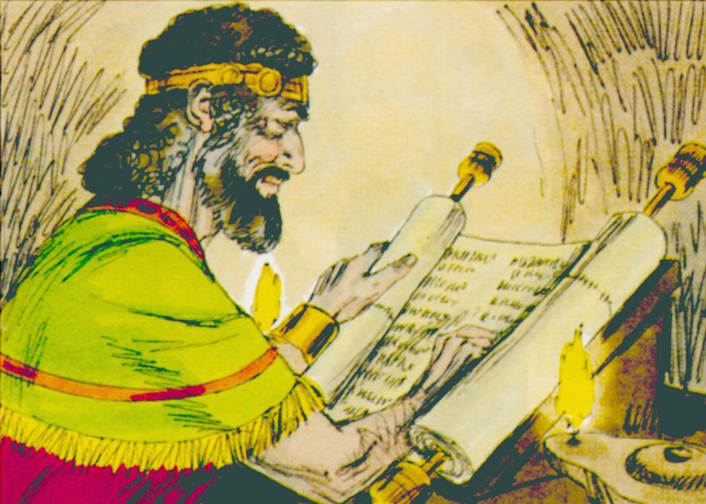
Source: Sweet Publishing - for illustration purposes of examining the Scriptures only
The prophets could not see what we believers can see today. It has been 2,000 years since CALVARY MOUNTAIN. No one knows how many more years until HOLY KINGDOM MOUNTAIN. The prophets did not know that Israel would reject their King. They did not know that God would cast Israel aside while He opened up a door of faith to the Gentiles (non-Jews).
先知们无法看到我们今天的信徒所看到的。 距骷髅地山已有 2,000 年历史。 没有人知道距离神圣王国山还有多少年。 先知们不知道以色列会拒绝他们的国王。 他们不知道上帝会在为外邦人（非犹太人）打开一扇信仰之门的同时抛弃以色列。
This age of Grace, GRACE AIRPORT, was a secret until Christ revealed it to the Apostle Paul (Ephesians 3). God used the Apostle Paul to preach to the Gentiles the unsearchable riches of Christ (Ephesians 3:8,9).
这个恩典时代，恩典机场是一个秘密，直到基督向使徒保罗透露（以弗所书 3 章）。 神使用使徒保罗向外邦人宣讲基督那测不透的丰富（以弗所书 3:8,9）。
Israel’s King is coming again. Someday SALVATION LINER will be caught up to meet Jesus in the air (1 Thessalonians 4:13-18). The prophets searched carefully and inquired about these things (1 Peter 1:10-11). God wants believers to search the Scriptures. The Apostle Paul spoke of the believers in Berea who received the Word with eagerness. They examined the Scriptures daily (Acts 17:11).
以色列的君王又来了。 有一天，救赎班轮会在空中与耶稣相遇（帖撒罗尼迦前书 4:13-18）。 先知们仔细研究并询问这些事情（彼得前书 1:10-11）。 神要信徒查考圣经。 使徒保罗谈到在庇哩亚的信徒热切地接受神的话。 他们每天查考圣经（使徒行传 17:11）。
Finally, the voice of the prophets stopped speaking because God was silent. The obedient prophets had the written Word. They ho ped and waited for the arrival of the King. KINGDOM BOULEVARD became twisted, destroyed and neglected. It was a highway in the darkness of sin. In the next lesson, A Voice will suddenly break the stillness.
最后，先知的声音停止了说话，因为上帝沉默了。 顺从的先知们有书面的话语。 他们满怀希望地等待国王的到来。 王国大道变得扭曲、破坏和忽视。 这是一条在罪恶黑暗中的大道。 在下一课中，一个声音 将突然打破沉寂。
Do you examine the Scriptures daily? If you do not, it is time to begin. How should you study to present yourself approved to God? By rightly dividing the Word of Truth (2 Timothy 2:15). It’s only in the letters of the Apostle Paul that the Body of Christ finds the wonderful truths and promises of God. It’s only in the letters of the Apostle Paul that we find the instructions for living a righteous life.
你每天查考圣经吗？ 如果你不这样做，是时候开始了。你应该如何学习，才能将自己呈现在上帝面前？ 通过正确地划分真理之道（提摩太后书 2:15）。只有在使徒保罗的书信中，基督的身体才能找到上帝奇妙的真理和应许。只有在使徒保罗的书信中，我们才能找到过公义生活的指导。
MEMORY VERSE: “These were more fair-minded than those in Thessalonica, in that they received the word with all readiness, and searched the Scriptures daily to find out whether these things were so” (Acts 17:11).
背诵经文：“这些人比帖撒罗尼迦的人更公道，甘心领受这道，天天查考圣经，要晓得这道是与不是”（使徒行传 17:11）。

LESSON 17 – WORKSHEET
According to 1 Peter 1:10,11 the prophets spoke about two things concerning Christ. What are they?根据彼得前书 1:10,11，先知谈到关于基督的两件事。 这些是什么？
- ______________________________________________________________________
- ______________________________________________________________________

There are some Scripture references listed below. Find them and write them under the mountain to which they refer:
下面列出了一些圣经参考资料。 找到它们并将它们写在他们所指的山下：
Psalm 69:21 Psalm 2:4-5 Isaiah 53:4-6
诗篇 69:21 诗篇 2:4-5 以赛亚书 53:4-6
Psalms 22:29 Micah 5:1 Psalm 2:6-8
诗篇 22:29 弥迦书 5:1 诗篇 2:6-8
CALVARY MOUNTAIN -------- HOLY KINGDOM MOUNTAIN
各各山 -------- 圣王国山

- ______________________________________________________________________
- ______________________________________________________________________
- ______________________________________________________________________

- What does 1 Peter 1:10 say that the prophets did in trying to understand these things?
彼得前书 1:10 说先知们在试图理解这些事情时做了什么？
______________________________________________________________________
- What does Paul say that the believers in Berea did in order to see if the things he preached were true? Acts 17:11. ___________________________________________.
保罗说庇哩亚的信徒做了什么来看看他所传的是否真实？ 使徒行传 17:11。
- What does God want us to do in order to understand the Word? 2 Timothy 2:15.
神要我们做什么才能明白圣经？提摩太后书2:15____________________________.
- Why was it that the prophets did not see the Dispensation of Grace? Ephesians 3:5
为什么先知没有看到恩典时代？以弗所书 3:5________________________ ______.
- Write Acts 17:11: _______________________________________________________ ___________________________________________________________________________________________________________________________________________.
写使徒行传 17:11：

