LESSON 16 – CAPTIVITY DEVIATION
第 16 课 – 囚徒歧路
Kings and Chronicles
列王纪和历代志
THEME: To show that true happiness comes only if we know and obey God.
主题： 表明真正的幸福只有在我们认识并服从上帝的情况下才会到来。
The Lord established between Himself and the Israelites the laws through Moses at Mount Sinai (Leviticus 26:46), He told them to obey His statutes and keep His commandments and He would give them rain for their crops (Leviticus 26:3-7). He would also give them peace from their enemies, and He would eliminate harmful beasts from the land. If they disobeyed all His commandments, He would do the following: He would cause terror, disease and fever. Also, their enemies would eat all their crops. They would be defeated by their enemies; and they would be ruled by them (Leviticus 26:14-17).
耶和华在西奈山通过摩西在他自己和以色列人之间建立了法律（利未记 26:46），他告诉他们遵守他的律例并遵守他的诫命，他会为他们的庄稼降雨（利未记 26:3-7） . 他也会使他们免受敌人的伤害，他会从这片土地上消灭有害的野兽。如果他们不遵守他的所有诫命，他会做以下事情：他会引起恐惧、疾病和热症。 而且，他们的敌人会吃掉他们所有的庄稼。 他们会被敌人打败并被他们统治（利未记 26:14-17）。
Although King Solomon knew God’s commandments, he disobeyed them. He loved many foreign women. The Lord had said to the sons of Israel, “You shall not intermarry with them, nor they with you. Surely they will turn away your hearts after their gods” (1 Kings 11:2). King Solomon had 700 wives of royal birth and 300 concubines. When Solomon was old, his wives turned his heart after other gods. Solomon’s heart was not wholly devoted to the Lord his God (1 Kings 11:1-4).
所罗门王虽然知道上帝的诫命，却不遵守。他爱过许多外国女人。耶和华曾对以色列的儿子说：“你不可与他们通婚，他们也不可与你通婚。他们肯定会使你的心转离他们的神”（列王纪上11:2）。 所罗门王有700个皇室妻子和300个妃嫔。 所罗门年老时，他的妻子使他的心转向其他神。 所罗门的心并没有完全献身于耶和华他的神（列王纪上 11:1-4）。
The Lord was angry and He said to Solomon, “Because you have done this, and have not kept My covenant and My statutes, which I have commanded you, I will surely tear the kingdom away from you and give it to your servant” (1 Kings 11:11). The Lord caused enemies, including a man called Jeroboam, to rebel against the king (1 Kings 11:26). King Solomon reigned for forty years in Jerusalem over all Israel. When he died, his son Rehoboam became king (1 Kings 11:42,43).
耶和华很生气，对所罗门说：“你既如此行，不遵守我所吩咐你的约和律例，我必将国从你手中夺去，赐给你的仆人”（列王纪上11:11)。耶和华使敌人，包括一个名叫耶罗波安的人，背叛国王（列王纪上 11:26）。 所罗门王在耶路撒冷统治以色列全境四十年。 当他死后，他的儿子罗波安成为国王（列王纪上 11:42,43）。
After Solomon’s death, Jeroboam returned from Egypt (1 Kings 12:1-4). He and all the Israelites spoke to King Rehoboam, saying, “Your father made our yoke heavy; now therefore, lighten the burdensome service of your father, and his heavy yoke which he put on us, and we will serve you” (1 Kings 12:2-4). King Rehoboam said, “My father made your yoke heavy, but I will add to your yoke...” (1 Kings 12:14). Therefore, Israel rebelled against God. The kingdom was divided into a northern part, the kingdom of Israel, and a southern part, the kingdom of Judah (1 Kings 12:16-20).
所罗门死后，耶罗波安从埃及回来（列王上12:1-4）。他和以色列众人对罗波安王说：“你父亲使我们的轭重了；因此，如果你现在减轻你父亲的给我们的重负，减轻他加在我们身上的重轭，我们会为你服务”（列王纪上12:2-4）。罗波安王说：“我父亲加重了你的轭，但我要加更多 ……”（列王纪上 12:14）。 因此，以色列人背叛了上帝。 王国分为南北两部分，以色列王国和南部的犹大王国（列王纪上 12:16-20）。
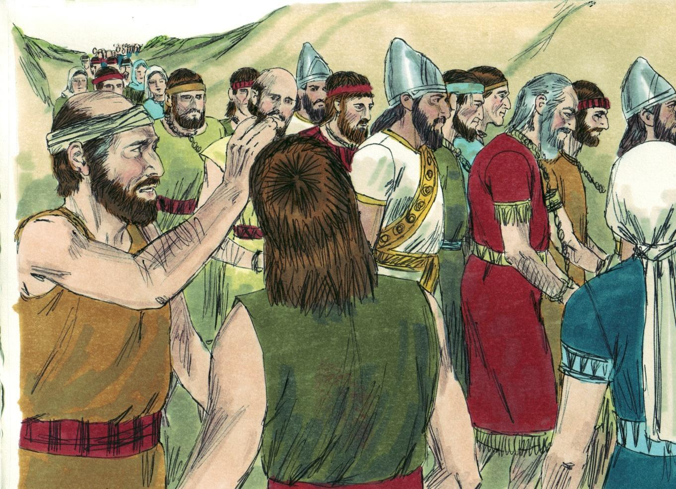
Source: Sweet Publishing - for illustration purposes of 2 Kings 25:7 only
Jeroboam became the first king of the kingdom of Israel (northern). He sinned greatly, and the kings who followed him sinned as well. As prophet Hosea predicted, God sent the promised judgment. The Assyrian army invaded Samaria (Israel) and made war with them for three years. The Assyrians then carried the Israelites away as captives to the land of Assyria. “For so it was that the children of Israel had sinned against the Lord their God...” (2 Kings 17:7). You can see why KINGDOM HIGHWAY on our chart is curved now because of sin.
耶罗波安成为以色列王国（北部）的第一位国王。他犯了很大的罪，跟随他的国王也犯了罪。 正如先知何塞亚所预言的，上帝发出了应许的审判。亚述军队入侵撒玛利亚（以色列）并与他们交战三年。 亚述人随后将以色列人俘虏到亚述地。“因为以色列人得罪了耶和华他们的神……”（列王纪下 17:7）。您可以看到为什么我们航程表上的王国大道现在因为罪恶而弯曲。
In the kingdom of Judah (southern) most of the kings who followed king Rehoboam were also wicked. Only a few kings obeyed the Lord God. One of them was King Hezekiah. He kept God’s commandments, which the Lord had commanded Moses (2 Kings 18:6). An interesting story to read is when God added fifteen years to Hezekiah’s life after he became mortally ill (2 Kings 20:1-6).
在犹大王国（南部），跟随罗波安王的大多数国王也是邪恶的。只有少数国王服从主神。 其中一位是希西家王。 他遵守了上帝对摩西的诫命（列王纪下18:6）。 一个有趣的故事是，在希西家致命的病重后，上帝将他的生命延长了 15 年（列王纪下20:1-6）。
Most kings of Judah ignored God’s words and His messengers, the prophets. The last king of Judah was Zedekiah. He was foolish and disobedient because he rebelled against the king of Babylon (2 Kings 24:20). Jeremiah the prophet warned: “And this whole land shall be a desolation and an astonishment, and these nations shall serve the king of Babylon seventy years” (Jeremiah 25:11).
大多数犹大的君王都忽视上帝的话语和他的使者——先知们。犹大的最后一位国王是西底家。 他愚蠢而悖逆，因为他背叛了巴比伦国王（列王纪下 24:20）。 先知耶利米警告说：“这全地要荒凉恐怖，这些民族要侍奉巴比伦王七十年”（耶利米书25:11）。
Nebuchadnezzar, king of Babylon, came with all his army against Jerusalem (Judah). Although King Zedekiah tried to escape, he was captured. The Babylonians slaughtered his sons before his eyes and then they put his eyes out. They bound him with bronze shackles and brought him to Babylon (2 Kings 25:1-7). We call this CAPTIVITY DEVIATION on our chart.
巴比伦王尼布甲尼撒率领全军前来攻打耶路撒冷（犹大）。西底家王虽然想逃跑，还是被俘虏了。 巴比伦人在他眼前屠杀了他的儿子，然后他们把他的眼睛挖了出来。 他们用铜镣铐把他绑起来，带到巴比伦（列王纪下 25:1-7）。 我们在航程表上将此称为囚徒歧路。
“...Nebuzaradan the captain of the guard, a servant of the king of Babylon, came to Jerusalem. He burned the house of the Lord and the king’s house; all the houses of Jerusalem, that is, all the houses of the great, he burned with fire” (2 Kings 25:8-9). The Chaldeans (Babylonians) broke the bronze pillars in pieces and carried the bronze to Babylon. They also took away the silver and gold from the temple (2 Kings 25:13-21). After seventy years, God allowed Judah to return to their land. Yet, the kingdom was gone (Jeremiah 29:10).
“……巴比伦王的仆人、护卫长尼布撒拉旦来到耶路撒冷。 他烧毁了耶和华的殿和王宫； 他用火焚烧了耶路撒冷的所有房屋，即神的家”（列王纪下25:8-9）。迦勒底人（巴比伦人）打碎了铜柱，将铜带到巴比伦。 他们还从圣殿中拿走了金银（列王纪下25:13-21）。 七十年后，上帝允许犹大人返回他们的土地。 然而，王国已经消失了（耶利米书 29:10）。
Disobeying God brings terrible consequences. Solomon and the other kings brought problems to their whole nation. God tells us that we are the servants of the one whom we obey (Romans 6:16). If we disobey God’s Word, we are serving ourselves. God wants us to obey the gospel of our Lord Jesus (2 Thessalonians 1:8). He wants children to obey their parents (Ephesians 6:1-3). God will not allow His beloved Son to be rejected forever. This present age of Grace will end someday. It has lasted more than 2,000 years. (Read 1 Thessalonians 5:3; 2 Thessalonians 1:6-9). Therefore, NOW is “THE ACCEPTABLE TIME” … NOW is “THE DAY OF SALVATION” (2 Corinthians 6:2). Submit to Christ today as He alone can give true happiness.
不服从上帝会带来可怕的后果。 所罗门和其他国王给他们的整个国家带来了麻烦。 上帝告诉我们，我们是我们所服从的那一位的仆人（罗马书 6:16）。 如果我们不遵守上帝的话语，我们就是在为自己服务。 上帝希望我们遵守我们主耶稣的福音（帖撒罗尼迦前书 1:8）。 他希望孩子们服从他们的父母（以弗所书 6:1-3）。上帝不会让他的爱子永远被拒绝。 恩典的这个时代总有一天会结束。 它已经持续了2000多年。（阅读帖撒罗尼迦前书 5:3；帖撒罗尼迦前书 1:6-9）。 因此，现在是“可以接受的时间”……现在是“救恩的日子”（哥林多后书 6:2）。 今天顺服基督，因为只有祂才能带来真正的幸福。
MEMORY VERSE: “Children, obey your parents in the Lord, for this is right” (Ephesians 6:1).
背诵经文：“孩子们，你们当在主里听从父母，因为这是对的”（以弗所书 6:1）。

LESSON 16 – WORKSHEET
Read Leviticus 26:3-12 and write down 6 of the blessings which God promised Israel if they walk in His statutes and keep His commandments.
阅读利未记 26:3-12 并写下上帝应许以色列人的 6 项祝福，如果他们遵守祂的律例并遵守祂的诫命。
- Give _________________________________________________________________
Grant ________________________________________________________________
给 _________________________________________________________________
授予 _______________________________________________________________
- Eliminate ______________________________________________________________
No ___________________________________________________________________
排除 ______________________________________________________________
不 ___________________________________________________________________

- Make _________________________________________________________________
Walk _________________________________________________________________
制作 _________________________________________________________________
走 _________________________________________________________________

Read Leviticus 26:16,17,20,22,25,29,31,33 and write down 6 of the terrible chastisements or punishments which would come upon Israel if they disobeyed God and turned to idols.
阅读利未记 26:16,17,20,22,25,29,31,33 并写下 6 种可怕的惩罚或惩罚，如果他们不服从上帝并转向偶像，他们会临到以色列。
- Appoint _______________________________________________________________
Set His face ___________________________________________________________
任命 _______________________________________________________________
定下他的脸__________________________________________________________
- Their strength __________________________________________________________
Let loose ______________________________________________________________
他们的力量 __________________________________________________________
放开 ______________________________________________________________
- Bring _________________________________________________________________
Scatter _______________________________________________________________
带来 _________________________________________________________________
分散 _______________________________________________________________
- But God loved His people and said He would remember the ______________________ of their ancestors. Leviticus 26:45.
但上帝爱祂的子民，并说祂会记念他们祖先的____________。 利未记 26:45。
- God tells us that we are the servants of _____________________________________. Romans 6:16.
上帝告诉我们，我们是________________________________的仆人。 罗马书 6:16。
- Write Ephesians 6:1: _____________________________________________________ ______________________________________________________________________
写下以弗所书6：1

