LESSON 15 – SOLOMON’S GLORIOUS KINGDOM
第 15 课 – 所罗门的荣耀国度
1 Kings 1 – 11 and 2 Chronicles 1 - 9
列王纪上1-11和历代志下1-9
THEME: To give a preview of the 1,000 year Kingdom.
主题： 千年王国的预览
Believers are going to reign with Christ one day in a position that is higher than any earthly king or queen (Ephesians 1-2; 2 Timothy 2:11-12, 3:12). King David desired to build a permanent house for the Ark of the Covenant. The word of the Lord came to him, saying, “… you have shed much blood and you have made great wars; you shall not build a house for My name, because you have shed much blood on the earth in my sight. Behold, a son shall be born to you, …He shall build a house for My name, and he shall be My son and I will be his Father; and I will establish the throne of his kingdom over Israel forever” (1 Chronicles 22:6-10). Then King David directed Solomon to build the sanctuary. When King David was old, he made his son Solomon king over Israel (1 Chronicles 23:1).
信徒有一天将与基督一起统治，其地位高于任何地上的国王或王后（以弗所书 1-2；2 提摩太后书 2:11-12, 3:12）。 大卫王想为约柜建造一座永久性的房子。 耶和华的话临到他说：“……你流了很多血，打了大仗；你不可为我的名建造房屋，因为你在我眼前流了很多血在地上。看啊，你要生一个儿子，……他要为我的名建造殿宇，他要作我的儿子，我要作他的父亲； 我要在以色列建立他王国的宝座，直到永远”（历代志上 22:6-10）。然后大卫王指示所罗门建造圣所。 当大卫王年老时，他立他的儿子所罗门作以色列王（历代志上 23:1）。
When Solomon began his reign as king over all Israel, he went to the high place at Gibeon (2 Chronicles 1:3). God’s tabernacle was there, which Moses had made in the wilderness. There King Solomon offered a thousand burnt offerings on the bronze altar. That night God appeared to Solomon and said to him, “Ask! What shall I give you?” (2 Chronicles 1:7). King Solomon asked God for wisdom and knowledge. He showed his wisdom during a dispute between two women who claimed to be the true mother of a baby (1 Kings 3:16-28). Because of this humble request, God also gave him riches, wealth and honour. King Solomon returned to Jerusalem and he reigned over Israel (2 Chronicles 1:1-13).
当所罗门开始他作为全以色列王的统治时，他去了基遍的高处（历代志下 1:3）。 上帝的帐幕在那里，是摩西在旷野建造的。 在那里，所罗门王在铜坛上献了一千燔祭。 那天晚上，上帝向所罗门显现，对他说：“祈求！ 你需要我给你什么？” （历代志下 1:7）。 所罗门王向上帝求智慧和知识。他在两个声称自己是婴儿真正母亲的女人发生争执时展示了他的智慧（列王纪上3:16-28）。 由于这个谦卑的要求，上帝也赐给他富足、财富和荣誉。 所罗门王回到耶路撒冷，统治以色列（历代志下 1:1-13）。
Solomon organized the kingdom with twelve governors over all Israel (1 Kings 4:7). He had 40,000 stalls of horses for his chariots, and 12,000 horsemen. He also spoke 3,000 proverbs, and his songs were 1,005 songs (1 Kings 4:26-32). His great throne was made of ivory and pure gold. All his drinking cups were made of gold. He was greater than all the kings of the earth in riches and wisdom (1 Kings 10:18-23).
所罗门用十二个总督管理整个以色列的王国（列王纪上 4:7）。 他的战车有四万匹马，还有骑兵一万二千。他还写了 3,000 句箴言，1,005 首歌曲（列王纪上 4:26-32）。 他的大宝座是用象牙和纯金制成的。他所有的酒杯都是金做的。他的财富和智慧胜过地上所有的君王（列王纪上 10:18-23）。
In 2 Chronicles 3 we read that Solomon began to build the Temple in Jerusalem on Mount Moriah, where the Lord answered the offerings of King David (1 Chronicles 21:26). The Temple consisted of a house for the Lord (1 Kings 6:2), a porch (1 Kings 6:3), an Inner Court (1 Kings 6:36) or Court of the Priests, and the Great Court (2 Chronicles 4:9) where the people assembled to worship. The house for the Lord had an inner sanctuary, the Holy of Holies, where the ark of the covenant of the Lord was placed (1 Kings 6:19).
在历王记下3 中，我们读到所罗门开始在耶路撒冷的摩利亚山上建造圣殿，主曾在那里回应了大卫王的献祭（历代记上21:26）。 圣殿由主殿 (列王纪上 6:2)、门廊 (列王纪上6:3)、内院 (列王纪上6:36) 或祭司院和大院子，即人们聚集敬拜的地方组成 (历代记下 4:9) 耶和华的殿有一个内殿，即至圣所，放置耶和华的约柜（列王上书 6:19）。

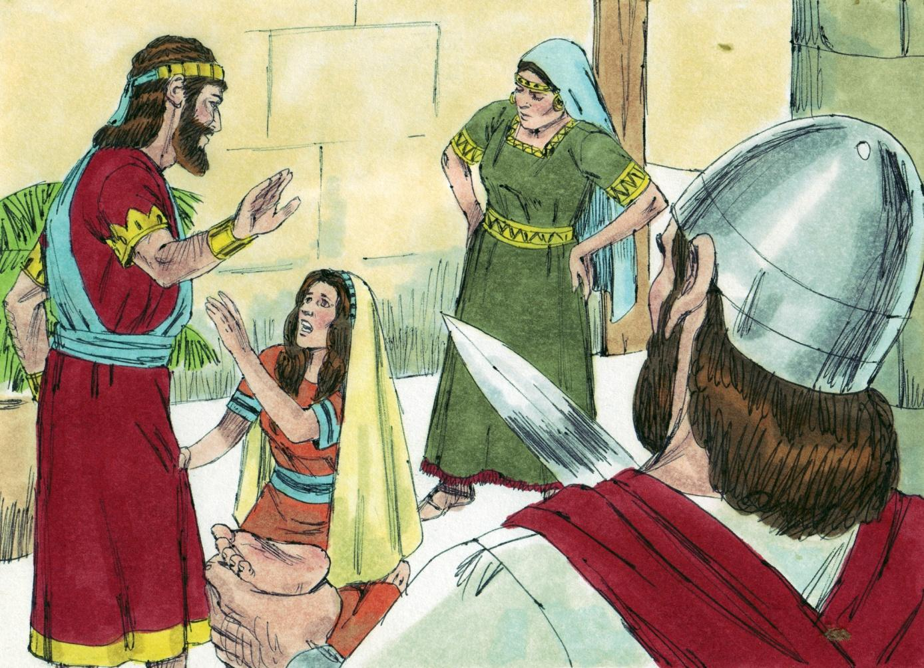
Source: Sweet Publishing - for illustration purposes of 1 Kings 3:26 only
The first altar was the Altar of Burnt Offering, also called the Brasen (bronze) altar. It stood before the house for the Lord (2 Kings 16:14). The animals that were offered in the burnt offerings were always the highest quality. The offerer laid his hands upon the animal, and he identified his sins with it. When the animal was killed (by the hand of the offerer), it died for the sins of the offerer. The second altar was the Altar of Incense, also called the Golden Altar (Exodus 30:1-10). It stood inside the house before the ark of the Testimony of the Lord.
第一个祭坛是燔祭祭坛，也称为黄铜（青铜）祭坛。它立在耶和华的殿前（列王纪下 16:14）。献在燔祭中的动物总是最优质的。献祭者把手放在动物身上，他认出了他的罪孽。 当动物被杀死（由献祭者的手）时，它为献祭者的罪而死。第二个祭坛是香坛，也称为金坛（出埃及记 30:1-10）。 它矗立在屋内，主的法柜前。
In 2 Chronicles 5,6 we read that all the work that Solomon performed for the house of the Lord was finished. King Solomon “brought in the things which his father David had dedicated…” (2 Chronicles 5:1). After King Solomon prayed that God would forgive the sins of the Israelites, fire from heaven came down (2 Chronicles 6:36-42). It “...consumed the burnt offering and the sacrifices; and the glory of the Lord filled the temple” (2 Chronicles 7:1). All the Israelites saw the fire come down and the glory of the Lord was on the temple. They bowed down on the pavement with their faces to the ground, and they worshiped the Lord. They praised Him saying, “For He is good, For His mercy endures forever” (2 Chronicles 7:3).
在历代志下 5,6 中，我们读到所罗门为耶和华的殿所做的一切工作都完成了。 所罗门王“将他父亲大卫所奉献的东西带来……”（历代志下 5:1）。在所罗门王祈求上帝赦免以色列人的罪孽之后，火从天而降（历代志下 6:36-42）。 它“……吃了燔祭和祭物；耶和华的荣耀充满了圣殿”（历代志下 7:1）。以色列人都看见火降临，耶和华的荣耀在殿上。他们在通道上俯伏而下，脸伏于地，敬拜主。他们赞美他说：“他本为善，他的慈爱永远长存”（历代志下 7:3）。
Recall that a type in the Bible is someone or something that is pictured before time. Solomon’s kingdom was a type of the great KINGDOM OF HEAVEN upon earth. God promised a kingdom to Abraham, Isaac, Jacob and David. On our chart it is represented by HOLY KINGDOM MOUNTAIN. It will probably be located on the site where Solomon’s Temple was built.
回想一下，圣经中描绘的某人或某事都是一种预表。所罗门的国度是地上伟大天国的预表。上帝应许亚伯拉罕、以撒、雅各和大卫建立一个王国。在我们的航程表上，它由圣山表示。 它可能位于所罗门圣殿的建造地点。
Our Lord Jesus Christ will reign as King of kings and Lord of lords (Revelation 19:16). All the nations will come and worship before Him (Revelation 15:4). Are you wondering where we, believers in Christ, will be then? We must look at GRACE AIRPORT. All who trust the Lord Jesus Christ as their personal Saviour become passengers on SALVATION LINER.
我们的主耶稣基督将作为万王之王和万主之主掌权（启示录 19:16）。万国都要来到他面前敬拜（启示录15:4）。你想知道我们这些信基督的人到时候会在哪里吗？我们必须看看恩典机场。 所有相信主耶稣基督是他们个人救主的人都会成为 救世班轮 的乘客。
Before Christ returns to reign on the earth, the Body of Christ will be “caught up” to meet the Lord in the air (1 Corinthians 12:27). Believers will be joined with Him forever (1 Thessalonians 4:15-17). While believers are waiting to be “caught up,” Christ wants us to be Ambassadors for Him. We must tell others about the gospel of Grace so that they can be reconciled to God (2 Corinthians 5:17-6:2).
在基督再来统治地球之前，基督的身体将被“提到”在空中与主相遇（哥林多前书12:27）。 信徒将永远与他汇合（帖撒罗尼迦前书 4:15-17）。当信徒等待“被提升”时，基督希望我们成为他的大使。我们必须告诉别人恩典的福音，这样他们才能与神和好（哥林多后书5:17-6:2）。
We have seen the glory which came to Solomon because he obeyed God. Next lesson we will see the tragedy when Solomon disobeyed God. We must learn from his mistakes.
我们已经看到所罗门因顺服上帝而获得的荣耀。 下一课我们将看到所罗门违背上帝的悲剧。 我们必须从他的错误中吸取教训。
It is our “blessed hope” to be caught up to meet the Lord in the air (Titus 2:13). Do you have this hope? It is not difficult to become His child. Trust Him as your personal Saviour from going to hell. Believe that He died, He was buried, and that He was resurrected for your sin. Then you will be a child of God and a fellow heir with Christ (Romans 8:16,17).
被提在空中与主相遇是我们“被祝福的希望”（提多书 2:13）。 你有这个希望吗？ 成为祂的孩子并不难。 相信祂是你免于下地狱的个人救主。 相信他死了，他被埋葬了，他为你的罪复活了。 然后你将成为神的孩子，与基督同为后嗣（罗马书 8:16,17）。
MEMORY VERSE: “and if children, then heirs- heirs of God and joint heirs with Christ, if indeed we suffer with Him, that we may also be glorified together” (Romans 8:17).
背诵经文：“若是儿女，就是神的后嗣，与基督同为后嗣；我们若与祂一同受苦，也可以一同得荣耀”（罗马书 8:17）。
LESSON 15 – WORKSHEET
Look up the Scriptures and fill in the correct word to complete the following statements.
查考圣经，填上正确的单词，完成下列陈述。
- God refused to let David build the Temple because he had _______________________
_______________________________________________________1 Chronicles 22:8.
上帝拒绝让大卫建造圣殿，因为他有 ___________________________历代志上 22:8。

- God said that David’s son ____________________ would build it. 1 Chronicles 22:9,10.
上帝说大卫的儿子 ____________________ 会建造它。历代志上 22:9,10。
- God said that the throne of the kingdom of Solomon would be established over Israel ______________________________________________________ 1 Chronicles 22:10.
上帝说所罗门王国的宝座将建立在以色列之上 ___________________ 历代志上 22:10。
- Solomon asked that God would give him ____________________________________ 2 Chronicles 1:10.
所罗门请求上帝赐给他 ____________________________________ 历代志下 1:10。
- God showed that He was pleased with the offerings and the prayer of Solomon by sending _______________________________________________________________ _______________________________________________________ 2 Chronicles 7:1.

上帝通过发送________________历代志下 7:1 表明他对所罗门的奉献和祈祷感到满意。
- God told Solomon: “If you turn away and forsake My statutes and My commandments which I have set before you, and go ________________________________________, then I will ______________________________________________________________ __________________________________________________________________________________________________________________________. 2 Chronicles 7:19,20.
上帝对所罗门说：“如果你转身离弃我摆在你面前的我的律例和诫命，去___________________，那么我将_______________________。 历代志下 7:19,20。
- Solomon’s kingdom was a type/picture of the great time to come when Christ will reign for 1,000 years (Millennium), and the earth will be full ___________________________ ____________________________________________________________ Isaiah 11:9.
所罗门的国度是基督将统治1000年（千禧年）的伟大时代的预表/图画，地球将充满____ ______ 以赛亚书 11:9。
- If we, the members of the Body of Christ, endure, ______________________________ ________________________________________________________. 2 Timothy 2:12.
如果我们，基督身体的成员，能够忍受，______________________。 2 提摩太 2:12。
- While we are waiting to be caught up to be forever with the Lord, God wants us to be ___________________________ for Christ. 2 Corinthians 5:20.
当我们等待被提永远与主同在时，上帝希望我们为基督而_______________。哥林多后书 5:20。

- Write Romans 8:17: _____________________________________________________ _________________________________________________________________________________________________________________________________________________________________________________________________________________.

写下罗马书 8:17：

