LESSON 14 – FROM PROMISE ROAD TO KINGDOM BOULEVARD
第 14 课 – 从应许之路到王国大道
1 Samuel 8 – 2 Samuel 6
撒母耳记上8–撒母耳记下6
THEME: To show the foolishness of letting self rule one’s life.
主题： 展示让自我主宰生活的愚昧。
“Give us a king to judge us,” said all the elders of Israel. “...Now make us a king to judge us like all the nations” (1 Samuel 8:5). The Israelites rejected the Lord God as their King. Samuel warned them about the behavior of their future kings (1 Samuel 8:9-18). They wanted a king they could see. They wanted a king to fight their battles (1 Samuel 8:20). Foolish Israelites! They did not understand the mistake that they were making in having sinful humans rule over them (1 Samuel 8:10-22).
“给我们一个国王来掌管我们，”以色列所有的长老说。 “......现在让我们像其他国家一样，有一个国王掌管我们”（1 Samuel 8：5）。 以色列人拒绝主神作他们的王。 撒母耳警告他们未来国王的行为（撒母耳记上 8:9-18）。 他们想要一个他们能看到的国王。 他们想要一个国王来为他们打仗（撒母耳记上 8:20）。 愚蠢的以色列人！ 他们不明白让有罪的人统治他们是很大的错误（撒母耳记上 8:10-22）。
Remember our verse about the way of life and the way of death from lesson 1? “There is a way that seems right to a man, but its end is the way of death” (Proverbs 14:12). There are many examples in the Bible of those who chose the way of death. Life on earth is about choosing the way of eternal life. It’s also about choosing the right way to serve God here on earth. Today we shall read about two kings- one who chose the way of death, and one who chose the way of life.
还记得在第一课中关于生命之道和死亡之道的经文吗？ “有一条路，人以为正，结局却是死亡之路”（箴言 14:12）。 圣经中有许多选择死亡之路的例子。 地球上的生命是为了选择永生之道。 也是为了选择正确的方式在地球上为上帝服务。 今天我们将读到两位国王——一位选择了死亡之道，一位选择了生命之道。
In Acts 13:18 the Apostle Paul explains that God put up with the Israelites’ ways in the wilderness for about forty years. After destroying seven nations in the land of Canaan, God distributed their land as an inheritance. Then He gave them judges until Samuel the prophet. The book of Judges states how they judged problems in Israel. It also describes how they fought to remove Israel from slavery. All of this took about 450 years (Acts 13:19,20). During that rebellious period, Israel broke the Law and they worshiped idols. By demanding human kings to rule over them, Israel sinned even more.
在使徒行传 13 章 18 节，使徒保罗解释说，神容忍以色列人在旷野的道路大约四十年。 在毁灭了迦南地的七个民族之后，上帝将他们的土地分配给以色列人作为产业。 然后他给了他们士师，直到先知撒母耳。 士师记叙述了他们如何判断以色列的问题。 它还描述了他们如何努力使以色列摆脱被奴役。 所有这一切花了大约 450 年（使徒行传 13:19,20）。 在那个悖逆的时期，以色列人违反了律法，崇拜偶像。 通过要求人类君王统治他们，以色列犯了更多的罪。
Israel’s first king was King Saul from the tribe of Benjamin (1 Samuel 9:1-2). He was tall and handsome. The Israelites were pleased, and they shouted, “Long live the king!” (1 Samuel 10:24). But God was not pleased when He saw the heart of Saul. Saul’s actions proved what was in his heart (1 Samuel 13).
以色列的第一位国王是本杰明支派的扫罗王（撒母耳记上 9:1-2）。他又高又帅。以色列人很高兴，大声喊道：“王万岁！” （撒母耳记上 10:24）。但神看到扫罗的心，并不喜悦。扫罗的行为证明了他的心意（撒母耳记上 13）。
Notice on your chart that there is a turn in the road where PROMISE ROAD becomes KINGDOM BOULEVARD. When King Saul began to reign, he led the people against their enemies the Philistines. However, the Israelites were afraid (1 Samuel 13:5-15). King Saul knew that only the prophet Samuel could do the burnt offering and the peace offering. But King Saul decided to do it himself. As soon as he finished offering the burnt offering, Samuel came. Samuel said, “You have done foolishly; … your kingdom shall not continue. The LORD has sought for Himself a man after His own heart…” (1 Samuel 13:13-14).
注意在你的航程表上，从应许之路变为王国大道的路上有一个转弯。 当扫罗王开始统治时，他带领人民对抗他们的敌人非利士人。 然而，以色列人害怕（1 Samuel 13:5-15）。 扫罗王知道只有先知撒母耳才能做燔祭和平安祭。 但扫罗王决定自己动手，当他献完燔祭，撒母耳来了。 撒母耳说：“你做了蠢事； ......你的王国不会继续存在。 耶和华为自己寻找合自己心意的人……”（撒母耳记上 13:13-14）。
Furthermore, King Saul disobeyed God after the battle with the Amalekites (descendents of Esau). God said, “...utterly destroy all that they have, and do not spare them” (1 Samuel 15:3). Yet, King Saul did not destroy everything as he had been commanded (1 Samuel 15:1-21). Therefore, God rejected Saul from being king of Israel (1 Samuel 15:22-35).
此外，扫罗王在与亚玛力人（以扫的后裔）争战后不服从上帝。上帝说，“……要彻底毁灭他们所有的，不要放过他们”（撒母耳记上 15:3）。然而，扫罗王并没有按照他的吩咐毁灭一切（撒母耳记上 15:1-21）。因此，上帝拒绝扫罗成为以色列的国王（撒母耳记上 15:22-35）。
God chose another man after His own heart as He had promised (1 Samuel 16:7). Samuel anointed David as king over Israel (1 Samuel 16:12-13). David also became Saul’s armour bearer (1 Samuel 16:21). God was pleased when He saw David’s heart. David’s actions proved what was in his heart (1 Samuel 17:45-47).
上帝按照他的应许，按照自己的心意拣选了另一个人（撒母耳记上 16:7）。撒母耳膏大卫作以色列的王（撒母耳记上 16:12-13）。大卫也成为扫罗的盔甲卫士（撒母耳记上 16:21）。 神看见大卫的心，就很高兴。 大卫的行为证明了他的心意（撒母耳记上 17:45-47）。

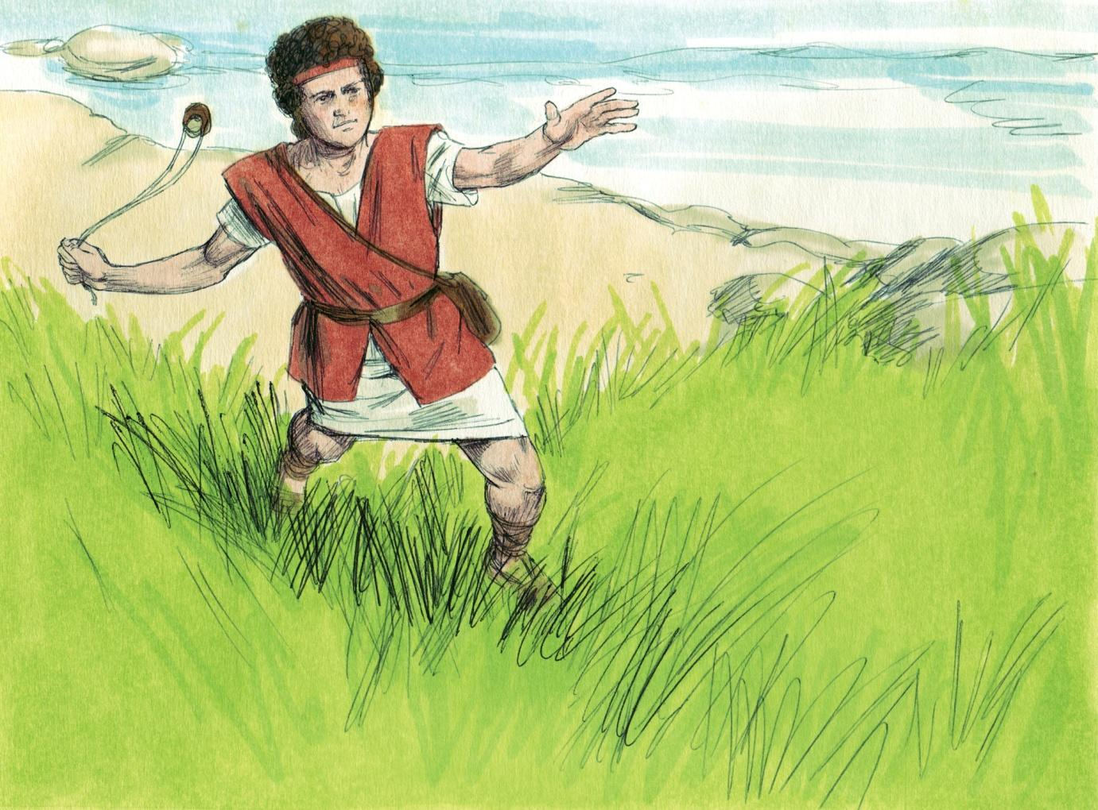
Source: Sweet Publishing - for illustration purposes of 1 Samuel 17:49 only

First Samuel 17 describes how David killed the giant Goliath who was the champion of the Philistines. David was brave, humble, loyal, and a man of faith who gave all the glory to God (1 Samuel 17:34-47).
撒母耳记上 17 章描述了大卫如何杀死作为非利士人冠军的巨人歌利亚。 大卫勇敢、谦逊、忠诚，是一个信实的人，他将所有的荣耀都归给了上帝（撒母耳记上 17:34-47）。
King Saul was envious of David, and he did not want to give his throne to him. In fact, King Saul tried to kill David (1 Samuel 18:1-14). Although David had to run for his life for several years, God kept him safe.
扫罗王嫉妒大卫，不想将王位让给他。事实上，扫罗王试图杀死大卫（撒母耳记上 18:1-14）。 尽管大卫不得不为他的生命奔跑好几年，但上帝保守他安全。
David had chosen the way of faith to serve God. However, King Saul continued to disobey God. He was afraid that the Philistines would defeat the Israelites. So he asked a pagan woman who practiced witchcraft for advice (1 Samuel 28:7-19). King Saul broke the law mentioned in Leviticus 19:31. King Saul had chosen the way that seemed right to man but it proved to be the way of death (1 Samuel 26:21).
大卫选择了信仰的方式来事奉上帝。然而，扫罗王继续违抗上帝。 他害怕非利士人会打败以色列人。 因此，他向一位行巫术的异教妇女寻求建议（撒母耳记上 28:7-19）。扫罗王违反了利未记 19:31 中提到的律法。 扫罗王选择了一条人认为正确的道路，但事实证明它是死亡之路（撒母耳记上 26:21）。
After King Saul’s death, King David reigned for forty years (2 Samuel 5:4). King Saul had also been king over Israel for forty years (Acts 13:21). After two years, King Saul was rejected as king in a spiritual sense, while he continued to be a king in a national sense (1 Samuel 13:1, 15:23).
扫罗王死后，大卫王在位四十年（撒母耳记下 5:4）。 扫罗王也作以色列王四十年（使徒行传 13:21）。 两年后，扫罗王在属灵意义上被拒绝为王，而他仍然是国家意义上的王（撒母耳记上 13:1, 15:23）。
David was thirty years old when he became king (2 Samuel 5:4). Saul’s son Jonathan attacked the Philistines’ headquarters in the beginning of his father’s reign (1 Samuel 13:3). He must have been at least twenty years old at that time (Numbers 1:3). Thus, Jonathan was about thirty years old when David was born. If David was fifteen years old when he killed Goliath, Jonathan was forty-five years old when they became friends (1 Samuel 20).
大卫登基时三十岁（撒母耳记下 5:4）。 扫罗的儿子约拿单在他父亲统治初期袭击了非利士人的总部（撒母耳记上 13:3）。 那时他一定至少有二十岁（民数记 1:3）。 因此，约拿单在大卫出生时大约三十岁。 如果大卫杀死歌利亚时是 15 岁，那么当他们成为朋友时，约拿单是 45 岁（1 Samuel 20）。
Jonathan was one of the most righteous men on earth. Although he was next in line to his father’s throne, Jonathan accepted the word of God that David was to be the next king. His father Saul never accepted it. Other men would have killed for the chance to be king. Jonathan honored God, and he gave the throne to David. Jonathan and David were spiritual-minded, and they were best friends who cared for each other.
约拿单是地球上最公义的人之一。虽然他是他父亲王位的第二顺位继承人，但约拿单接受了上帝的话，大卫将成为下一任国王。他的父亲扫罗从未接受。其他人会为了成为国王的机会而杀人。约拿单尊荣神，将王位赐给大卫。 约拿单和大卫有属灵的心意，他们是彼此关心的最好的朋友。
King Saul symbolizes the old self-nature. King David symbolizes the new spiritual nature. We all should trust the Lord Jesus Christ as our personal Saviour. Christ became for us wisdom from God (1 Corinthians 1:30), and His name is Wonderful Counselor (Isaiah 9:6). Proverbs 12:15 states, “The way of a fool is right in his own eyes, but he who heeds counsel is wise.”
扫罗王象征着旧的本性。大卫王象征着新的灵性。我们都应该相信主耶稣基督是我们个人的救主。基督为我们成为来自上帝的智慧（哥林多前书 1:30），他的名字是奇妙的策士（以赛亚书 9:6）。 箴言 12 章 15 节说：“愚昧人的道，自以为正，听从劝告的，才是有智慧的。”
As King Saul tried to kill David several times, the old self-nature is always trying to destroy the new spiritual nature. Are you going to be foolish or wise? Christ wants to be your Wonderful Counselor. It is wise to obey Him.
扫罗王数次试图杀死大卫，旧的本性总是试图摧毁新的属灵本性。你会变得愚蠢还是明智？ 基督想成为你奇妙的策士。 顺服祂是明智的。
MEMORY VERSE: “The way of a fool is right in his own eyes, but he who heeds counsel is wise” (Proverbs 12:15).
背诵经文：“愚昧人的道，自以为正；听从劝告的，为有智慧”（箴言 12:15）。
LESSON 14 – WORKSHEET
第 14 课 – 工作表
- Why is THE HIGHWAY OF LIFE now called KINGDOM HIGHWAY? 1 Samuel 8:5-6. _____________________________________________________________________.
为什么生命大道现在被称为王国大道？ 1 撒母耳记 8:5-6。
What were Saul’s three greatest mistakes as king of Israel?
扫罗作为以色列王的三个最大错误是什么？
- 1 Samuel 13:13 _________________________________________________________
______________________________________________________________________

- 1 Samuel 15:23 _________________________________________________________
______________________________________________________________________

- 1 Samuel 28:7__________________________________________________________
______________________________________________________________________

What were the three best things about David as king of Israel?
大卫作为以色列王的三件事是什么？
- 1 Samuel 16:7__________________________________________________________
______________________________________________________________________

- 1 Samuel 17:45 _________________________________________________________
______________________________________________________________________

- 1 Samuel 18:5__________________________________________________________
______________________________________________________________________

- According to Proverbs 12:15, why would you say that Saul was a fool?
根据箴言 12:15，你为什么说扫罗是个傻瓜？
______________________________________________________________________

- How can we have wisdom? 1 Corinthians 1:30
我们怎样才能拥有智慧？ 哥林多前书 1:30
______________________________________________________________________

- Write Proverbs 12:15:
写下箴言12：15____________________________________________________ _________________________________________________________________________________________________________________________________________________________________________________________________________________.

