LESSON 13 – JOSHUA LEADS ISRAEL INTO THE PROMISED LAND
第 13 课 – 约书亚带领以色列人进入应许之地
Joshua 1 - 11
约书亚记1-11
THEME: To show that possession of God’s blessings depends upon taking hold of that which God’s Word promises.
主题： 表明拥有上帝的祝福取决于把握上帝话语的应许。
With our swords and shields, we are going to be fighting battles as we travel on PROMISE ROAD. You will learn the secret of how to enjoy the blessings of the Christian life.
带着我们的剑和盾，我们将在承诺之路上进行战斗。你将学习如何享受基督徒生活的祝福的秘诀。
When God’s faithful servant Moses died, God buried him in a valley in Moab (Deuteronomy 34:5,6). Joshua was appointed to lead a new generation into the PROMISED LAND (Deuteronomy 34:9). Joshua had shown his faith at Kadesh when the unbelieving spies had feared to go into the land (Numbers 13). During the forty years of wandering in the wilderness, the old generation of Israelites had died (except Caleb and Joshua). God spoke to Joshua and He made promises to him:
当上帝忠实的仆人摩西死后，上帝将他埋葬在摩押的山谷中（申命记 34:5,6）。 约书亚被任命带领新一代进入应许之地（申命记 34:9）。 当不信的探子害怕进入那地时，约书亚在加低斯表明了他的信心（民数记 13）。 在旷野流浪的四十年中，老一代以色列人已经死去（除了迦勒和约书亚）。 神对约书亚说话，他向他许诺：
- “Every place that the sole of your foot will tread upon, I have given you, as I said to Moses” (Joshua 1:3).
- “你脚掌所踏的每一个地方，我都给了你，正如我对摩西所说的”（约书亚记 1:3）。
- “…. As I was with Moses, so I will be with you. I will not leave you nor forsake you” (Joshua 1:5).
“…… 就像我和摩西在一起一样，我也会和你在一起。 我不会撇下你，也不会抛弃你”（约书亚记 1：5）
- “Only be strong and very courageous, that you may observe to do according to all the law which Moses My servant commanded you; do not turn from it to the right hand or to the left, that you may prosper wherever you go. This Book of the Law shall not depart from your mouth, but you shall meditate in it day and night, that you may observe to do according to all that is written in it. For then you will make your way prosperous, and then you will have good success. Have I not commanded you? Be strong and of good courage; do not be afraid, nor be dismayed, for the Lord your God is with you wherever you go” (Joshua 1:7-9).
——“只要刚强壮胆，谨守遵行我仆人摩西所吩咐你的一切律法；不要偏离它的左右，使你无论往哪里去，都可以顺利。这律法书不可离开你的口，而是要昼夜思想在其中，使你可以谨守遵行其中所写的一切。因为那时你将使你的道路繁荣昌盛，从而获得伟大的成功。我没有吩咐过你吗？ 坚强，勇敢； 不要害怕，也不要惊惶，因为无论你走到哪里，耶和华你的神都与你同在”（约书亚记 1:7-9）。
Joshua’s success depended upon him believing and obeying the Book of the Law. Israel came near to the first great city of Jericho. Joshua sent two spies ahead. The spies came into the house of Rahab who saved them from death (Joshua 2). They promised her that she and her family would be safe when the city was overtaken. Rahab had to tie a scarlet cord in the window through which she let them down. The spies used the same cord to escape (Joshua 2). The scarlet thread is a picture of salvation through the shed blood of the Lord Jesus Christ.
约书亚的成功取决于他相信并遵守律法书。当以色列接近第一个大城耶利哥。约书亚派两个探子往前走。 探子进入喇合的家，喇合将他们从死亡中拯救出来（约书亚记 2）。他们向她保证，当这座城市被占领时，她和她的家人被保全。喇合必须在让他们逃跑的窗户上系上一条朱红色的绳子。探子用同样的绳索逃跑（约书亚记 2）。朱红色线是通过主耶稣基督的宝血得救的画面。
Next, the Israelites prepared to cross the Jordan River that was opposite Jericho. Priests carried the Ark of the Covenant before the people. When their feet dipped in the edge of the water, the waters which were flowing down rose up in one heap. And those waters, which were flowing down toward the Salt Sea, were completely cut off. The Israelites crossed on dry ground. The priests, who carried the Ark of the Covenant of the Lord, stood firm on dry ground in the middle of the Jordan River (Joshua 3:14-17).
接下来，以色列人准备过耶利哥对面的约旦河。祭司将约柜抬到人们面前。当他们的脚一浸在水边时，往下流的水就升高成了一堆。那些流向盐海的水被完全切断了。以色列人在干地上过河。 抬着耶和华约柜的祭司，站在约旦河中间的干地上（约书亚记 3:14-17）。
In the 6th chapter of Joshua, Israel was given directions to conquer Jericho. The men of war circled the city daily for six days. On the seventh day, they marched around the city seven times, and the priests blew trumpets. After hearing the sound of the trumpets, all the people shouted loudly. Then the city walls fell down flat.
约书亚记第 6 章指示以色列人征服耶利哥。 战士们连续六天绕成而走。 第七天，当他们绕城七次的时候，祭司吹响了号角。 听到号角声后，所有的人都大声喊叫。于是城墙倒塌了。
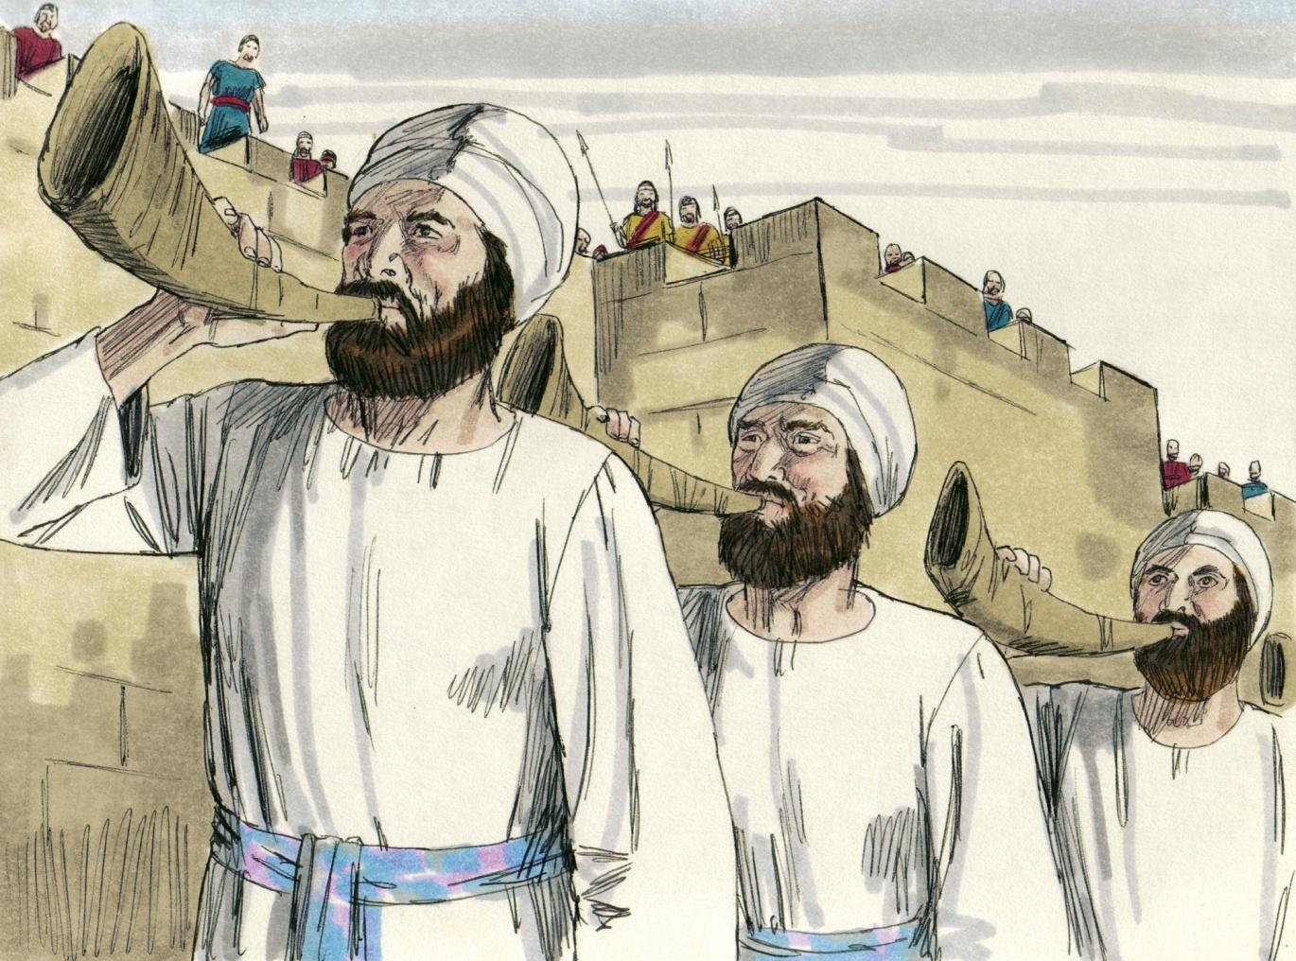
Source: Sweet Publishing - for illustration purposes only

God wants us to learn that His ways are not our ways. He wants amazing things done so that He will receive the glory. Let’s reflect on the following questions.
上帝要我们知道他的道路不是我们的道路。他希望令人惊奇的事情成就，以此获得荣耀。 让我们思考以下问题。
What made the walls of Jericho fall down flat? Faith in God and obedience to His commandments (Hebrews 11:30).
是什么让耶利哥的城墙倒塌？ 对上帝的信心和服从他的诫命（希伯来书 11:30）。
What saved Rahab? Faith in God through the spies whom she had peacefully welcomed (Hebrews 11:31).
是什么拯救了喇合？ 通过她平静接纳探子而展示的对上帝的信心（希伯来书 11:31）。
What made Joshua successful? Faith in God. He showed faith by obeying his Captain. He did not forget the Book of the Law. He trusted and obeyed God even though the orders seemed strange.
是什么让约书亚成功了？ 信仰上帝。 他通过服从他的统帅来表现出信心。 他没有忘记律法书。 尽管命令看起来很奇怪，但他相信并服从上帝。
What brings success to believers? Believers in Christ also have a battle to fight as we travel on THE HIGHWAY OF LIFE. There are things to notice about our battle:
什么给信徒带来成功？ 当我们在生命的高速公路上旅行时，基督的信徒也有一场战斗要打。 我们的战斗有几点需要注意：
- Our ‘promised land’ - heavenly places in Christ (Ephesians 1:3, 1:20, 2:6). By faith we are no longer controlled by sinfulness and rebellion. We have been rescued from spiritual death. We are given spiritual life through Christ Jesus in the heavenly places.
我们的“应许之地”——基督里的天堂（以弗所书 1:3, 1:20, 2:6）。 凭着信心，我们不再被罪恶和叛逆所控制。我们已经从属灵的死亡中被拯救出来。 我们在天上通过基督耶稣获得了属灵的生命。
- Our ‘enemies’ - rulers, powers, forces of darkness and wickedness (Ephesians 6:12).
我们的“敌人”——统治者、掌权者、黑暗势力和邪恶势力（以弗所书 6:12）。
- Our ‘victory’ - accomplished through faith in our Captain, the risen Lord Jesus Christ. He gave us the gospel of the Grace of God through the Apostle Paul: “Christ died for our sins according to the Scriptures, and that He was buried, and that He rose again the third day according to the Scriptures” (1 Corinthians 15:3,4). By trusting this message of truth, we will be saved from going to hell. We show our faith by obeying the instructions of the apostle Paul. This will produce the fruit of the Holy Spirit: love, joy, peace, patience, kindness, etc. (Galatians 5:22,23). Our enemies will try to keep us from enjoying our fellowship with the Spirit. We must glorify Him in all things.
我们的“胜利”——通过对我们的元帅，复活的主耶稣基督的信心而实现。 他通过使徒保罗将上帝恩典的福音传给我们：“基督照圣经所说，为我们的罪死了，而且埋葬了，又照圣经所说，第三天复活了”（哥林多前书 15： 3,4)。 通过相信这个真理的信息，我们将免于下地狱。 我们通过遵守使徒保罗的指示来表明我们的信心。 这将结出圣灵的果子：仁爱、喜乐、和平、忍耐、仁慈等（加拉太书 5:22,23）。 我们的敌人会试图阻止我们享受与圣灵的相交。 我们必须在所有事情上荣耀他。
After the battle of Jericho, Israel never fully conquered the land of Canaan. They did not completely obey God’s Word. Once they entered Canaan, they divided the land as God directed.
在耶利哥战役之后，以色列从未完全征服迦南地。 他们没有完全遵守上帝的话语。 一旦他们进入迦南，他们就按照上帝的指示分割了这片土地。
Have you trusted in Christ as your personal Savior? If not, you are like Rahab, living in a place which is doomed for destruction. You can be saved by faith just like Rahab. You show your faith by confessing that Christ is your Saviour. Then you can bring your family into the safety of Christ just as Rahab saved hers from destruction. How? By telling them the gospel of the Grace of God.
你是否相信基督是你个人的救主？ 如果不是，你就像喇合一样，生活在一个注定要毁灭的地方。 你可以像喇合一样因信得救。 你通过承认基督是你的救主来表明你的信心。 然后你可以把你的家人带到基督的平安中，就像喇合拯救她的家人免于毁灭一样。 如何做到？ 通过告诉他们上帝恩典的福音做到。
MEMORY VERSE: “Have I not commanded you? Be strong and of good courage; do not be afraid, nor be dismayed, for the LORD your God is with you wherever you go” (Joshua 1:9).
背诵：“我没有吩咐过你吗？ 坚强，勇敢； 不要害怕，也不要惊惶，因为无论你往哪里去，耶和华你的神都与你同在”（约书亚记 1:9）。
LESSON 13 – WORKSHEET
- Who became Israel’s leader after Moses died? Joshua 1:1-2. _________________.
摩西死后谁成为以色列的领袖？ 约书亚记 1:1-2。
- Why was he appointed? Deuteronomy 34:9
他为什么被任命？申命记34:9___________________________________ ______________________________________________________________________ _____________________________________________________________________.

- What three special promises did God make to Joshua?
神对约书亚做了哪三个特别的应许？
Joshua 1:3 ____________________________________________________________. Joshua 1:5 ____________________________________________________________. Joshua 1:8 ____________________________________________________________ _____________________________________________________________________.
Choose the correct word to complete the following statements:
选择正确的词来完成下列陈述：
- Joshua’s success depended upon (hard work / obedience / good organization). Joshua 1:8.
约书亚的成功取决于（努力工作/服从/良好的组织）。 约书亚记 1:8。
- It was by (praying / fighting / faith / pushing) that the walls of Jericho fell down flat. Hebrews 11:30
正是通过（祈祷/战斗/信仰/推动），耶利哥的城墙倒塌了。 希伯来书 11:30
- Rahab was saved because she (was good / was bad / kept the Law / had faith). Hebrews 11:31.
喇合得救是因为她（好/坏/遵守律法/有信心）。 希伯来书 11:31。
The experience of those who live now in the dispensation of Grace is like the experience of the Israelites in many ways. Look up the following Scriptures and fill in the spaces.
现在生活在恩典时代的人的经历在很多方面与以色列人的经历相似。 查阅下列经文并填空。
- Israel was promised physical blessings in the land of Canaan and we have many promised spiritual blessings in ________________________________. Ephesians 1:3.
以色列在迦南地得到了物质上的祝福，我们在 _____________________ 得到了许多应许的属灵祝福。 以弗所书 1:3。
- Israel’s enemies were the nations who possessed Canaan and our enemies are ___________________________________________________________________________________________________________ in the heavenly places. Ephesians 6:12.
以色列的敌人是拥有迦南的国家，而我们的敌人是天上的_______________________。 以弗所书 6:12。
- Victory for Israel depended upon believing and obeying, and victory for us depends upon _________________________________________________. Ephesians 6:13-17.
以色列的胜利取决于相信和服从，而我们的胜利取决于______________。 以弗所书 6:13-17。
- Write Joshua 1:9:
写下约书亚记1：9_______________________________________________________ ______________________________________________________________________

