LESSON 12 – UNDER THE LAW ON PROMISE ROAD
第12课 应许之路上的遵循律法
Numbers 8 - 14
民数记8-14
THEME: To show that there is one Mediator between men and God.
主题： 表明人与神之间只有一位中保。
As we journey on THE HIGHWAY OF LIFE, we learn that Israel needed a mediator. There were penalties (curses) when the Israelites broke the Law. There were great blessings when the Israelites obeyed the Law (Deuteronomy 28).
当我们踏上生命的大道时，我们了解到以色列需要一位中间人。以色列人违反律法会受到惩罚（诅咒）。 当以色列人遵守律法时，就有了极大的祝福（申命记 28 章）。
After giving the Law at Mount Sinai, God gave Moses directions for preparing the Levites for priesthood (Numbers 7:89-8:5-22). God also commanded when the Israelites would journey, and He commanded when they would camp. The covering cloud during the day or the appearance of fire by night helped lead the Israelites (Numbers 9:15-23). God also commanded them to make two trumpets of silver. These trumpets were blown not only for assembling camps, but they were also blown during battles and festivals (Numbers 10:1-10).
在西奈山颁布律法后，上帝指示摩西如何预备利未人担任祭司（民数记 7:89-8:5-22）。 上帝也吩咐以色列人什么时候出发，祂也吩咐他们什么时候扎营。 白天的云层或夜间出现的火光帮助带领以色列人（民数记 9:15-23）。 神也吩咐他们用银子制造两个号角。 这些号角不仅是为集结的时候吹响，也在战斗和节日期间吹响（民数记 10:1-10）。
After they left from the wilderness of Sinai, they went to the wilderness of Paran (Numbers 10:11-36). When the people complained, the Lord heard it. His anger was kindled, and the fire of the Lord burned among them. Moses prayed to the Lord, and the fire died out. The name of that place was called Taberah, because the fire of the Lord burned among them (Numbers 11:1-3). Moses was the mediator between the Israelites and God.
他们离开西奈旷野后，来到了巴兰旷野（民数记10:11-36）。当人们抱怨时，主听到了。 他的怒火被点燃，耶和华的火在他们中间燃烧。摩西向耶和华祷告，火就灭了。那地方的名字叫做他贝拉，因为耶和华的火在他们中间燃烧（民数记 11:1-3）。摩西是以色列人和上帝之间的中保。
Since there were 600,000 men, God gave Moses seventy elders to assist him (Numbers 11:16-21). Miriam and Aaron became jealous of their brother Moses. Because they gossiped about him, Miriam was stricken with leprosy. Then Moses asked God to heal her, and she was healed after seven days. Again Moses was a mediator (Numbers 12).
因为以色列有 600,000 人，上帝于是赐给摩西七十位长老来帮助他（民数记 11:16-21）。 米利暗和亚伦嫉妒他们的兄弟摩西。因为他们说他的闲言碎语，米利暗患上了麻风病。摩西求神医治她，七日后她就痊愈了。 摩西再次成为中保（民数记 12）。
When the Israelites camped at Kadesh, Moses sent spies to the land of Canaan. He sent twelve spies, one from each tribe. After forty days, the spies gave their report to the Israelites. They showed them the fruit. They said, “We went to the land where you sent us. It truly flows with milk and honey, and this is its fruit” (Numbers 13:27).
当以色列人在加低斯安营时，摩西派探子到迦南地。他派了十二个探子，每个部落一个。 四十天后，探子向以色列人报告了他们的情况。 他们向他们展示了水果。 他们说：“我们去了你派我们去的地方。 它真的流奶与蜜，这就是它的果子”（民数记 13:27）。
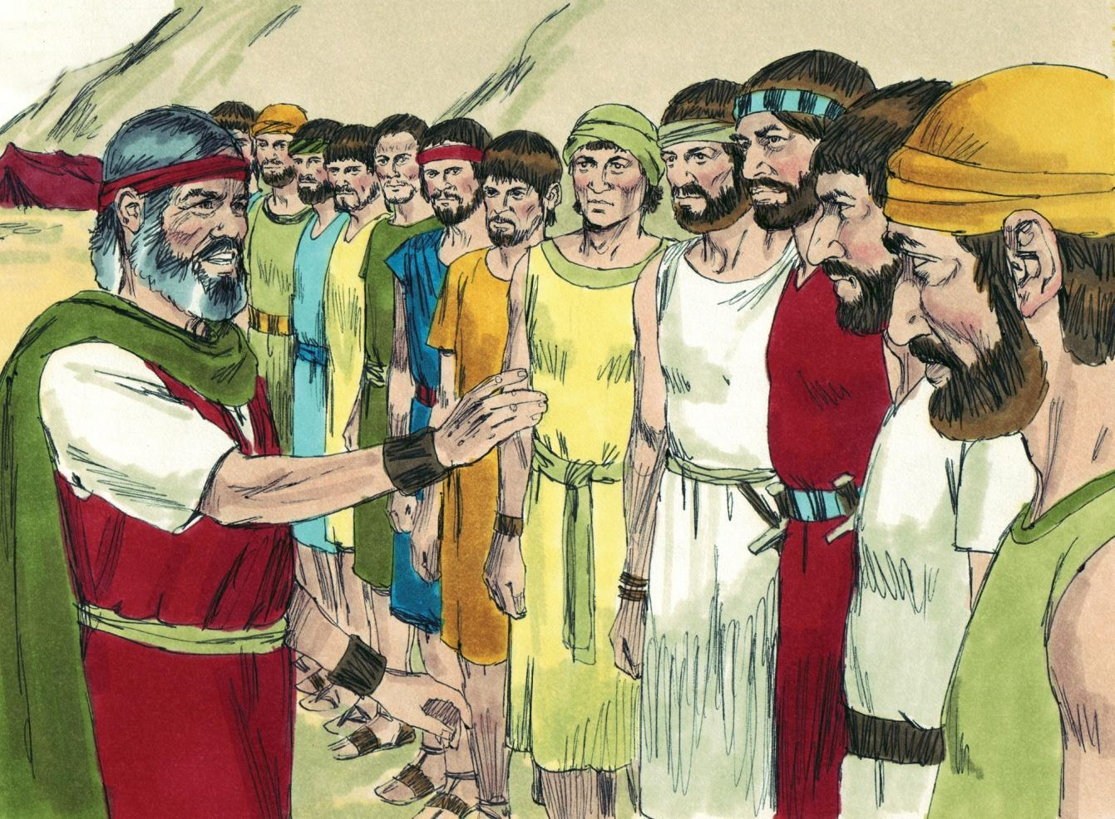
Source: Sweet Publishing - for illustration purposes of Numbers 13:1-3 only

They also said that the people were strong, and the cities were large and fortified. They said that the children of Anak (giants) live there. Then Calab quieted the people before Moses. He said, “Let us go up at once and take possession, for we are well able to overcome it” (Numbers 13:30). But the ten spies said, “We are not able to go up against the people, for they are stronger than we” (Numbers 13:31). The people complained against Moses, Aaron and the Lord. They threatened to appoint a leader and return to Egypt.
他们还说那里的人民很强壮，城市又大又坚固。他们说阿纳克（巨人）的孩子住在那里。 迦勒在摩西面前叫百姓安静。 他说：“让我们立刻上去夺取，因为我们完全能够战胜它”（民数记 13:30）。 但十个探子说：“我们不能上去攻击百姓，因为他们比我们强”（民数记 13:31）。 百姓抱怨摩西、亚伦和耶和华。 他们威胁要任命一位领导人并返回埃及。
Moses and Aaron fell down in grief in front of all the Israelites. Joshua and Caleb (two of the spies) tore their clothes in grief. They told them not to rebel against the Lord. They also told them not to fear the giants. Yet, the Israelites wanted to stone them (Numbers 14:1-10).
摩西和亚伦在所有以色列人面前悲痛地匍匐在地。约书亚和迦勒（其中两个探子）伤心地撕破衣服。 他们告诉他们不要背叛主。 他们还告诉他们不要害怕巨人。 然而，以色列人想用石头打死他们（民数记 14:1-10）。
Then the glory of the Lord appeared in the tabernacle before all the Israelites. The Lord said to Moses, “How long will these people reject Me? And how long will they not believe Me, with all the signs which I have performed among them? I will strike them with the pestilence and disinherit them, and I will make of you a nation greater and mightier than they” (Numbers 14:11-12).
这时，耶和华的荣光出现在帐幕中，在所有以色列人面前。主对摩西说：“这些人会拒绝我到几时呢？ 他们不相信我要到几时呢？即使我在他们中间行了所有神迹， 我要用瘟疫击打他们，剥夺他们的产业，使你们成为比他们更强大的国家”（民数记 14:11-12）。
Moses was a mediator for the people. The Lord answered him. He said that only Caleb and Joshua would be permitted to go into the Promised Land. All the Israelites aged twenty years old and upward would have to wander in the wilderness for forty years. The faithless ten spies died by a plague (Numbers 14:13-38).
摩西是人民的中保， 主回应他。 他说只有迦勒和约书亚被允许进入应许之地。 所有二十岁以上的以色列人都要在旷野漂流四十年。十个背信弃义的探子死于一场瘟疫（民数记 14:13-38）。
The Israelites deserved to be destroyed because of their unbelief and sin. According to our guidebook, the Bible, all people deserve to be destroyed. “All have sinned” (Romans 3:23). “The wages of sin is death...” (Romans 6:23). But, “...while we were still sinners, Christ died for us” (Romans 5:8). Christ intercedes for us (Hebrews 7:25). Christ is our Mediator before the Father. He stands between us and God’s judgment of sin. There is only one Mediator and that is Jesus Christ (1 Timothy 2:5-6). Christ has taken our deserved punishment for sin. When we trust Him as our personal Saviour from going to hell, God sees Christ’s righteousness in us.
以色列人因他们的不信和罪恶而应受毁灭。 根据我们的指南，圣经，所有人都应该被毁灭。 “世人都犯了罪”（罗马书 3:23）。 “罪的工价就是死……”（罗马书 6:23）。 但是，“……当我们还是罪人的时候，基督就为我们死了”（罗马书 5:8）。 基督为我们代求（希伯来书 7:25）。 基督是我们在父面前的中保。 他站在我们和上帝对罪的审判之间。 只有一位中保，那就是耶稣基督（提摩太前书 2:5-6）。 基督已经为我们的罪承担了应得的惩罚。 当我们相信祂是我们个人的救主使我们免于下地狱时，上帝就会在我们身上看到基督的公义。
We have learned that Moses was a type of Christ. Christ is the only Mediator between God and man. Is He your Mediator?
我们已经知道摩西是基督的映射。 基督是神与人之间唯一的中保。 他是你的中保吗？
MEMORY VERSE: “For there is one God, and one mediator between God and men, the Man Christ Jesus, who gave Himself a ransom for all, to be testified in due time” (1 Timothy 2:5-6).
背诵经文：“因为只有一位神，也是神与人之间的中保，就是人基督耶稣，他为众人舍了赎价，要按时作见证”（提摩太前书 2:5-6）。
LESSON 12 – WORKSHEET
Israel traveled after they accepted the Law. We see that there were penalties attached to breaking the Law. Fill in the blanks below according to the Scriptures.
以色列人接受律法后就开始旅行。 我们看到违反法律会受到处罚。 根据经文填空。
Sin committed Penalty for sin
犯下的罪对 罪的惩罚
- Numbers 11:1 ____________. Numbers 11:1 ______________________________.

- Numbers 12:1 ____________. Numbers 12:10 _____________________________.

- Numbers 14:11 ___________. Numbers 14:29 _____________________________.

- What did Moses do in each of the situations found in these verses:
在这些经文中发现的每种情况下，摩西做了什么：
Numbers 11:2 Numbers 12:13 Numbers 14:19
______________________________________________________________________

- Moses was an intercessor or mediator between God and sinful people. What is the name of the One who always lives to make intercession/prayer for us? Hebrews 7:22-25. _________________.
摩西是神与罪人之间的中保或中保。 永远活着为我们代求/祈祷的那位叫什么名字？ 希伯来书 7:22-25。 _________________。
- Fill in the spaces to show why saved people need Christ to pray for them. 1 John 2:1. “My little children, I am writing these things to you so that you may not _____________. And if anyone ____________, we have an Advocate (mediator/intercessor) with the Father, Jesus Christ the righteous.”
填空说明为什么得救的人需要基督为他们祷告。 约翰一书 2:1。 “我的孩子们，我写这些东西给你们，以免你们_____________。 如果有人____________，我们在天父那里有一位中保（中保/代祷者），即正义的耶稣基督。”
- Why do all people deserve to be punished? Romans 3:23 _______________________
_____________________________________________________________________.
为什么所有的人都应该受到惩罚？ 罗马书 3:23 ___________________________。

- What did Christ do while we were yet sinners? Romans 5:8 ______________________.
当我们还是罪人的时候，基督做了什么？ 罗马书 5:8 ______________________.
- Fill in the spaces in the verses below to show the powerful work of the Lord Jesus Christ as our Saviour. 填上以下经文中的空格，展示主耶稣基督作为我们救主的大能工作。
His work for the unsaved: 1 Timothy 1:15. Christ Jesus came into the world to _______ sinners. 他为未得救的人所做的工作：提摩太前书 1:15。 基督耶稣降世为_______罪人。
His work for the saved: Hebrews 7:25. He is able to _________ forever those who draw near to God through Him, since He always lives to make _________________ for them.
他为得救的工作：希伯来书 7:25。 他能够永远_________那些通过他亲近上帝的人，因为他总是活着为他们创造_______。
- Write 1 Timothy 2:5-6: ___________________________________________________
______________________________________________________________________
写出 1 提摩太后书 2:5-6：

