LESSON 11 – A MOUNTAIN SHADOWS PROMISE ROAD
第 11 课 – 遮蔽应许之路的山
Exodus 15 - 32
出埃及记 15 - 32
THEME: To show why God gave the Law and to whom it was given.
主题： 展示上帝为何赐下律法以及将律法赐给谁。

Today, we follow Israel to Mount Sinai (2,285 metres high). The Israelites traveled to the PROMISED LAND. God tested His people to see if they could govern the land that He promised to Abraham, Isaac and Jacob. He also wanted to prove to Israel that they needed Him all along the way.
今天，我们跟随以色列来到西奈山（2,285 米高）。 以色列人前往应许之地。 上帝考验祂的子民，看他们能否治理祂应许给亚伯拉罕、以撒和雅各的土地。 他还想向以色列证明他们一路上都需要他。
After Israel passed through the Red Sea, they came into the Wilderness of Shur (a strip of land between Egypt and Canaan). From here the tests began:
以色列人渡过红海后，来到书珥旷野（埃及和迦南之间的一片地带）。测试从这里开始：
- First test: the bitter waters of Marah- (Exodus 15:22-25). When the Israelites came to Marah, they could not drink the bitter waters. The people failed the test when they grumbled; but God was faithful. The Lord showed Moses a tree which he threw into the waters, and the waters became sweet. The tree symbolizes Christ who makes the bitter become sweet. Christ died on the tree to take the bitterness of sin upon Himself.
第一个考验：玛拉的苦水——（出埃及记 15:22-25）。 当以色列人来到玛拉时，那里的水很苦不能喝。 当人们抱怨时，他们没有通过测试； 但上帝是信实的。 耶和华指示给摩西一棵树，他把它扔到水里，水就变甜了。 树象征着使苦变甜的基督。 基督死在木头上，让自己承担罪的苦毒。
- Second test: hunger- (Exodus 16:3-21). In the Wilderness of Sin, the people grumbled because they were hungry. They failed the test, but God proved to be faithful. He sent them manna. The manna is a type of Christ, the Bread of Life (John 6).
第二个测试：饥饿——（出埃及记 16:3-21）。在罪恶的旷野，人们因为饥饿而抱怨。 他们没有通过考验，但事实证明上帝是信实的。他送他们吗哪。吗哪象征着基督，生命的粮（约翰福音 6 章）。
- Third test: thirst at Rephidim (Exodus 17:1-7). From the Wilderness of Sin, the Israelites camped at Rephidim, and there was no water. The people failed by angrily complaining to Moses. God provided them water from the rock after striking it. The rock is Christ, and the water symbolizes the Holy Spirit (John 7:37-39; 1 Corinthians 10:4). The striking of the rock pictured Christ being struck and crucified when He came to earth more than 2,000 years ago.
第三个考验：利非订的饥渴（出埃及记 17:1-7）。 以色列人从汛的旷野安营在利非订，那里没有水。 愤怒地向摩西抱怨，他们再次没有通过测试。 上帝在击打岩石后从岩石中提供了水。 磐石是基督，水象征圣灵（约翰福音 7：37-39；哥林多前书 10：4）。 岩石的撞击描绘了基督在 2000 多年后来到世上并被击打，钉死在十字架上的情景
Once the Israelites arrived at Mount Sinai, they camped in front of the mountain. When Moses went up into the mountain, God told him that He wanted the sons of Israel to be priests of a holy nation. They had to obey His voice and keep His covenant. All the people agreed to obey God. The Lord told Moses that He would speak to him in a thick cloud. God wanted the people to hear Him while they were at the foot of the mountain (Exodus 19).
以色列人一到西奈山，就在山前扎营。 当摩西上山时，上帝告诉他，祂希望以色列人成为圣洁民族的祭司。 他们必须听从祂的声音并遵守祂的约。 所有的人都同意服从上帝。 主告诉摩西，他会在浓云中对他说话。 上帝希望人们在山脚下听到他的声音（出埃及记 19）。
God tested the Israelites’ obedience to the Law. They feared God’s holiness when they heard the Ten Commandments (Exodus 20:1-21). Yet, they broke the first two commandments. Exodus 32 tells about the golden calf, God’s wrath, Moses breaking the two stone tablets of the Ten Commandments and the Levites killing 3,000 Israelites (Deuteronomy 9:10-21).
上帝试验了以色列人对律法的遵守。 当他们听到十诫（出埃及记 20:1-21）时，他们害怕上帝的圣洁。 然而，他们违反了前两条诫命。 出埃及记 32 讲述了金牛犊、上帝的愤怒、摩西打破十诫的两块石版和利未人杀死 3,000 名以色列人（申命记 9:10-21）。
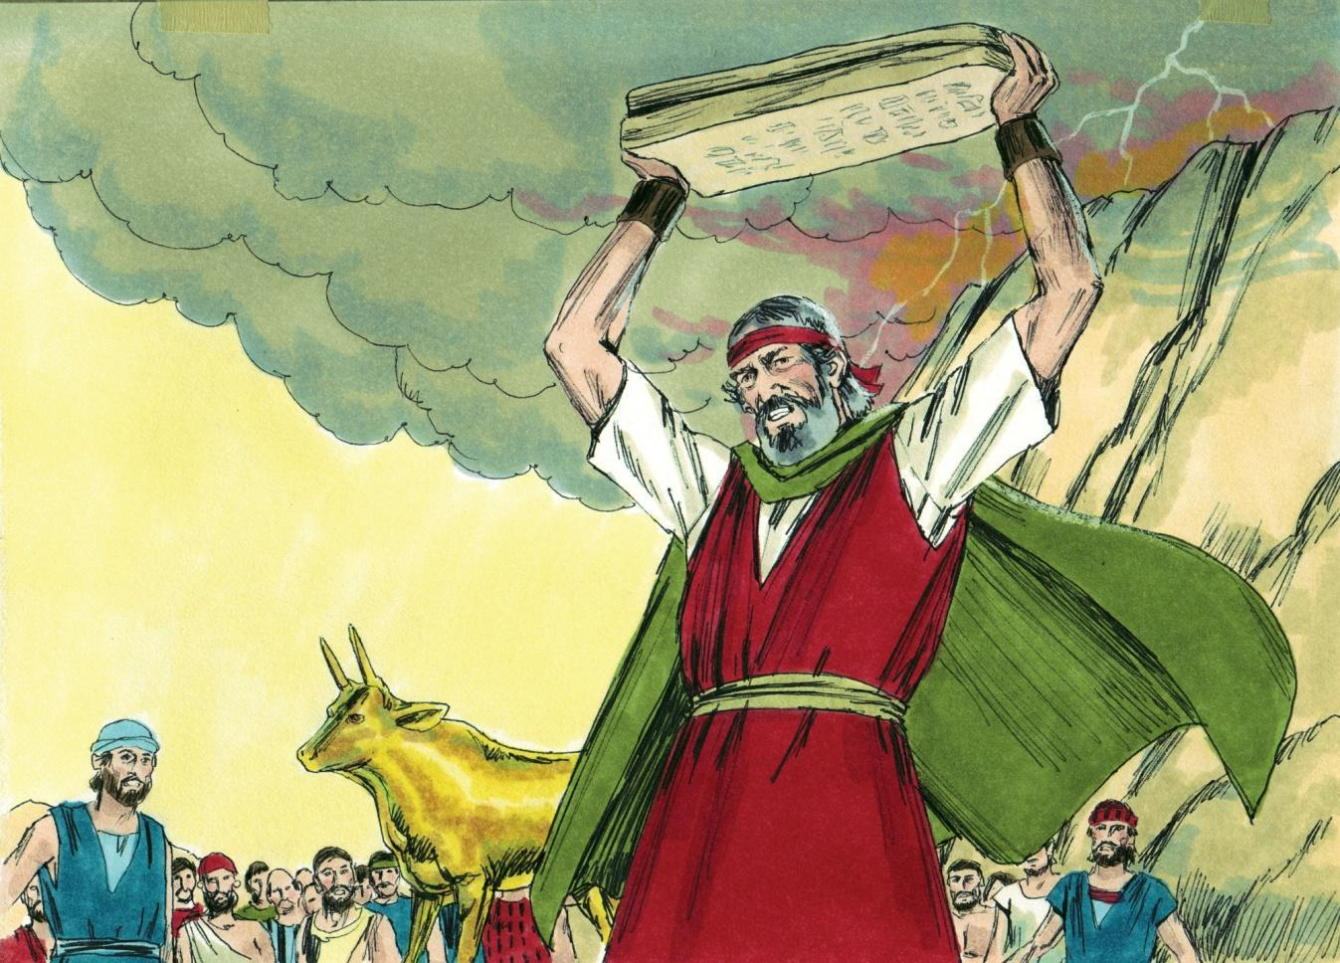
Source: Sweet Publishing - for illustration purposes of Exodus 32:19 only

The Israelites broke God’s commandments continuously. God gave them the Law to obey because of their sins (Galatians 3:19). The Israelites sinned because their hearts were hardened. The Law proved that the Israelites were sinful (Romans 3:19-20). The Law proved that God’s holiness required perfect righteousness (Exodus 20:3-6). Israel’s only hope was the Promised One, our Lord Jesus Christ (Galatians 3:24).
以色列人不断地违反上帝的诫命。 由于他们的罪，上帝赐给他们需要遵守的律法（加拉太书 3:19）。 以色列人犯罪是因为他们的心刚硬。 律法证明以色列人是有罪的（罗马书 3:19-20）。 律法证明上帝的圣洁需要完全的公义（出埃及记 20:3-6）。 以色列唯一的希望是应许的那一位，我们的主耶稣基督（加拉太书 3:24）。
The Law was given to Israel. The Law was nailed to the cross of Calvary (Colossians 2:14). We can learn from the Law the same things that Israel learned. We are weak and sinful. God demands perfect righteousness. We can only get perfect righteousness by trusting the Lord Jesus Christ as our personal Saviour. Trusting in the finished work of Christ upon the cross will save anyone who believes in Him.
律法已赐给以色列。 律法被钉在髑髅地的十字架上（歌罗西书 2:14）。 我们可以从律法中学习以色列所学到的同样的东西。 我们是软弱而有罪的。 神要求完全的公义。 只有相信主耶稣基督是我们个人的救主，我们才能得到完全的义。 相信基督在十字架上完成的工作将拯救任何相信他的人。
MEMORY VERSE: “What purpose then does the law serve? It was added because of transgressions, till the Seed should come to whom the promise was made; and it was appointed through angels by the hand of a mediator” (Galatians 3:19).
背诵经文：“那么，律法的目的是什么？ 它是因过犯而加的，直到那应许的后裔来到； 是由中保借天使设立的”（加拉太书 3:19）。
LESSON 11 – WORKSHEET
第 11 课 – 工作表
As the Israelites journeyed from Egypt to the land of Canaan, God tested them. He wanted to see if they would walk in His way and if they were ready to govern the Promised Land. From the Scriptures below fill in the blanks to show what the tests were and how God provided for their needs.
当以色列人从埃及前往迦南地时，上帝试探了他们。 他想看看他们是否会走在他的路上，以及他们是否准备好治理应许之地。从下面的经文中填空，说明测试是什么，以及上帝如何满足他们的需要。
- Exodus 15:22-25. At Marah the waters were _________________. God told Moses to throw a ________________ into the waters and they became _________________.
出埃及记15:22-25。在玛拉，水是_________________。神吩咐摩西把_____________ 扔进水里，他们变成了 _________________。

- Exodus 16:1-4. In the wilderness of ____________ the people thought they would die of _______________, but God said He would rain _____________ from ____________.
出埃及记 16:1-4。 在 ____________ 的旷野，人们以为他们会死于 _____________，但上帝说他会从 ____________ 下雨 _____________。

- Exodus 17:1-6. At Rephidim they became __________________ because there was no ______________, but God told Moses to strike the ______________ and _____________ would come out.
出埃及记 17:1-6。 在利非订，他们变成了 ________，因为没有 ______________，但上帝告诉摩西击打 ______________，然后 _____________ 就会出来。

- There is only one person who can satisfy our spiritual hunger and our spiritual thirst. Look up the verses below and write the name of this One.
John 6:35 ________________________; John 4:14 _______________________.
只有一个人能满足我们属灵的饥渴和属灵的渴求。 查阅下面的经文并写下这个人的名字。约翰福音 6:35___________________ 约翰福音 4:14 ____________________。
- Where was Israel when God gave them the greatest test of all? Exodus 19:1-2 ____________________________________________.
当上帝给他们最大的考验时，以色列在哪里？ 出埃及记 19:1-2 _________________。
The Bible references below tell why the Law was given. Look them up and fill in the spaces.
下面的圣经参考说明了为什么要颁布律法。 查找它们并填写空格。
- Galatians 3:19. The Law was added because of __________________________.
加拉太书 3:19。 增加该法是因为_________________________
- Romans 3:19. The Law was given that every _________________________________.
罗马书 3:19。 法律规定每 ___
- Romans 3:19. The Law was given that all the world might become ________________.
罗马书 3:19。 律法被赐下，全世界都可以___________
- What did Israel worship in breaking the first two commandments of the Law and what did Moses do with this? Exodus 32:4,20. _____________________________________
_____________________________________________________________________.
以色列人在违反律法的前两条诫命时崇拜什么？摩西对此做了什么？ 出埃及记 32:4,20。 __________________________________
- Write Galatians 3:19: ____________________________________________________
______________________________________________________________________
写下加拉太书 3:19：

