LESSON 10 – A PASS-OVER AND A PASS-THROUGH ON PROMISE ROAD
第 10 课 – 在应许之路上的逾越和穿越
Exodus 1 - 14
出埃及记 1 - 14
THEME: To teach the completeness of salvation in Christ.
主题： 教导在基督里完全的救恩。
Today as we journey we shall learn how God’s people were saved from three kinds of death as they travelled on PROMISE ROAD. The last lesson left us in Egypt after the death of Israel and Joseph. While Joseph was in power, everything went well for the children of Israel. After many years, a different Pharaoh came to power. Since he feared the multitude of the growing Israelites, he made them work as slaves (Exodus 1:8-22).
今天，我们将在旅途中学习上帝的子民在应许之路上如何从三种死亡中得救。 以色列和约瑟夫死后，在埃及我们还有最后一课。 当约瑟掌权时，以色列人的一切都很顺利。 多年后，另一位法老上台。 由于他害怕人数众多的以色列人，所以他让他们做奴隶（出埃及记 1:8-22）。
When the affliction became more than the Israelites could bear, they cried out to God (Exodus 2:23-25). “So God heard their groaning, and God remembered His covenant with Abraham, with Isaac, and with Jacob” (Exodus 2:24). God called another Israelite named Moses to lead His people out of Egypt to the land God had promised to give Abraham, Isaac, and Jacob. We call this land the PROMISED LAND (Exodus 3:8).
当苦难变得超出以色列人所能承受的范围时，他们向上帝呼求（出埃及记 2:23-25）。 “于是神听见了他们的叹息，就记念他与亚伯拉罕、以撒、雅各所立的约”（出埃及记 2:24）。 神呼召另一个名叫摩西的以色列人带领他的子民离开埃及，来到神应许赐给亚伯拉罕、以撒和雅各的土地。 我们称这片土地为应许之地（出埃及记 3:8）。
Moses questioned God four times when God gave him instructions to take the Israelites out of Egypt (Exodus 3-4). God became angry (Exodus 4:14). He gave his brother Aaron to be his spokesman before Pharaoh (Exodus 4:16). With God’s power, Moses performed all the wonders before Pharaoh (Exodus 4:21-23). Moses was eighty years old and Aaron was eighty-three years old when they spoke to Pharaoh. Read the exciting story of the ten plagues in Exodus 7:8–11:10. God treated the Egyptians differently than the Israelites (Exodus 11:7). Yet, Pharaoh still refused to allow the Israelites to leave Egypt and the Israelites continued to suffer (Exodus 6:9).
当上帝指示他将以色列人带出埃及时，摩西四次质疑上帝（出埃及记 3-4）。 神发怒了（出埃及记 4:14）。 他让他的兄弟亚伦在法老面前做他的代言人（出埃及记 4:16）。 凭借上帝的力量，摩西在法老面前行了所有的奇迹（出埃及记 4:21-23）。 当他们对法老说话时，摩西八十岁，亚伦八十三岁。 阅读出埃及记 7：8-11：10 中关于十灾的激动人心的故事。 神对待埃及人和以色列人不同（出埃及记 11:7）。 然而，法老仍然拒绝让以色列人离开埃及，以色列人继续受苦（出埃及记 6:9）。
For the last plague, “...all the firstborn in the land of Egypt shall die...and all the firstborn of the animals” (Exodus 11:5). God gave Moses and Aaron the plans for the Passover Lamb. God protected the Israelites from the tenth plague. All the Israelite families had to kill a pure male lamb of a year old (Exodus 12:5). They placed some of its blood on the *doorposts and on the lintels of the houses where they ate the roasted lambs. When the Lord saw the blood, He passed over the Israelites’ doors (Exodus 12:23). Where there was no blood, every firstborn was killed by the destroying angels (Exodus 12:23-29; Psalm 78:49-50).
最后一场灾难，“……埃及地一切头生男孩都必死……包括牲畜中一切头生的”（出埃及记 11:5）。 上帝给了摩西和亚伦逾越节羔羊的计划。 上帝保护以色列人免受第十灾。 所有的以色列家庭都必须宰杀一只一岁的纯公羊羔（出埃及记 12:5）。 并把它的血涂在门柱上和他们吃烤羊羔的房子的门楣上。 耶和华看见血，就从以色列人的门前过去（出埃及记 12:23）。 在没有血的地方，每个长子都被毁灭天使杀死（出埃及记 12:23-29；诗篇 78:49-50）。
“...The Lord struck all the firstborn in the land of Egypt, from the firstborn of Pharaoh who sat on his throne to the firstborn of the captive who was in the dungeon, and all the firstborn of livestock” (Exodus 12:29). That night in Egypt death came to all houses and there was the sound of great wailing throughout the land. Pharaoh arose in the night. He told Moses and Aaron to leave with the other Israelites, their flocks and their herds.
“……耶和华击杀了埃及地所有的长子，从坐宝座的法老，直到被掳在监里之人的长子，并一切头生的牲畜”（出埃及记 12:29） ）。 那天晚上在埃及，死亡临到了所有的房屋，整个土地都响起了巨大的哀号声。 法老在夜间起来。 他告诉摩西和亚伦和其他以色列人带着他们的羊群和牛群一起离开。
The Israelites requested from the Egyptians their silver, gold, and clothing. The Lord had given them favor, and they let them have their requests (Exodus 12:36). When the Israelites had not been gone long, Pharaoh changed his mind. He and his army chased them to the Red Sea (Exodus 13:18).
以色列人向埃及人索取金银和衣服。 主恩宠他们，他们让他们有他们的要求（出埃及记 12:36）。 以色列人离开不久，法老改变了主意。 他和他的军队追赶他们到红海（出埃及记 13:18）。
Moses said to the people, “Do not be afraid. Stand still, and see the salvation of the Lord … the Lord will fight for you...” (Exodus 14:13-14). Then Moses lifted up the rod and he stretched out his hand over the sea. The Lord swept the sea back by a strong east wind all night, and He turned the sea into dry land. The Israelites went through the midst of the sea on the dry land. The waters were like a wall to them on their right hand and on their left (Exodus 14:21,22). The Egyptians thought they could go through the sea. Instead, they drowned in the midst of it.
摩西对百姓说：“不要害怕。站稳了，看耶和华的救恩……耶和华必为你争战……”（出埃及记 14:13-14）。 摩西举起杖，向海伸出手臂。 主用整夜的强劲东风把海吹开，使海变成干地。 以色列人在海中干地走过。 水在他们的左右就像一道墙（出埃及记 14:21,22）。 埃及人认为他们也可以穿越大海。 结果，他们却淹死在海中。
God saved Israel from three kinds of death: 1) from the destroying angels; 2) from the sea; and, 3) from the army of Pharaoh. God did it all by His power. Today, we can have victory over three kinds of death: 1) the world; 2) the flesh; and 3) the devil.
上帝将以色列从三种死亡中拯救出来：1）从毁灭的天使手中；2）从大海手中； 并且，3）从法老的军队手中。上帝用他的能力完成了这一切。今天，我们可以战胜三种死亡：1）世界； 2）肉体； 3) 魔鬼。
Our life is similar to the Israelites. Egypt symbolizes the world. Israel was saved by faith from God’s judgement on Egypt by the blood applied to the doorposts and on the lintels of the houses. Believers in Christ shall be saved by faith from God’s judgement on the world by the blood of the Lord Jesus Christ applied to our hearts.
我们的生命与以色列人相似。 埃及象征着世界。以色列因信得救，免于上帝对埃及的审判，因为血涂在门框和房屋的门楣上。 相信基督的人将因信得救，因主耶稣基督的宝血涂在我们的心上，免于上帝对世界的审判。

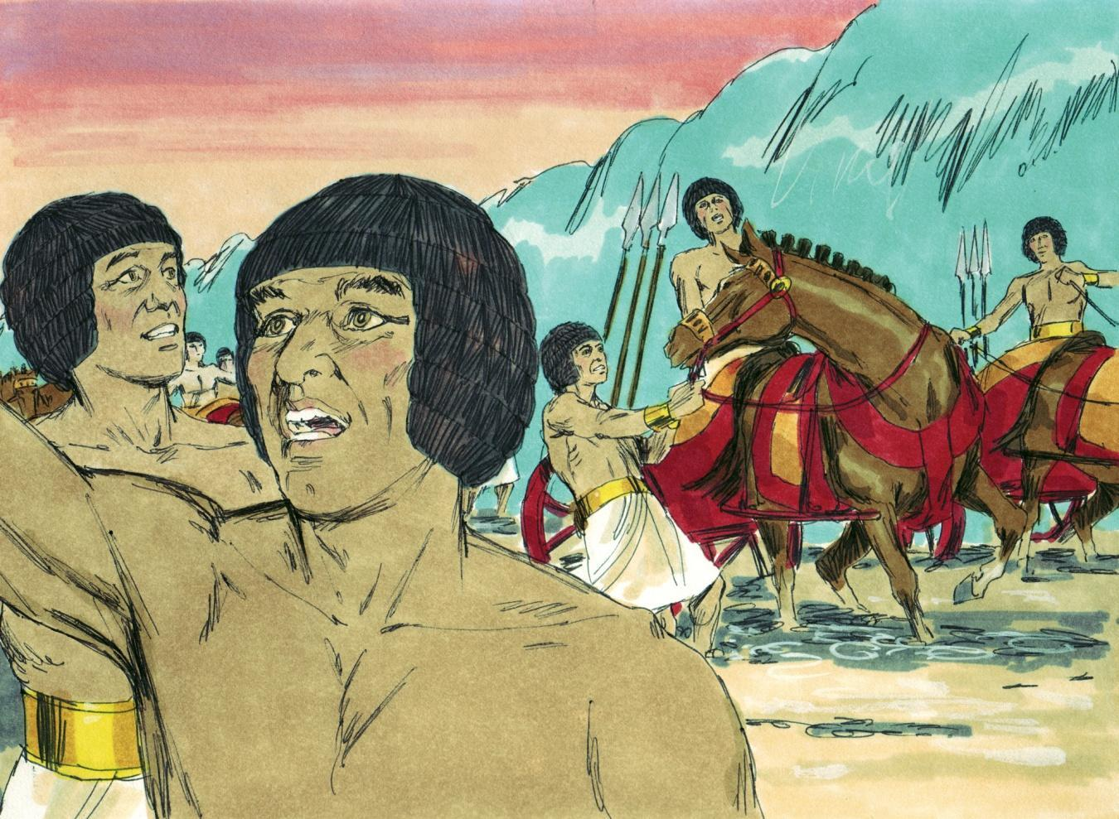
Source: Sweet Publishing - for illustration purposes of Exodus 14:24-25 only
Our sin nature symbolizes the flesh. It fights against the spiritual man. The Israelites ate the roasted flesh of the Passover Lamb to receive strength for their journey. Believers get nourishment by studying His Word rightly divided (2 Timothy 2:15). Believers must put off the Old Self (old nature), and we must put on the New Self (new nature) who is renewed in knowledge according to the image of the One who created him (Colossians 3:9,10).
我们的罪性象征肉体。 它与属灵的人作战。 以色列人吃了逾越节羔羊的烤肉，为他们的旅程获得力量。 信徒通过正确地学习神的话语来获得营养（提摩太后书 2:15）。 信徒必须脱去旧我（旧本性）穿上新我（新本性），新我（新本性）按照创造他的那一位的形象在知识上得到更新（歌罗西书 3:9,10）。
Pharaoh and his armies symbolize the devil. Israel was saved by faith in following the instructions of Moses who received them from God. Believers are saved by faith in following the instructions of the Apostle Paul who received them from the risen Lord Jesus Christ. By faith we win the battle against the old sin nature in us. We gain victory over the temptations and trials by following the writings of the Apostle Paul. If we do not obey his instructions, we are following the enemy. The Israelites needed to obey Moses to defeat Pharaoh and his armies.
法老和他的军队象征着魔鬼。 以色列因信从上帝领受摩西的指示而得救。 信徒因信奉从复活的主耶稣基督那里接受到信息的使徒保罗的指示而得救。凭着信心，我们战胜了我们里面旧有的罪性。 跟随使徒保罗的著作，我们就能战胜诱惑和试炼。 如果我们不听从他的指示，我们就是在跟随敌人。以色列人需要服从摩西才能打败法老和他的军队。
Israel’s salvation required believing and obeying God. Our salvation from the world, the flesh and the devil requires believing and obeying God’s Word. Jesus Christ, our Passover, was sacrificed for us.
以色列的救赎需要相信和顺服神。我们从世界、肉体和魔鬼中得救需要相信和顺服神的话语。 耶稣基督，我们的逾越节，是为我们牺牲的。
Just as the Israelites had their names written in stone, those of us who have trusted Christ as our Savior have our names written in the Book of Life. “And anyone not found written in the Book of Life was cast into the lake of fire” (Revelation 20:15).
正如以色列人的名字被刻在石头上一样，我们这些信靠基督为我们救主的人的名字也被写在了生命册上。“没有写在生命册上的，就被扔在火湖里”（启示录 20:15）。
This book is also called “the Lamb’s Book of Life” (Revelation 21:27). Just as God told the Israelites to cover their names with the blood of the lamb, you can have your name written in the Book. You need to believe in the redemption in Christ, through His blood, the forgiveness of sins, according to the riches of His grace (Ephesians 1:7).
这本书也被称为“羔羊的生命册”（启示录 21:27）。 正如上帝告诉以色列人用羔羊的血遮盖他们的名字一样，你可以将你的名字写在圣经中。 你需要相信在基督里的救赎，因着他丰富的恩典，通过他的血，罪得以赦免（以弗所书 1:7）。
MEMORY VERSE: “Therefore, purge out the old leaven, that you may be a new lump, since you truly are unleavened. For indeed Christ, our Passover, was sacrificed for us” (1 Corinthians 5:7).
背诵经文：“所以你们要除掉旧酵，使你们成为新的团块，因为你们确实是无酵的。 因为基督，我们的逾越节，为我们牺牲了”（哥林多前书 5:7）。
The doorposts and the lintels of their mudbrick homes were made of stone. These homes were inscribed with the names of those who lived there.
他们泥砖房的门框和门楣是用石头砌成的。 这些房子都刻有住在那里的人的名字。
LESSON 10 – WORKSHEET
- The Israelites had followed PROMISE ROAD to what country?
Exodus 1:1___________________.
以色列人跟随应许之路到了哪个国家？
出埃及记 1:1___________________。

- Why do we call Canaan the PROMISED LAND? Exodus 12:25.
为什么我们称迦南为应许之地？出埃及记12:25。_______________________________________________________.

- Listues God sent upon Egypt. Exodus 7-11. the 10 judgments/plag
列出上帝派往埃及的清单。 出埃及记 7-11。 10个判决
1) _______________________; 6) ________________________;
2) _______________________; 7) ________________________;
3) _______________________; 8) ________________________;
4) _______________________; 9) ________________________;
5) _______________________; 10) ________________________.
God saved His people from three kinds of death as they escaped from Egypt to Canaan on PROMISE ROAD. Write what the 3 deaths were:
当他们从埃及逃到应许路上的迦南时，上帝将祂的子民从三种死亡中拯救出来。 写出 3 种死亡情况：
- Exodus 12:12-13 ______________________________________________.
- Exodus 14:22-23 ______________________________________________.
- Exodus 14:27-28 ______________________________________________.
Today we have an enemy who wants to destroy our body and soul. The verses below warn us. Look them up and fill in the spaces below.
今天我们有一个敌人想要摧毁我们的身体和灵魂。 下面的经文警告我们。 查找它们并填写下面的空格。
- (Galatians 1:4) Christ gave Himself for our sins so that He might rescue us from _____________________________________________________. So Jesus Christ should be our personal Saviour and Lord.
（加拉太书1:4）基督为我们的罪舍己，好拯救我们脱离_______________。 所以耶稣基督应该是我们个人的救主和主。
- (Romans 8:13) If we are living according to the ___________________ we must die. But if by the Spirit we are putting to death the _____________ _______________, we will live. So we should not live according to the flesh.
（罗马书 8:13）如果我们按照 ___________________ 生活，我们就必须死。 但是，如果我们靠着圣灵治死 _____________ _______________，我们就会活着。 所以我们不该随从肉体而活。
- (Ephesians 6:11) Put on the full armor of God, so that you will be able to stand firm against the ________________________. So we should put on the full armor of God in order to stand firm.
（以弗所书6:11）穿上上帝的全副军装，这样你就能坚定地对抗__________。 所以我们应该穿上神的全副军装，才能站稳。

- Write 1 Corinthians 5:7: _________________________________________
写出哥林多前书 5:7：_

